Today’s activity is for an M8 Number – Exercise Routine. Carefully counting each movement to 10 and then stop.
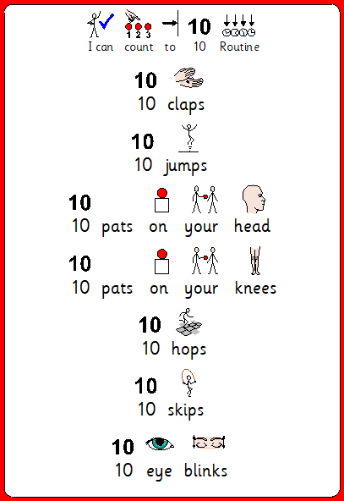
10 days of numbers to 10. activity is for an M8 Number –
Watch Numbers with Rodd:
Counting with Rodd 1:
https://www.bbc.co.uk/programmes/p0161z9n
Counting with Rodd 2:
https://www.bbc.co.uk/programmes/p0162095
Counting with Rodd 3:
https://www.bbc.co.uk/programmes/p01626vj
Counting with Rodd 4:
https://www.bbc.co.uk/programmes/p01620zs
Counting with Rodd 5:
https://www.bbc.co.uk/programmes/p01621p2
Counting with Rodd 6:
https://www.bbc.co.uk/programmes/p0161344
Counting with Rodd 7:
https://www.bbc.co.uk/programmes/p01629rc
Counting with Rodd 8:
https://www.bbc.co.uk/programmes/p01629yk
Counting with Rodd 9:
https://www.bbc.co.uk/programmes/p0161394
Counting with Rodd 10:
https://www.bbc.co.uk/programmes/p01613g2
Each day after introducing the number with the video. Practise writing the number. Hide pieces of paper with the number around the room. Build a tower with that many blocks. Practise counting out pasta and stopping at the number.
Today’s activity is for an M8 number.
Blast off to 10. Cut the numbers out put them in order and practise counting forward and backwards to blast the rocket off.
Colour your rocket with your favourite colours.
Finish with countdown blast off with Rodd. https://www.bbc.co.uk/programmes/p015z46n
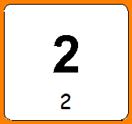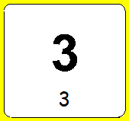
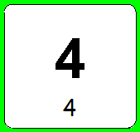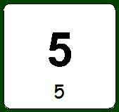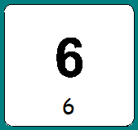
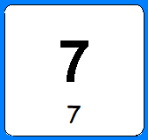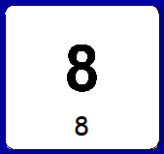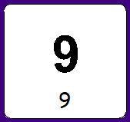
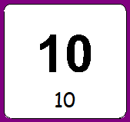

Today’s activity is for M8 number. Can you count on from a given number all the way to 10.
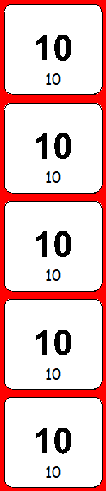
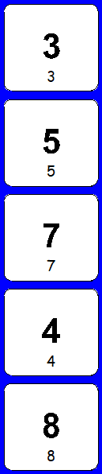
Say the number then carry on to 10. Help your family to count on from any number from 0-9.

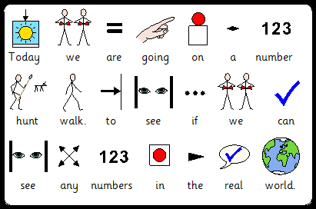
Today’s activity is for M8 number. Today we are going to go outside for your exercise walk. Have a look for numbers in the real world. Can you do a tick for every number that you have seen?

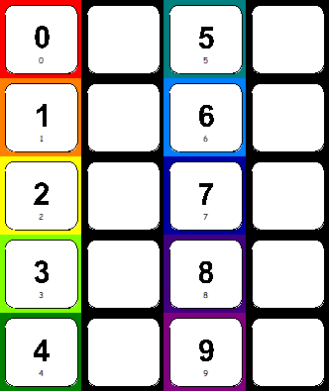
Today’s activity is for M8 number. Today is a practical activity.
Children will have some objects, couls be cereal, blocks, pegs, socks etc. Adult to give children an amount of objects between 0-10. Children will count out the objects (1 and a time) and then match the numeral.

Today’s activity is counting a fixed amount and matching to the correct numeral. Please try to write the number in the box.

Today’s activity is for an M8 Number. Today we will be deciding which jar has more and which has less..
- Try and practise with a real pot, firstly with exaggerated more and less
Can you stick the more and less symbols on each picture.
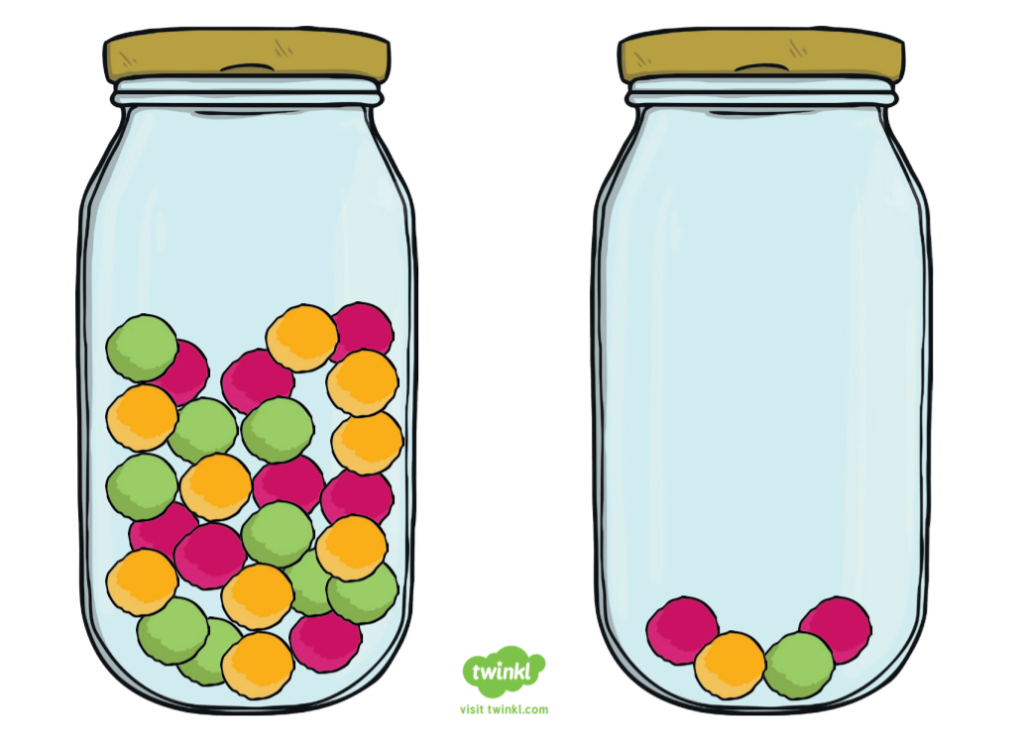
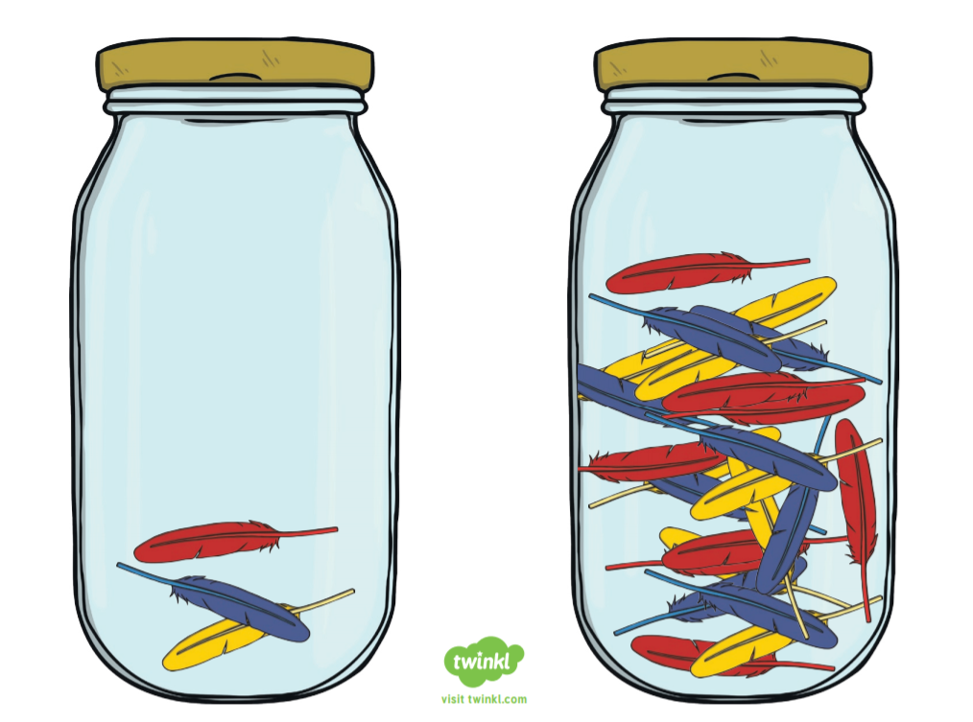

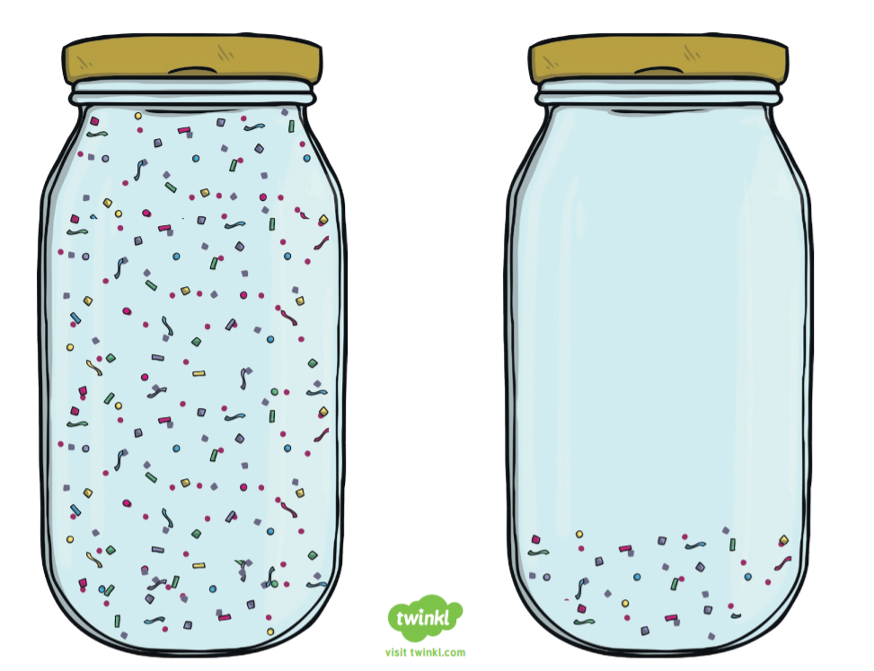

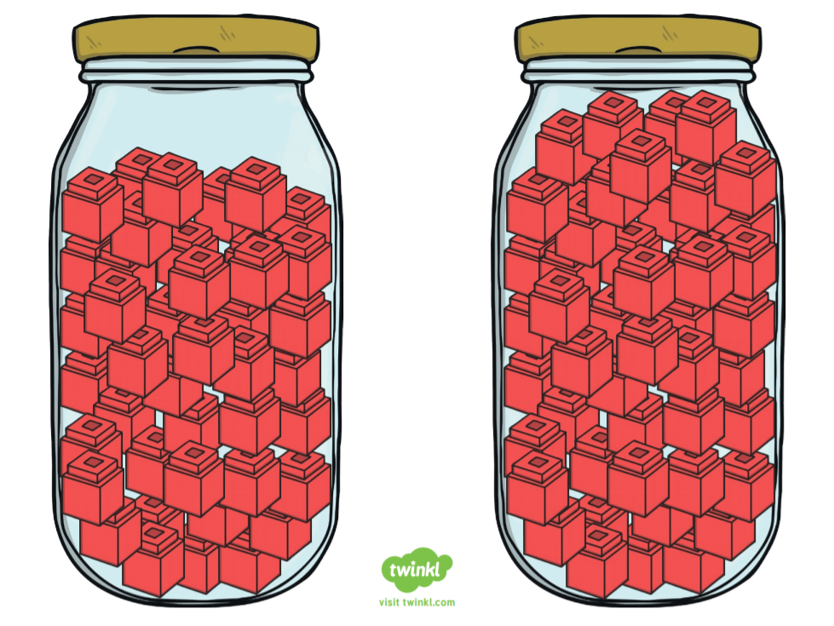

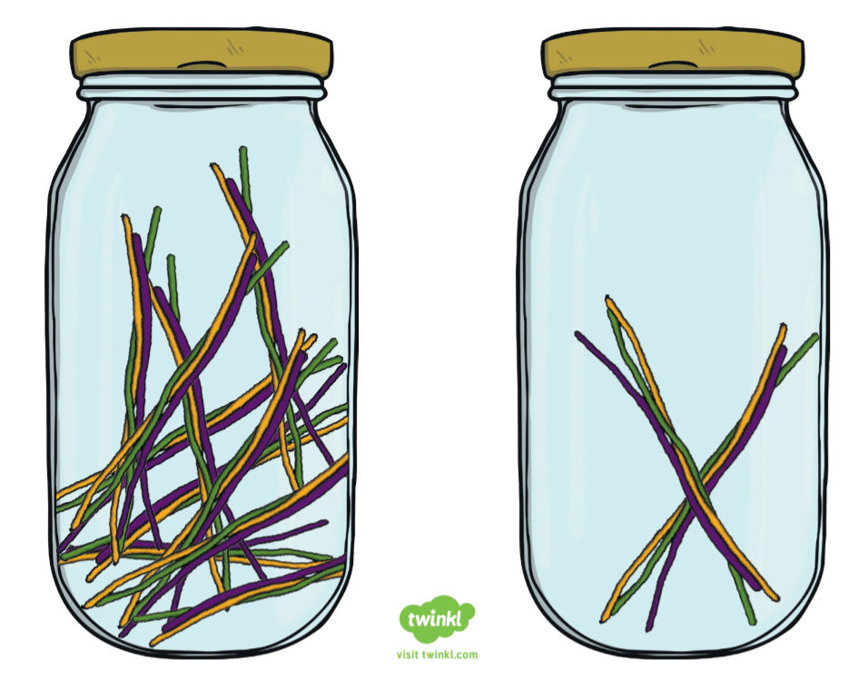

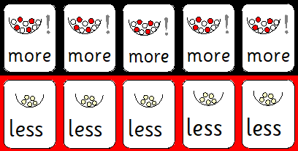

Today’s activity is for an M8 in Number. Today we are exploring taking away (subtraction practically).
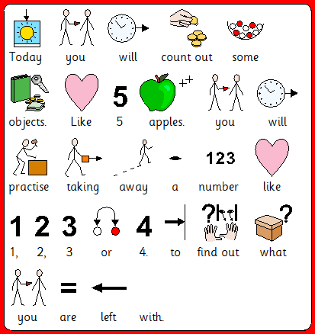
Please can you repeat this with different objects around the house. You can even try up to 10 objects.
Why not sing some number songs –such as 5 currant buns, 5 little ducks, 5 little speckled frogs. Making a point of saying how many are left.
Here are some subtracting with Rodd Episodes to watch.
https://www.bbc.co.uk/programmes/p07w79g6 https://www.bbc.co.uk/programmes/p015z3np https://www.bbc.co.uk/programmes/p015z387 https://www.bbc.co.uk/programmes/p015z330
Today’s activity is ordering numbers.
Can you get 5 toys, could be cars, bricks, dolls ect. Cellotape different numbers from 0-10 on them. Place them all in a box and tip them out. Could you please put them in order in a straight line. This can be with tins, crisp packets. Anything just use you imaginations.
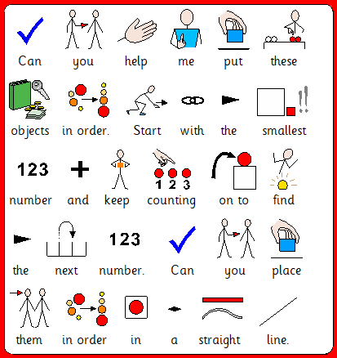
Today’s activity is for an M8 in Number. Today we are exploring adding (addition practically).
Can you find two small bowls in the house. A small object like pasta, cereal etc. Please use the number cards below to pick card that will total up 5 at first and then 10 if they are keen to continue.
Adult to choose 1 card and you will count out the objects into the first bowl. The adult will choose the second card and you will count out the objects into the second bowl. Then say the number sentence e.g. 2 add 3 ---- how many is there when we add them together. Then physically add them into 1 bowl. Together at first count out the objects one at a time. Repeat the sentence ‘2 add 3 equals -- 5. Then repeat. This isn’t limited to small items. Why not try these:
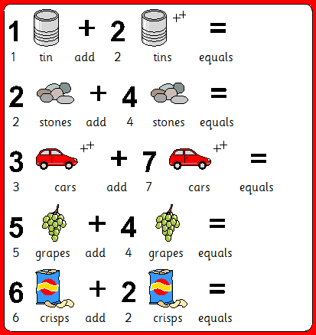
Here are some addition videos with Rodd.
https://www.bbc.co.uk/programmes/p015z2zf https://www.bbc.co.uk/programmes/p015z2m8 https://www.bbc.co.uk/programmes/p015z22s https://www.bbc.co.uk/programmes/p015z1x3

