Today’s activity is for an M9 Number – To match the written number to the numeral
one | two | three | four
five | six | seven | eight
nine | ten | Can you cut out and match the written word to the numerals?
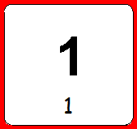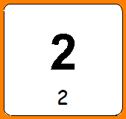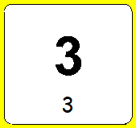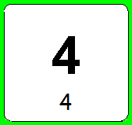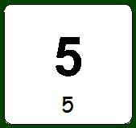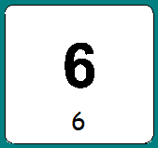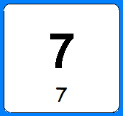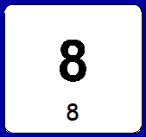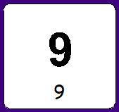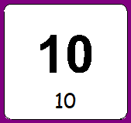
10 days of numbers to 10. activity is for an M9 Number –
Watch Numbers with Rodd:
Counting with Rodd 1:
https://www.bbc.co.uk/programmes/p0161z9n
Counting with Rodd 2:
https://www.bbc.co.uk/programmes/p0162095
Counting with Rodd 3:
https://www.bbc.co.uk/programmes/p01626vj
Counting with Rodd 4:
https://www.bbc.co.uk/programmes/p01620zs
Counting with Rodd 5:
https://www.bbc.co.uk/programmes/p01621p2
Counting with Rodd 6:
https://www.bbc.co.uk/programmes/p0161344
Counting with Rodd 7:
https://www.bbc.co.uk/programmes/p01629rc
Counting with Rodd 8:
https://www.bbc.co.uk/programmes/p01629yk
Counting with Rodd 9:
https://www.bbc.co.uk/programmes/p0161394
Counting with Rodd 10:
https://www.bbc.co.uk/programmes/p01613g2
Each day after introducing the number with the video. Practise writing the number. Hide pieces of paper with the number around the room. Build a tower with that many blocks. Practise counting out pasta and stopping at the number.
Today’s activity is for M9 Number- To read and write numbers to 20 – Roll a dice and fill in the missing side and count them altogether.
Altogether ___________ Altogether ___________
Altogether ___________ Altogether ___________
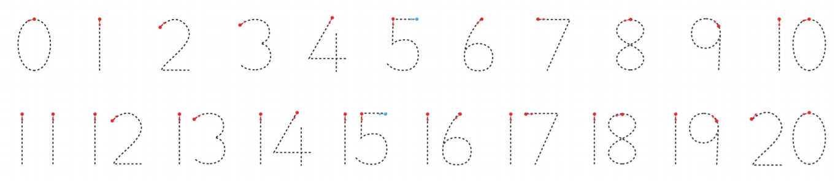
Altogether ___________ Altogether ___________
Altogether ___________ Altogether ___________

Today’s activity if for M9. Get a cardboard box, a pen, paper and 20 toys.label each toy with a circle of dots. Make 20 raffle tickets that have numbers 1-20 on them. When you call out the raffle ticket match them to the toys. Play with your family.
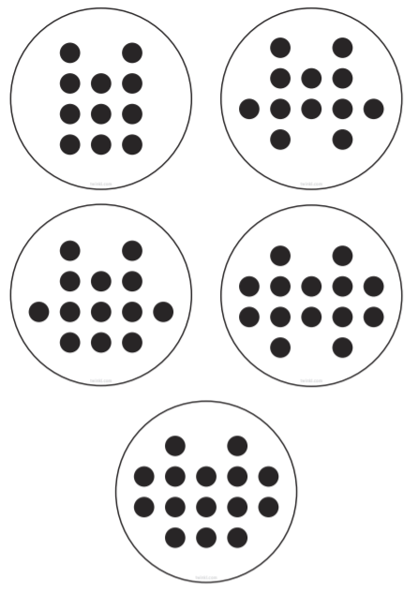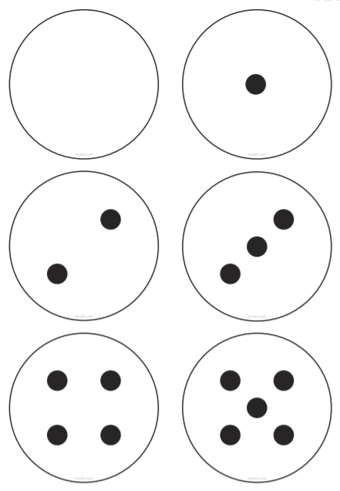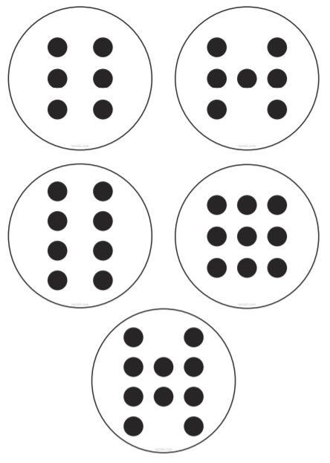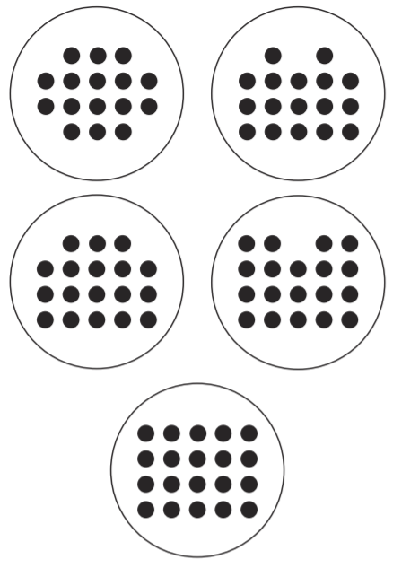
Today’s activity is for an M9 in Number.
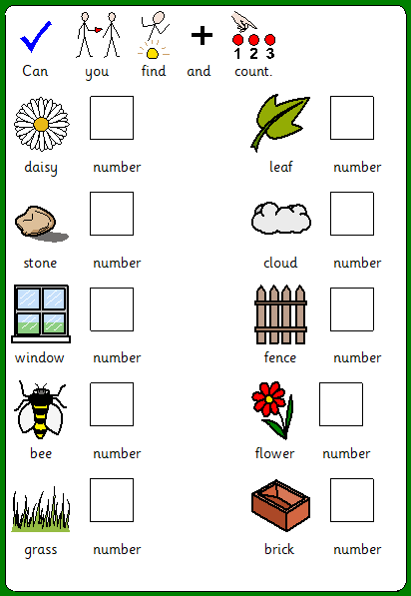
Go on a walk/hunt outside or in your garden. Can you count how many things you can find up to 20.

Today’s activity is for M9 in Number. We are ordering 0-20
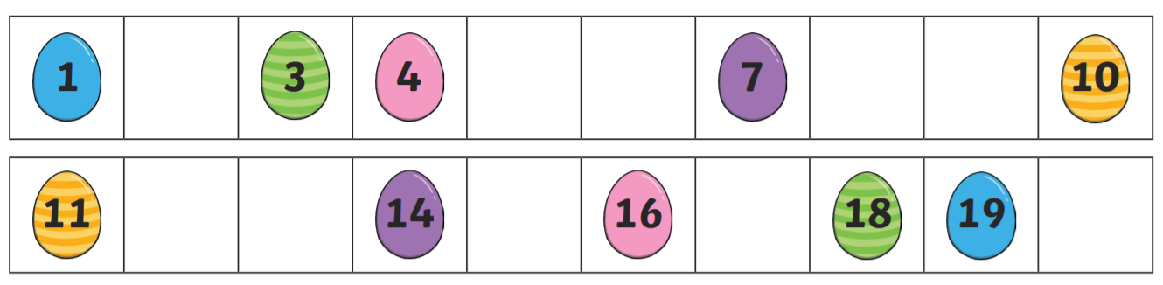
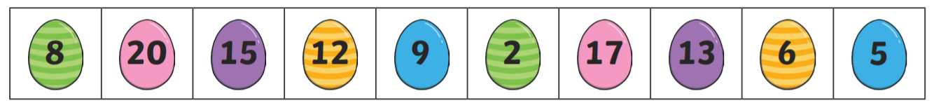
Can you cut the easter eggs
And stick them in the
Correct place in order.
Today’s activity is for M9 in Number. Can you follow the dot to dot fom 1-20.
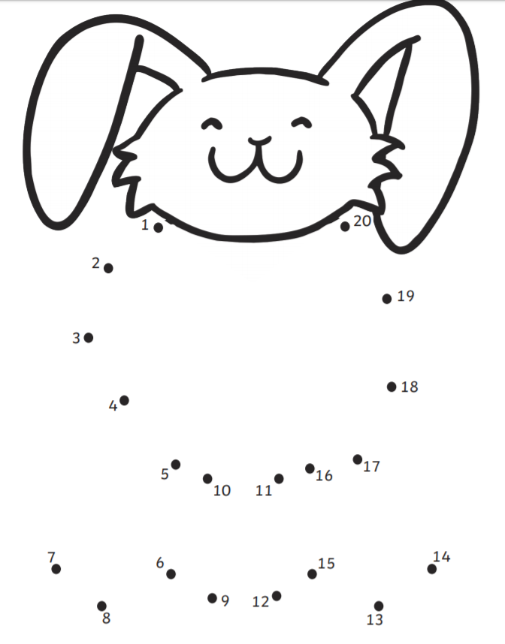
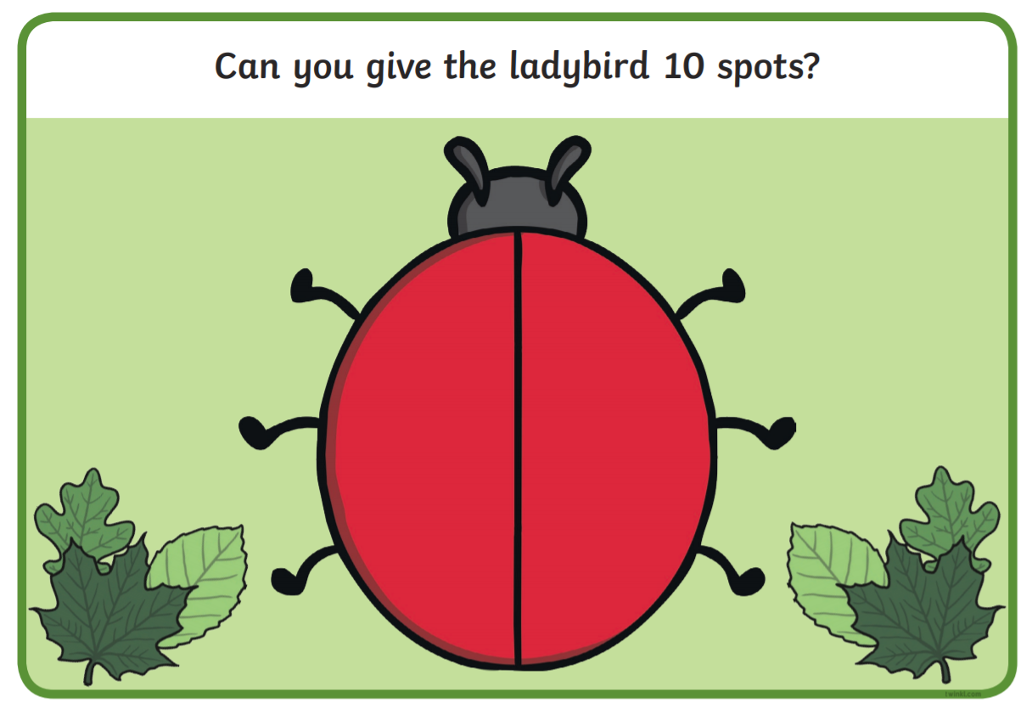
Today’s activity is for an M9 in Number. Making number bonds to 10

Can you use the 10 dots to find all of the number sentences to make 10.

Can you write all of the number bonds to 10 you could find?
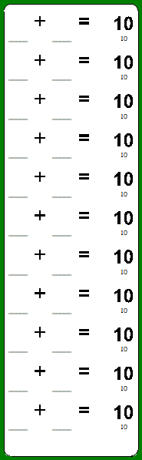

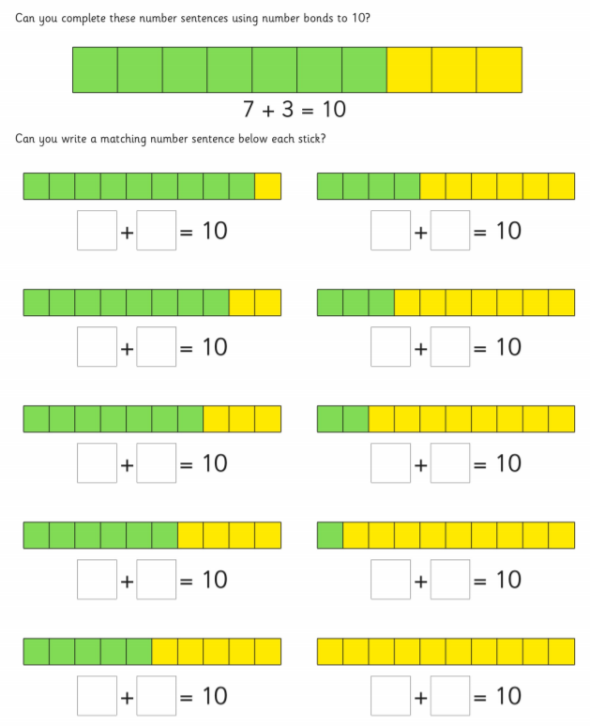
Today’s activity is for an M9 in number. Can you write the number sentences that go with the number bonds to 10.
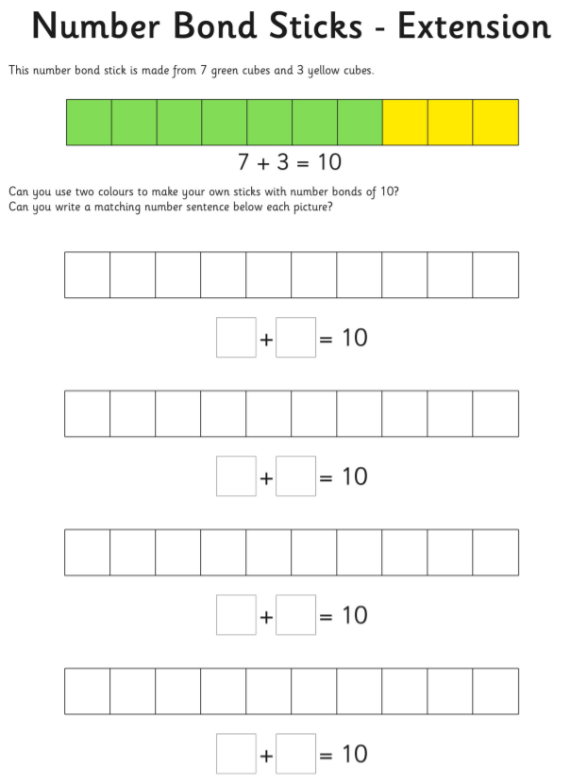
Today’s activity is for an M8 in Number. Today we are exploring taking away (subtraction practically).
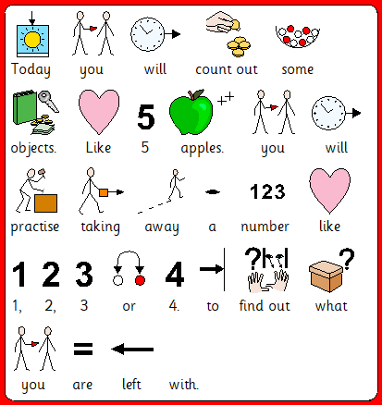
Please can you repeat this with different objects around the house. You can even try up to 10 objects.
Why not sing some number songs –such as 5 currant buns, 5 little ducks, 5 little speckled frogs. Making a point of saying how many are left.
Here are some subtracting with Rodd Episodes to watch.
https://www.bbc.co.uk/programmes/p07w79g6 https://www.bbc.co.uk/programmes/p015z3np https://www.bbc.co.uk/programmes/p015z387 https://www.bbc.co.uk/programmes/p015z330
Today’s activity is for an M9 in number. Today we are using a number line to take away (subtract).
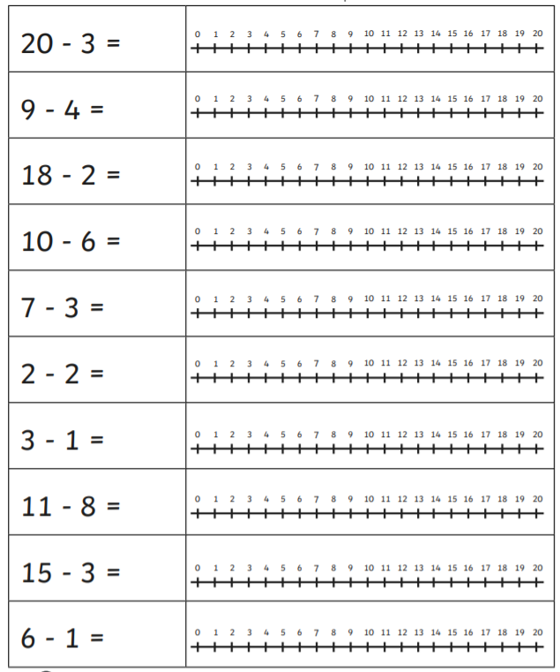
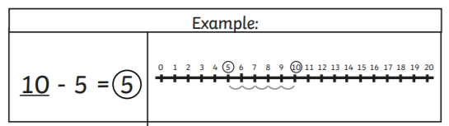

Today’s activity is for an M8 in Number. Today we are exploring adding (addition practically).
Can you find two small bowls in the house. A small object like pasta, cereal etc. Please use the number cards below to pick card that will total up 5 at first and then 10 if they are keen to continue.
Adult to choose 1 card and you will count out the objects into the first bowl. The adult will choose the second card and you will count out the objects into the second bowl. Then say the number sentence e.g. 2 add 3 ---- how many is there when we add them together. Then physically add them into 1 bowl. Together at first count out the objects one at a time. Repeat the sentence ‘2 add 3 equals -- 5. Then repeat. This isn’t limited to small items. Why not try these:
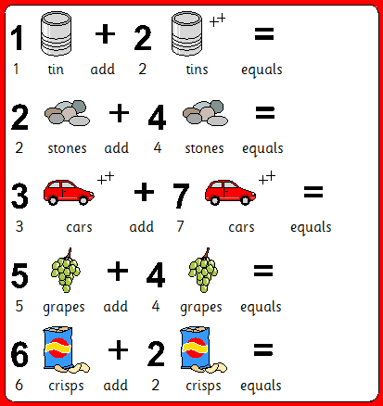
Here are some addition videos with Rodd.
https://www.bbc.co.uk/programmes/p015z2zf https://www.bbc.co.uk/programmes/p015z2m8 https://www.bbc.co.uk/programmes/p015z22s https://www.bbc.co.uk/programmes/p015z1x3

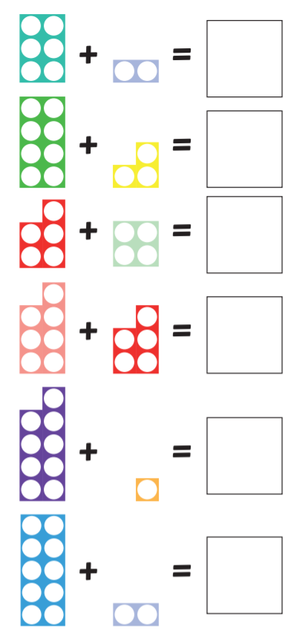
Today’s activity is for M9 in Number. Could you look at these picture number sentences and write the total in the box?

Today’s activity is for an M9 in Number. Can you use a number line to solve addition number sentences.
