Practical Activities
Outdoor learning
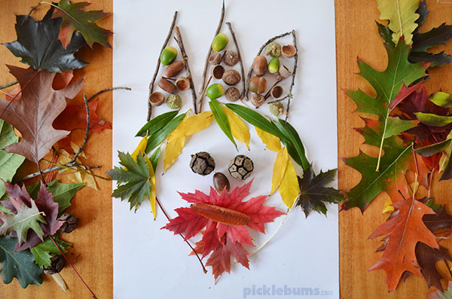
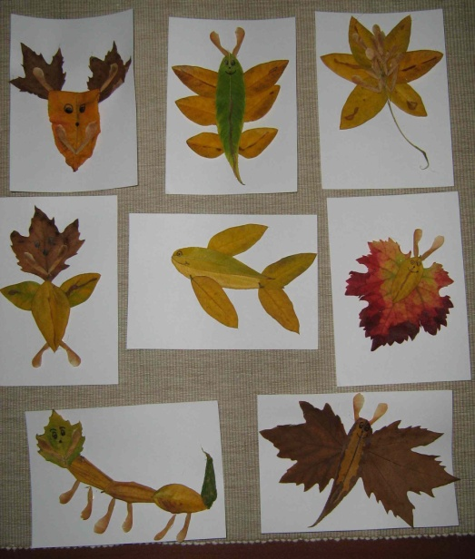
Get out into your garden or go for a walk to your local outdoor area! See what you can find. Collect leaves, sticks, pinecones, acorns etc. When you get home see what pictures you can make?
-Faces
-Animals
-Insects

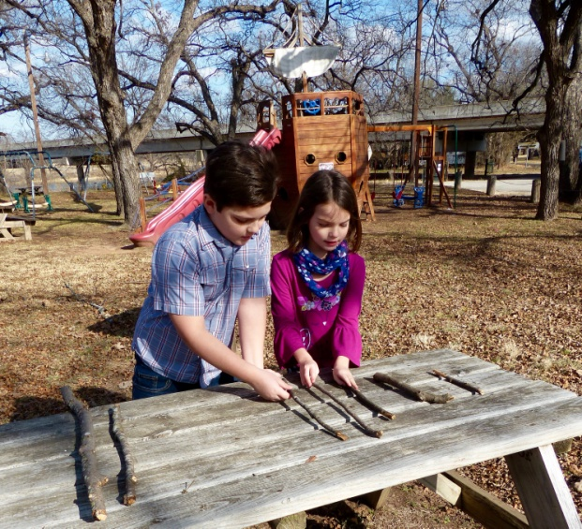
Measurement using sticks
Go to the woods or local outdoor area. Children to find different size sticks. Teach the vocabulary of tallest, shortest, biggest and smallest.
Can the children put these in order?
From biggest- smallest?
Tallest- shortest?
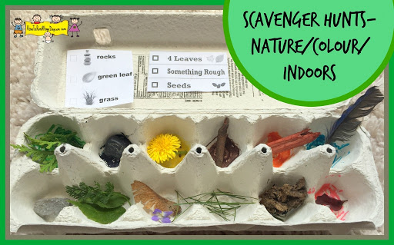
Nature colour hunt
What colours can we see? Can we find objects that are red, orange, white or pink? – take photos. Collect them in a bag. Children to sort by colour when they are home. Talk about what you can hear, smell, see?
Older children could write simple words about what they could see and hear?

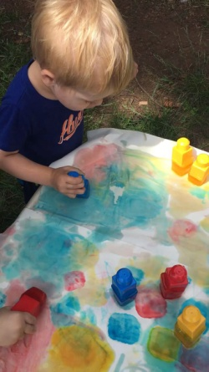
Painting with ice cubes
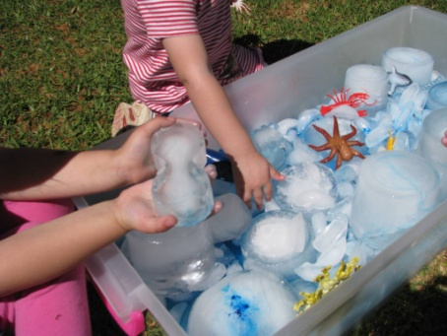
Put a little drop of food colouring or paint into an ice cube tray and freeze. Children to paint with them outside or inside on large sheets of paper. Or put some small plastic toys inside the ice cube trays. Freeze them. Children to explore ways to get their animal out of the frozen tray.
Question your child whilst playing with them:
Which animals live in the colder climates? Which animals live in the hotter climates? Do polar bears live in Africa? Why not?
What happens when ice warms up? Or if water freezes?
Cooking
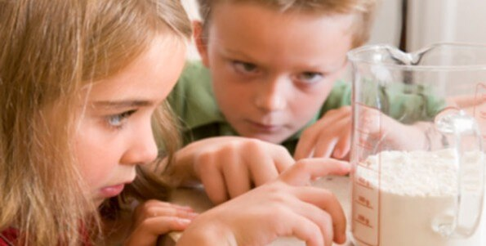
Cooking is one of our children’s favourite activities. It holds an enormous amount of learning too! Measurement and weighing are important for our number lessons. Rolling and chopping are vital for our fine motor skills.
Sandwich Making
Why not create a picnic to have on the floor in the lounge or in the garden. Children can have a tea party and give each guest a plate and a cup (all skills vital for 1-1 correspondence) The children could create a tally chart of which filling is the most popular in the house. They can use a knife to spread butter and cut the sandwich in halves and quarters. They can write instructions about how to make a sandwich or they could write a list of ingredients. You could take photos of them making their sandwich or video them and then you could ask them to recall verbal instructions.
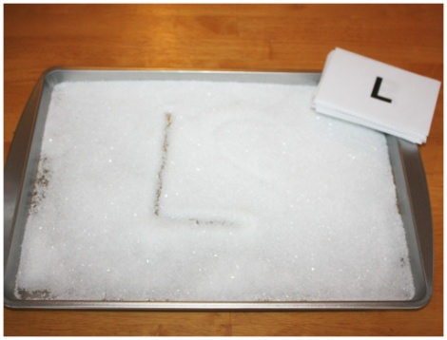
Sensory writing and sensory play
Practice letter formation or mark making in salt, sand, flour, rice or cornflour. Children can write simple CVC words such as mat, cat, dog etc. They can practice writing their names or initial letter of their name.
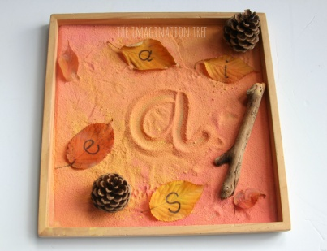
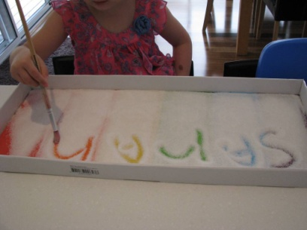
What about numbers? Children could write their numbers to 10 in the salt too?
Fine motor activities
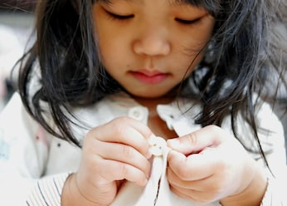
Fine motor activities are something we work on everyday at school. This is simple to carry on at home too and they do not always have to be writing activities.
- Peg out the washing- children use their pincer grip to squeeze the pegs
- Building- make towers out of blocks
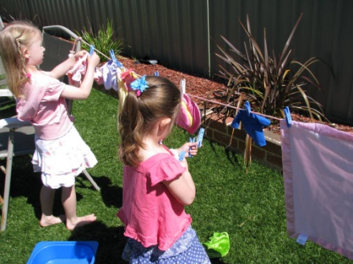
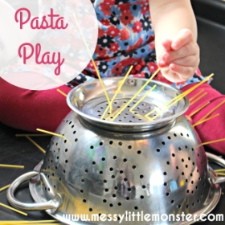
- Do up buttons on clothing
- Do up zips on clothing
- Practice putting on my socks and shoes
- Cutting skills
- Putting hair bands around toilet tubes
- Using playdough to strengthen their hands
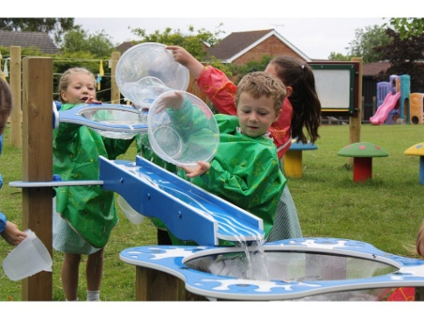
Water play
Outside in the garden or in the bath:
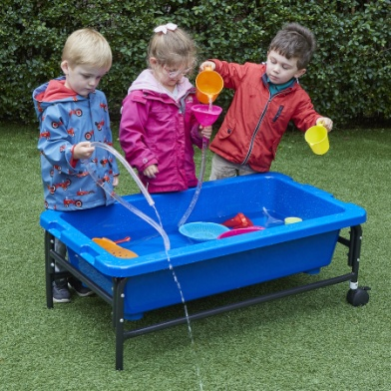
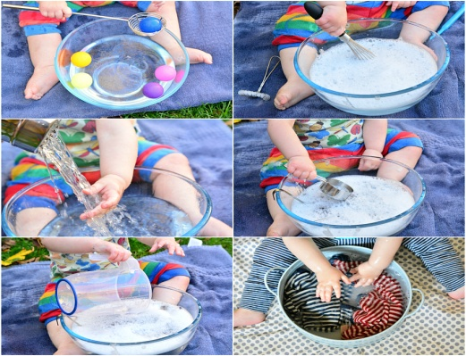
Capacity- different size containers: Which will hold most? Least? Look at the vocabulary of full/ half full and empty.

Play Games and have fun!
Turn taking games (These are vital to ensure children learn to take turns) play hide and seek, musical bumps, musical statues, have running races, do yoga, fitness classes.
Make dens- read stories in them, eat popcorn, role play stories, sit together and watch a film, write letters to loved ones, write shopping lists, make cards, plant flowers in the garden, cook dinner together.

Do all the activities you wish you had the time normally to do!!

