Writing an evacuee letter
- Pretend you are a child who was evacuated during World War II. You would have been moving from a town to the countryside to be safe.
- Decide who you are going to write to e.g. parents, grandparents, friends.
- Talk about what has happened to you and what your life is like now.
- You can draw pictures as well.

Write about your train journey from your home to the place you are moving to. How did you feel? Remember, your parents would not be going with you.

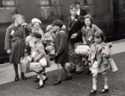
Write about arriving at the station and waiting to meet the family you would be living with.

Write about what it was like when you arrived in the countryside where you were going to live? What did you see, hear or smell? How was it different from the town where you lived?
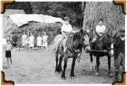
Write about what your new home on a farm or in the countryside is like. How is it different from your home in the town? What jobs do you have to do? What is your new house like? What are the people you are living with like?

Note to parents/carers:
If your child finds writing a bit tricky, you could write down their ideas for them.
Your child could draw pictures of different parts of their train journey and what their new home might look like.

