Anderson Shelter Facts
Here are some facts about Anderson Shelters, popular air raid shelter used during the Blitz.
- The Anderson shelter was designed in 1938.
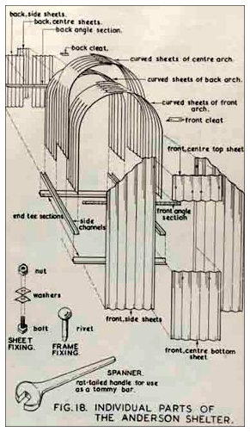
- It was named after Sir John Anderson, the man responsible for preparing Britain to withstand German air raids.
- Anderson shelters were designed for 6 people.
- The construction of the shelter was reasonably simple. The main part of the shelter was formed from six corrugated steel panels. Flat corrugated steel panels were bolted on to form the sides and end panels (one of which contained the door).
- The shelters measured 1.4m wide, 2m long and 1.8m tall. They were quite cramped and someone taller than 6ft would not have been able to stand up in one.
- Once constructed, the Anderson shelters were buried over 1 meter in the ground and then they were covered over with a thick layer of soil and turf.
- Anderson shelters were free to those with an annual income of less than £250. For those who didn’t fall into this category, the price was £7.
- Approximately 3.5 million Anderson shelters were built either before the war had started or during the conflict.
- Anderson shelters were very effective at saving lives and preventing major injuries during air raids, but they were really cold during the winter months. To try to prevent people going back to their warm houses at night when the weather got colder, the Government issued some guidelines about how to make the Anderson shelters more comfortable. They also developed the Morrison shelter which could be used indoors.
- Many Anderson shelters have survived to this day. Lots were dug up and used as garden sheds.
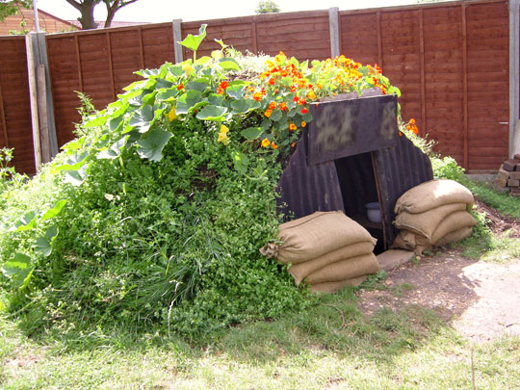
- Families were provided with the materials and were expected to construct the Anderson shelters from a set of instructions.

Anderson Shelters and Morrison Shelters
- Anderson shelters were designed to house six people.
- They used curved and straight panels of galvanized corrugated steel, and they performed really well in bomb tests.
- Over 3 million Anderson shelters were put up all over Britain. They were free to all families who earned less than £250 a year.
- The Morrison shelter was essentially a reinforced metal dining room table that a family could sleep under during the nighttime air raids.
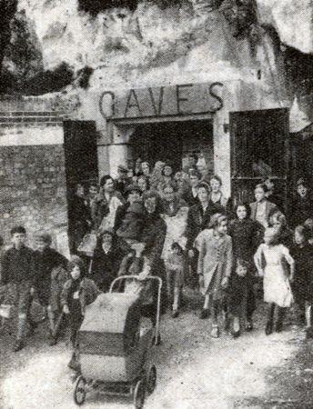
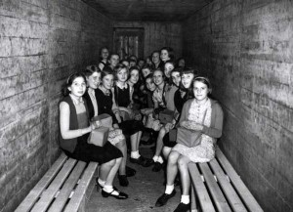
- It was not designed to offer protection against a direct hit, but it was very effective at sheltering people from bomb blasts and falling debris. One study of bomb damaged houses showed that more than 80% of those sheltering in correctly positioned and constructed Morrison shelters survived without major injury.

Morrison Shelter Facts
Here are some facts about Morrison shelters, or, to use it’s official name, the ‘Table (Morrison) Indoor Shelter’.
- The Morrison shelter was designed by John Baker and named after the Minister of Home Security, Herbert Morrison.
- The shelters came in kits which could be assembled (bolted together) in the home.
- Morrison shelters were 2 metres in length, 1.2 metres in width and 75 cm tall. It was designed to be slept under at night and used as a table for the rest of the time.
- The shelter had over 350 parts, but mainly consisted of a steel top (like a table top) and wire mesh sides (one of which could be lifted open and acted as the door).
- The Morrison shelter was not designed to survive a direct hit from a bomb, but it was really effective at protecting people from the effects of a bomb blast.
- Over 500,000 Morrison shelters were made and they were given free of charge to families who earned less than £350 a year.

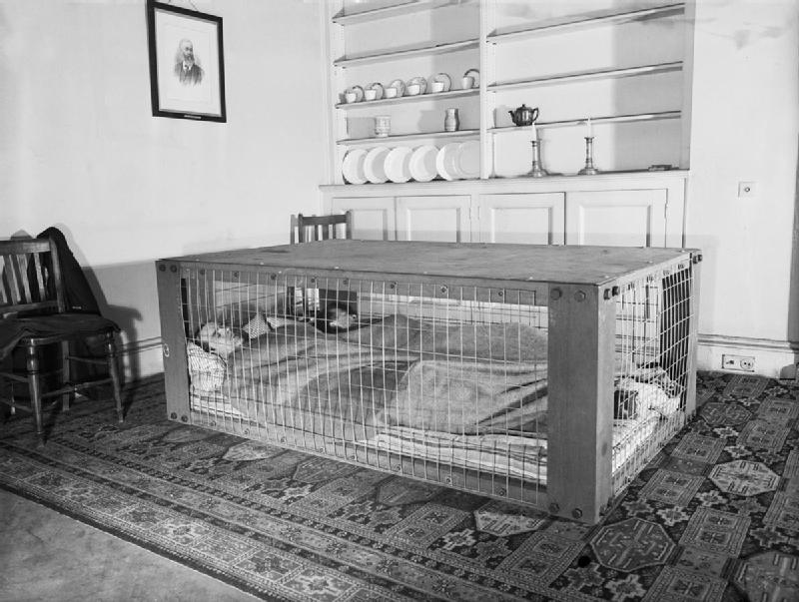
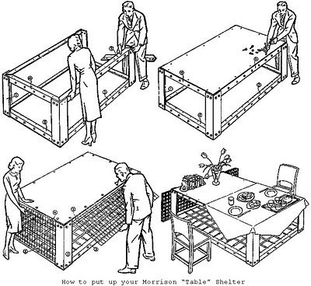

World War 2 Air Raid Shelters: Facts and Information
Several different types of air raid shelters were used by the people of Britain during the Blitz of World War 2. Some of these shelters made use of structures and underground spaces which already existed, and some of the shelters were constructed from scratch.
Here are some details about some of the different types.

Cellars and Basement
- Cellars were used as very effective underground bomb shelters. Unfortunately, compared to other European countries, very few houses in Britain had cellars – they were only built in large houses and older properties.
- The basements of public buildings such as schools, hospitals, and the basements of businesses were used as shelters during the Blitz. The basements offered underground protection from bombs, but there was the risk of heavy machinery falling on top of the shelter if the site was hit.

Railway Arches and the Underground
- Railway arches, constructed of brick, offered good protection from falling bombs and they were certainly used as air raid shelters in the Blitz. The only problem was that railway lines were sometimes targeted by the Germans in bombing raids.
- The Government was against people sheltering in the Underground tunnels during air raids. They thought that disease would spread (due to the small number of toilets in some stations), people would fall on the tube lines and that people might be tempted to never leave the safety of the tunnels. All of these arguments were proved wrong and Londoners took matters into their own hands by forcing their way into the Underground stations.
- The Government changed its views on this type of shelter and started fitting out Underground stations with bunks, first aid kits and chemical toilets.
- Underground stations were not completely safe as bomb shelters – they were still vulnerable to a direct hit.
- It is estimated that over 170,000 people used the London Underground as an air raid shelter during the Blitz.

Other Tunnels and Caves
Throughout Britain during the Blitz, people were making use of any underground spaces as a means of sheltering from the German bombs. Naturally forming caves and tunnels under castles, palaces and other historical buildings were frequently used.

Street Communal Shelters
- The Government started aaprogramme of building street communal shelters in March 1940. These shelters were to be constructed by private builders (under the supervision of Government inspectors and surveyors).
- The shelters were built with thick brick walls and a reinforced concrete roof.
- They could house about 50 people.
- Many street communal shelters were built.
- Unfortunately, the shelters didn’t perform very well in air raids. The brick walls were often shaken down allowing the concrete roof to fall on those inside.
- Improved designs were introduced, but public confidence in the communal shelters had been lost.
- The trend moved towards individuals building shelters on their own property with materials supplied by the Government.

Anderson Shelters and Morrison Shelters
- Anderson shelters were designed to house six people.
- They used curved and straight panels of galvanized corrugated steel, and they performed really well in bomb tests.
- Over 3 million Anderson shelters were put up all over Britain. They were free to all families who earned less than £250 a year.
- The Morrison shelter was essentially a reinforced metal dining room table that a family could sleep under during the nighttime air raids.
- It was not designed to offer protection against a direct hit, but it was very effective at sheltering people from bomb blasts and falling debris. One study of bomb damaged houses showed that more than 80% of those sheltering in correctly positioned and constructed Morrison shelters survived without major injury.
