Mimic a Painting Artist – Piet Mondrian
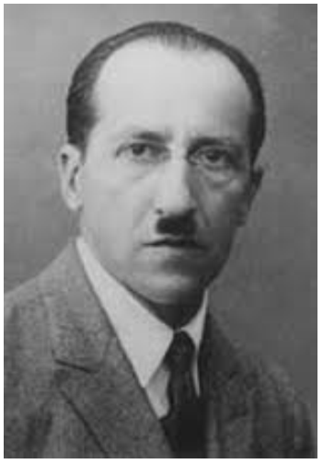
Piet Mondrian was a famous Dutch painter.

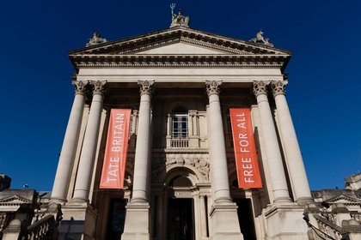
His paintings are on display in the famous gallery in London called the Tate Gallery.

Here is one of his paintings, do you like it?
You can mimic or copy his painting with pencils, crayons, paints, chalks or felt tips. Start by drawing black lines, a ruler or something straight can help. Then colour some parts red, blue and yellow.
