Carrot Cake
Ingredients:
2 cups (225g) Self Raising Flour
2tsp Baking Powder
1 Cup (150g) Soft Brown Sugar
2 medium Carrots grated
2 small ripe Bananas, mashed
2 Eggs
¾ cup (150ml) Sunflower oil
175g cream cheese
1 ½ Cups Icing Sugar

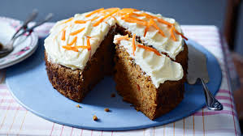
Method:
Lightly grease an inch tin
Pre-heat oven to 180 degrees Celsius
Put flour, baking powder and sugar into a bowl and mix
Using your hand, squeeze as much liquid from the carrots and add into a bowl. Add mashed bananas and mix.
Beat in eggs and oil and pour into mixture.
Beat together with wooden spoon
Spoon into tin and then cook for 1 hr.
Leave to cool
Beat cream cheese and icing sugar until thick. Spread on cake.
Decorated with candies, nuts or grated chocolate and….
ENJOY!!!

