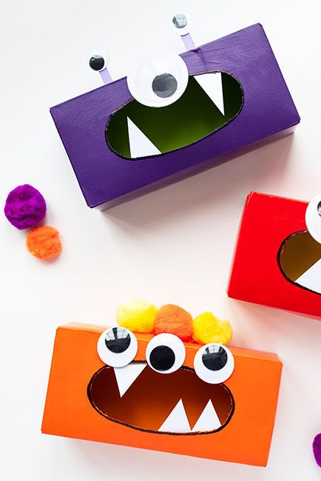
Things you will need:
DIY Tissue Box Monsters
- Empty tissue box
- Paint
- Googly eyes
- Card/paper
- Pom poms
- Glue
Firstly, paint all of the outside of your box (or colour in if you don’t have access to paint). Secondly design the monster, choose how many eyes you want and then glue them on. Now cut up pieces of card/paper in the shape of triangles. Stick them within the inside of the ‘mouth’, to resemble teeth. Then glue some pom poms for hair on top of the box. Wait for all the glue to dry and now you have your very own monster.
A game you can play with these is to try and feed your monster, by using any leftover pom poms or dry cereal if not. Aim and throw your food into the monsters mouth and see how many you can get in.

