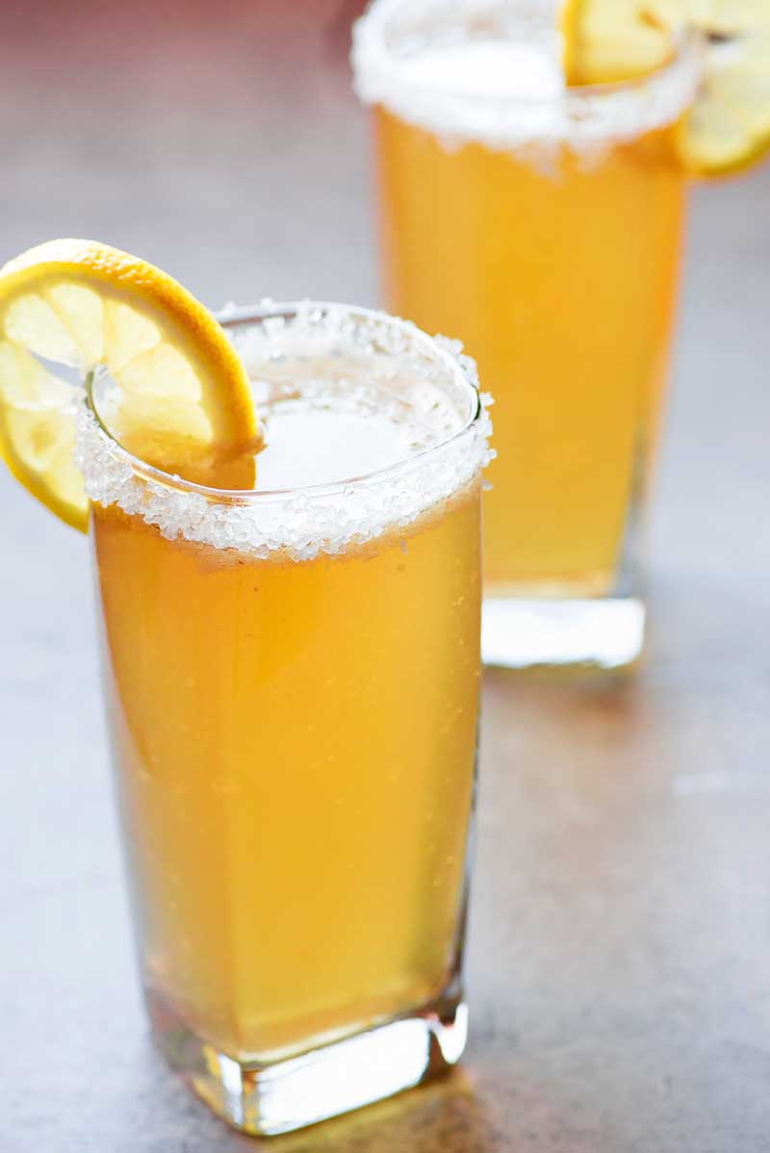
Ginger Beer
- 1 gallon of boiled water.
- 1 lb sugar. ½ oz yeast.
- 1 level teaspoon ground ginger.
- 1 level teaspoon cream of tartar.
Put yeast in a basin with a teacup full of sweetened water almost cold. Let stand till yeast rises. Put boiled water, sugar, ginger and cream of tartar into a large jug and stir in the yeast when the water is luke warm. Stand till cool, then skim well and bottle carefully, it will be ready for use in two days.

