Lord Woolton’s Pie

Ingredients – filling
- 1lb seasonal vegetables such as potato, swede, cauliflower, and carrot
- 3–4 spring onions
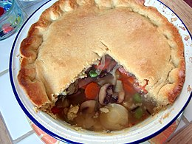
- 1 tablespoon oatmeal
- Chopped parsley
- Method

Ingredients – pastry
- 8oz wholemeal flour
- 1 level teaspoon baking powder
- Pinch of salt
- Pinch of dried sage (optional)
- 1 pint cold milk, or milk and water

Method
Dice the vegetables and spring onions. Cook together with the vegetable extract and oatmeal for 10 minutes with just enough water to cover. Stir occasionally to prevent the mixture from sticking. Allow to cool.
To make the pastry, mix all the dry ingredients together then stir in the milk and water, and roll out the mixture.
Finally, put the filling in a pie dish and sprinkle with chopped parsley, then cover with the pastry. Bake in a moderate oven until the pastry is nicely brown and serve hot with brown gravy.

