Make a Tree

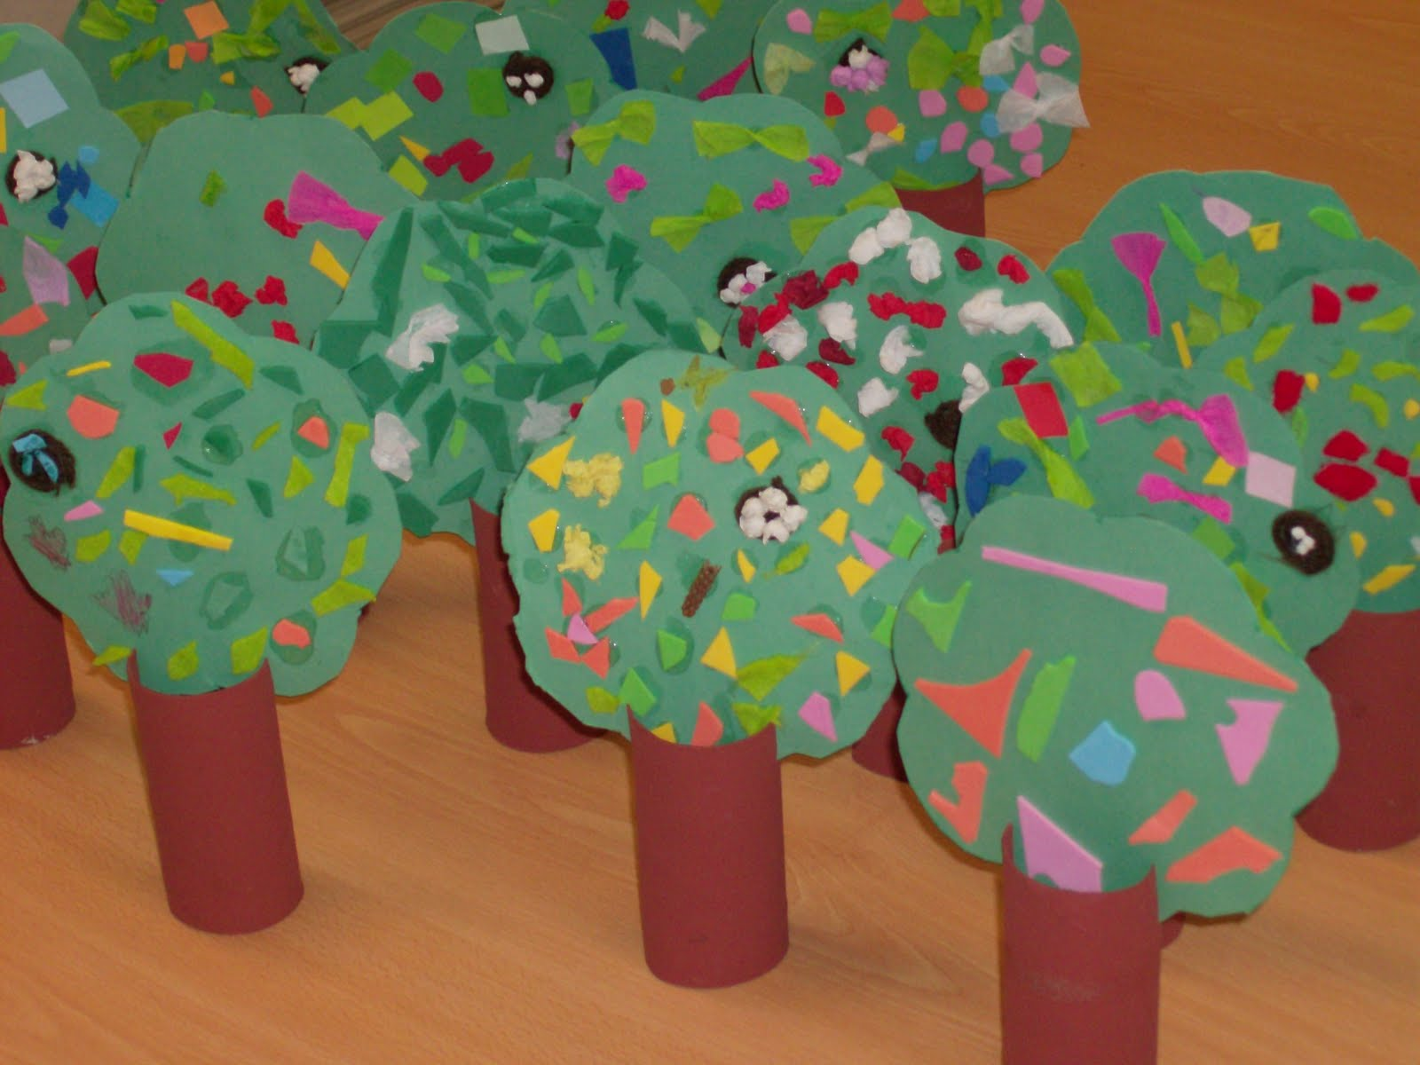

What you will need

Piece of green paper or card, a toilet roll tube, little pieces of coloured paper or tissue, glue, brown paint or coloured pens/pencils.

What to Do
Paint or colour the toilet roll tube brown and when dry cut two small slits in the sides to make the tree trunk.
Cut out a wavy circle from the paper or card and stick on lots of little coloured pieces of paper or scrunched up tissue to decorate.
Slide the top of the tree into the toilet roll slots and stand up your tree.

