Pinterest ideas for money
- Playing shops
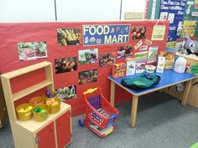
If you have a till or play money – role play going to the shops and exchanging money for an item.

If you do have a role-play shop, you could get your child to exchange a coin when they have a snack. They are given a certain number of coins every day; when they are out of coins, no more snacks.
(Maybe extra coins can be given as an award)

If your child is able to access a snack shop; you could price some of their favourite snacks. They will have to work out with the amount of money they have which snacks they can have.

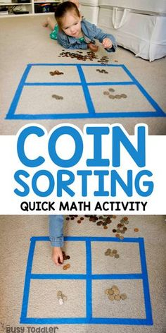
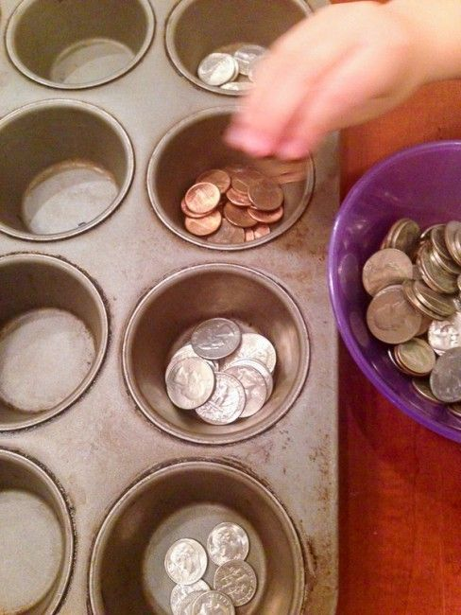
Sorting coins
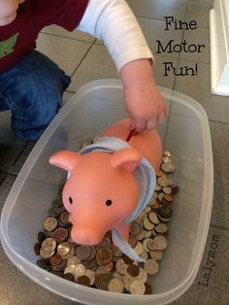
To make sorting coins more fun, hide lots of coins in oats, water, rice, sand ... can your child find all the coins?
As they find them can they sort the coins or match them?
Or just finding coins and putting them in a piggy bank is great fun!
