**Step 1:** Draw a picture on the card using the glue.

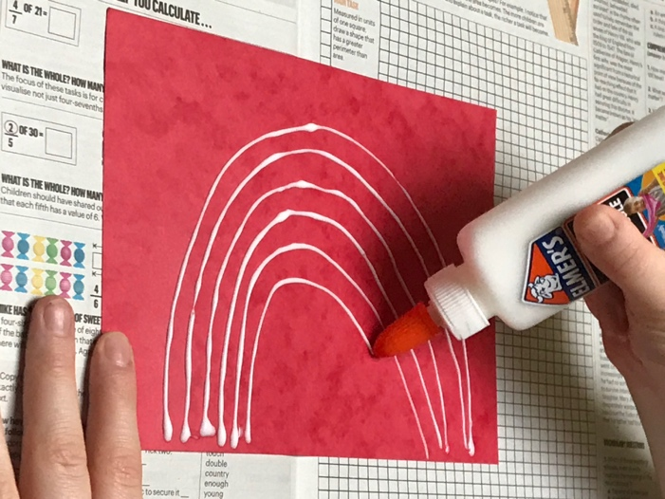

**What you’ll need:**

* Card (you can also use cardboard or paper plates)
* Squeezy glue
* Salt
* Water and food colouring (substitute for liquid watercolours)
* Paintbrushes

**Step 5:** Let dry and display

**Step 3:**

Add a few drops of food colouring to a little bit of water.

Mix together to create your paint.

**Step 4:** Use your paintbrush to gently paint over the salt.

The paint will magically travel along the salt!

**Step 2:** Pour the salt all over the glue.

Tip off any excess salt.

