Superworm

Hi All,
Its Mrs ward again……..
I wanted to share another story I have been reading with Jude and to show you some of the work we created.
Jude really loves this book so I hope you do too! If you don’t have this book at home then here is a link to watch it online.

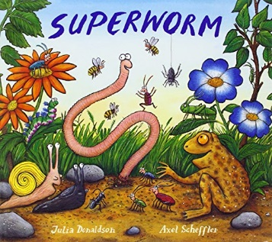
https://www.youtube.com/watch?v=7Jnk3XApKBg

- You could sing the song about a worm at the bottom of the garden, when you listen to this song dance around, wiggle and have fun with your family at home.
https://www.youtube.com/watch?v=2kimp-v5KUk

- You can make a super worm sock toy/puppet
We needed – a pair of tights, cotton wool, and I found some stickers that I cut out to make them look like eyes. You really can choose anything you like. When we had finished making the worm, we painted a picture of a garden and pretended the worm was in the garden. If you don’t have any tights you could pick some ideas from below.

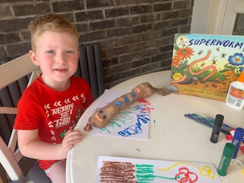
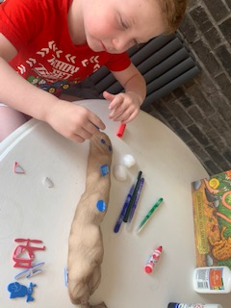
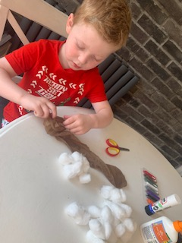

Odd socks
Stuffing - You could stuff your sock with paper, torn up strips of leaflets or envelopes, other odd sock, some old fabric or even some stuffing if you have some. Stuff your worm until he’s as full as you want him then tie of the open end with some string, wool or an elastic band.
Some collage materials for eyes – you could use milk bottle lids, cut out paper shapes or anything you have to hand to make your super worm eyes.

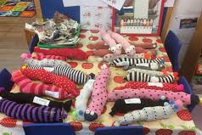
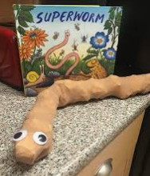

- String printing. This is a little bit like using a worm to paint a picture.
Wrap some wool/string around a stick/lolly. You can then dip the string into the paint easily without getting too messy (although getting messy is the fun bit). You then move the string around the paper to make a pattern.

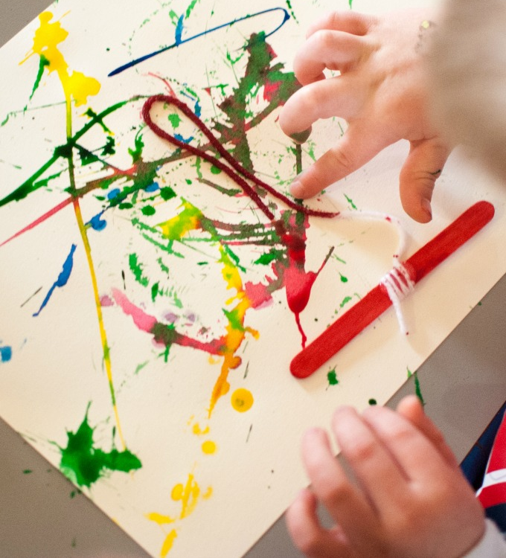

- If you are feeling really creative you could make a wormery.

Jude wants to make one of these but we need to get all the bits together! If you do make one I would love to see some photos and I will send some of Jude when we have done it.
Layer the jar or plastic pot with dirt and sand before adding the worms. Don’t forget you need to feed them. Some of the things that worms eat include dead plants, live plants, and other microscopic animals. You can add vegetable peelings and leaves to the top of the jar/pot. When you have finished watching them, you can let them go in the garden or park.

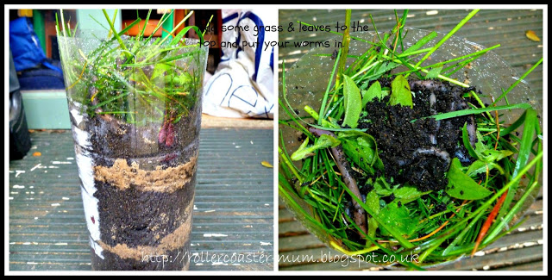

Miss you all take care.

Mrs Ward

