Toilet Roll Craft

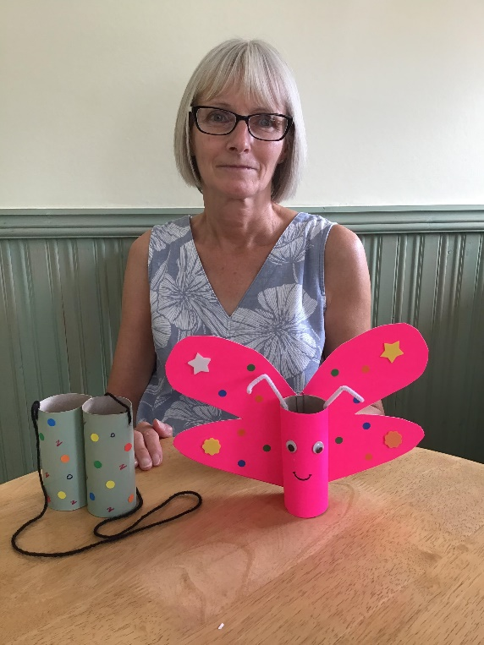

Butterfly
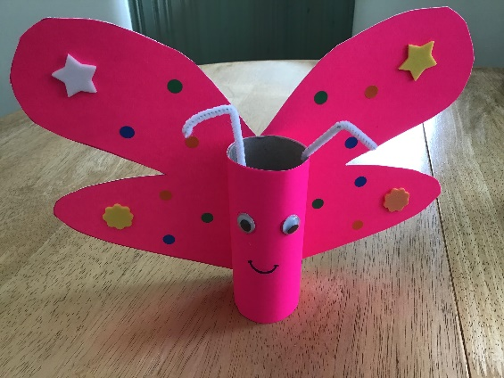
Items Required
-1 Toilet Roll Tube.
-2 Sheets Coloured Paper or Thin Card
-1 Pipe Cleaner or Straw
- Stickers and/or colouring pens
-Glue
- 2 Paper Clips
- Sellotape
-Scissors

How To Make
1- Cut a piece of paper to the same height and long enough to wrap around the tube and overlap.
2- Wrap the paper around the tube and glue overlap use paper clips to hold paper on tube whilst the glue dries.
3-Use second piece of coloured paper/ card, fold in half, draw wing shape, cut along wing shape and unfold card. (See photo)

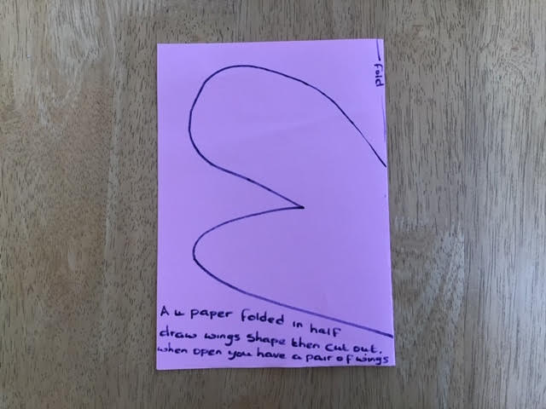

Binoculars

Items Required
-2 Toilet Roll Tubes
-Paint or Coloured Paper To Cover Tubes With
-Wool
-Stickers or Coloured Pens
-Stapler or Sellotape
-Glue

How To Make
1- Paint or cover the 2 toilet roll tubes
2-Decorate the tubes with stickers or coloured pens
3- Fix the 2 tubes together with a stapler or sellotape
4-Make a small hole at either side of the tubes towards the top
5-Attach wool through hole at either side and tie in place at both ends.

Enjoy playing with your binoculars. Well done.

