ANSWERS

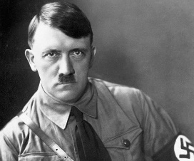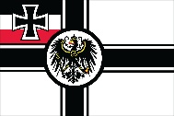

1st September

1939

Evacuations to countryside begins

1st September

1939

Germany invades Poland

29th September

1938

Munich agreement

1933

Adolf Hitler is voted leader of the Nazi party

1918

End of World War 1

Germany forced to give up land and banned from having an army

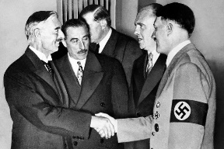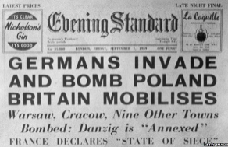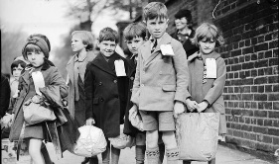

7th January

1940

Rationing begins

10th June

1940

Italy join forces with Germany as an axis

October

1939

Dig for Victory campaign is launched

3rd September

1939

World War 2 begins.

Britain and France declare war on Germany

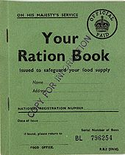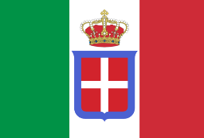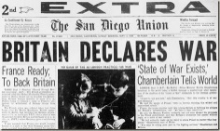

7th September

1940

Blitz kills nearly 2,000 in London on the first night

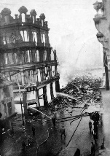

10th October

1943

Italy swap sides

Italy become and ‘ally’

28th September

1943

Italy surrenders

18th December

1941

National Service Act

Women called up for work

19-21st February

1941

Swansea 3 Night Blitz

230 killed, 400 injured

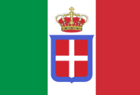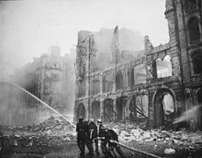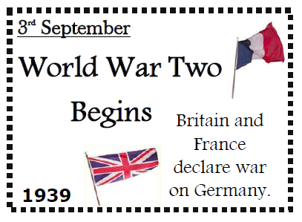

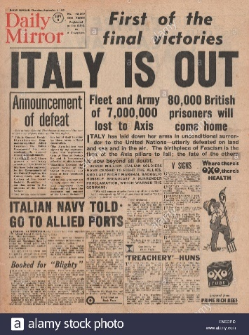

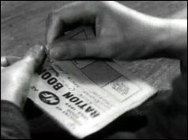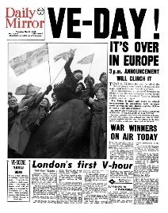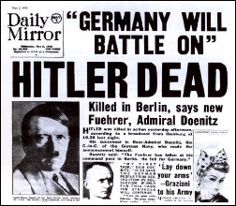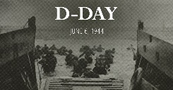

6th June

1944

D-Day

Allied troops land in France – Battle of Normandy

4th July

1954

Rationing ends

30th April

1945

Hitler commits suicide

8th May

1945

VE Day

Victory in Europe

2nd September

1945

End of World War 2

Japan surrender



1918

End of World War 1

Germany forced to give up land and banned from having an army

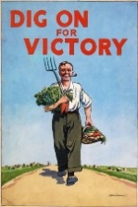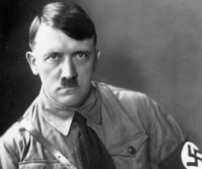

October

1939

Dig for Victory campaign is launched

1933

Adolf Hitler is voted leader of the Nazi party

6th June

1944

D-Day

Allied troops land in France – Battle of Normandy

3rd September

1939

World War 2 begins.

Britain and France declare war on Germany



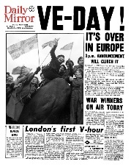

8th May

1945

VE Day

Victory in Europe

10th June

1940

Italy join forces with Germany as an axis

18th December

1941

National Service Act

Women called up for work

7th September

1940

Blitz kills nearly 2,000 in London on the first night



29th September

1938

Munich agreement

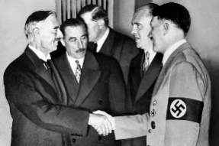

30th April

1945

Hitler commits suicide

1st September

1939

Evacuations to countryside begins

4th July

1954

Rationing ends

1st September

1939

Germany invades Poland

2nd September

1945

End of World War 2

Japan surrender



1st September

1939

Evacuations to countryside begins

10th October

1943

Italy swap sides

Italy become and ‘ally’

7th January

1940

Rationing begins

19-21st February

1941

Swansea 3 Night Blitz

230 killed, 400 injured



28th September

1943

Italy surrenders



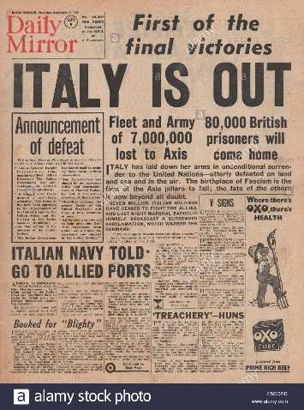

959 x 2 =

________

End of World War 1

Germany forced to give up land and banned from having an army

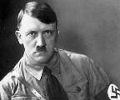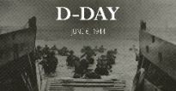

3rd September

1282+657=

_______

World War 2 begins.

Britain and France declare war on Germany

7th September

388 x 5 =

___________

Blitz kills nearly 2,000 in London on the first night

6th June

4403-2459=

________

D-Day

Allied troops land in France – Battle of Normandy

19.33 x 100 =

_________

Adolf Hitler is voted leader of the Nazi party

October

1939

Dig for Victory campaign is launched

19-21st February

1941

Swansea 3 Night Blitz

230 killed, 400 injured

30th April

939 + 553 + 453 =

___________

Hitler commits suicide

29th September

323 x 6 =

_________

Munich agreement

10th June

7760 ÷ 4 =

__________

Italy join forces with Germany as an axis

18th December

5000 – 3059 =

__________

National Service Act

Women called up for work

8th May

One thousand,

nine hundred

and forty-five.

__________

VE Day

Victory in Europe

1st September

1939

Germany invades Poland

7th January

485 x 4 =

_______

Rationing begins

2nd September

5/6 of 2334 =

___________

End of World War 2

Japan surrender

1st September

1939

Evacuations to countryside begins

10th October

237 + 854

+ 852 =

__________

Italy swap sides

Italy become and ‘ally’

4th July

19540 ÷ 10 =

__________

Rationing ends

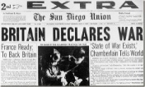



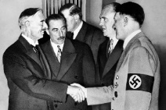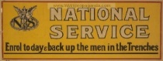

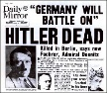



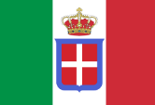

28th September

One thousand, nine hundred and forty three.

_________

Italy surrenders

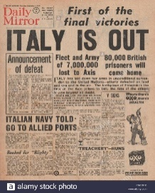

137 x 14 =

________

End of World War 1

Germany forced to give up land and banned from having an army



4th July

532.7 + 1421.3

=

________

Rationing ends

10th October

237 + 854

+ 852 =

__________

Italy swap sides

Italy become and ‘ally’

1st September

11634 ÷ 6

=

_______

Evacuations to countryside begins

2nd September

5/6 of 2334 =

___________

End of World War 2

Japan surrender

7th January

97 x 20 =

_______

Rationing begins

1st September

1939

Germany invades Poland

8th May

One thousand,

nine hundred

and forty-five.

__________

VE Day

Victory in Europe

18th December

10186 – 8245 =

__________

National Service Act

Women called up for work

10th June

7760 ÷ 4 =

__________

Italy join forces with Germany as an axis

29th September

323 x 6 =

_________

Munich agreement

30th April

7577 – 5632 =

_________

Hitler commits suicide

19-21st February

1941

Swansea 3 Night Blitz

230 killed, 400 injured

October

7/8 0f 2216 =

_________

Dig for Victory campaign is launched

1480.16 +

452.84 =

_______

Adolf Hitler is voted leader of the Nazi party

6th June

1.944 x 1000 =

_________

D-Day

Allied troops land in France – Battle of Normandy

7th September

388 x 5 =

________

Blitz kills nearly 2,000 in London on the first night

3rd September

1282+657=

_______

World War 2 begins.

Britain and France declare war on Germany

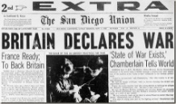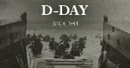



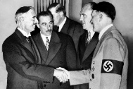

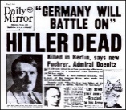





28th September

67 x 29 = _____________

Italy surrenders

