Literacy, Art and Design, D and T, PSHE World War 2
- Create dens in your homes- pretend they are air raid shelters. Play videos on you tube to see what life was like? Talk to the children about their feelings? How would they feel? What would it look like inside?
What would it feel like inside? Would it be warm? Cold? Smelly?
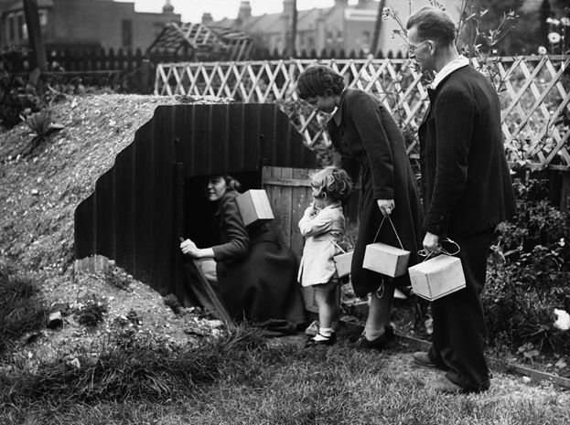
The Shelters were called Anderson Shelters they were made from corrugated iron and they were half buried into the ground with earth heaped on top to protect people from bomb blasts during WW2.
Maybe take pictures of your houses and family. Compare them to these. What is the difference? What is the same?
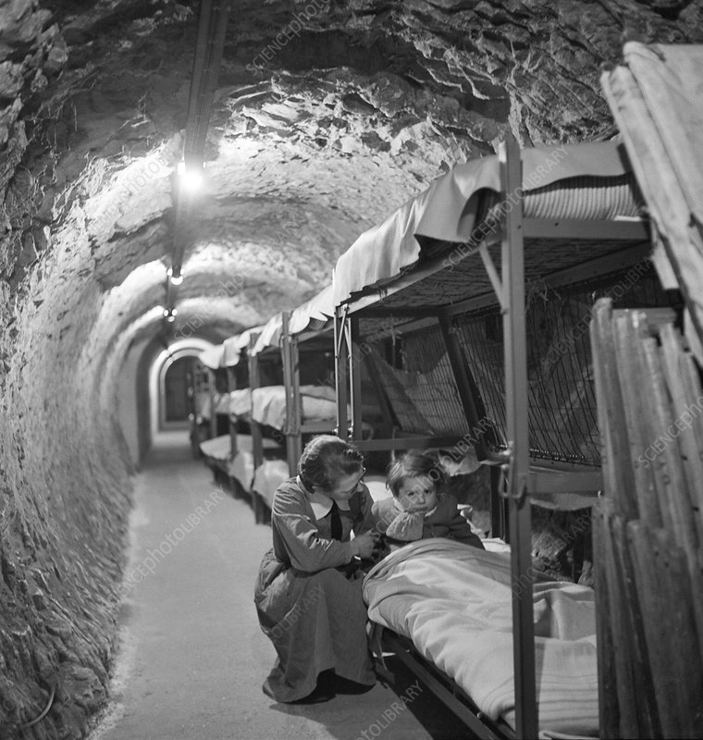

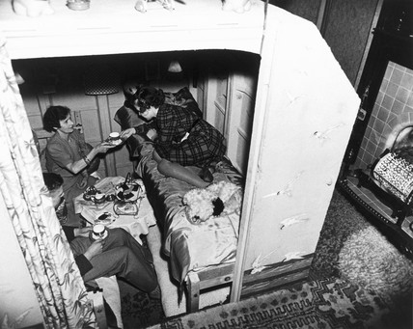
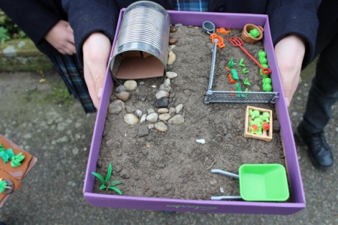
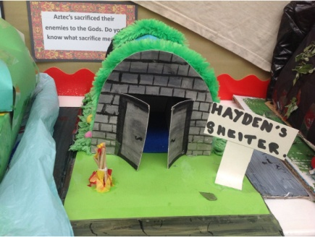
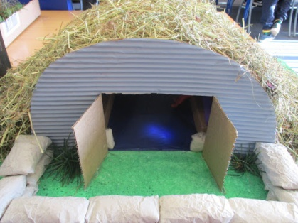
- Children (and parents) could make an Anderson shelter from junk modelling materials e.g. Cans, cardboard, plastic. Maybe adding mud and sticks from the garden or when out on your daily exercise to hide the shelters from above. Get the children to think about what they would look like? How would they have been built?

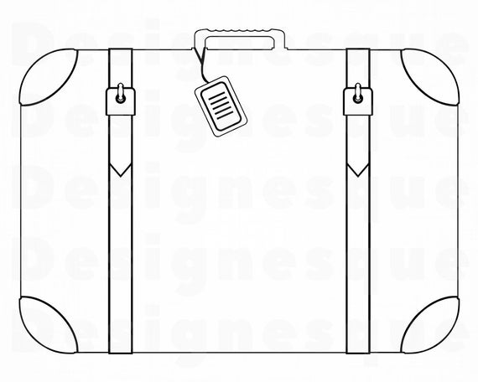
- Thinking, discussion, practical ideas and role play: Think about being evacuated and taking a suitcase of your favourite items. What would you put in it? Children get a small bag and put in their favoured items.
Work: Children can take pictures of their favourite toys or draw them. The Children are to explain what they have in their suit case and why these items are of importance.
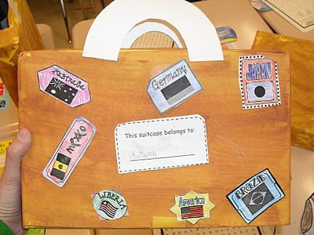
- Extension activity: Create a Suitcase - what would they pack if they were being evacuated? – Create a suitcase using junk modelling materials e.g. a cereal box. Put things that an evacuee would have in the suitcase
- Cooking in WW2
Eggs were rationed in World War 2 which means families could not get them very easily and when they did they could only have a small amount. Therefore cooking tasty treats like cakes were very difficult.
Why not try a World War 2 recipe at home:
Eggless cake!
Preparation Time: 20 minutes
Cooking Time: 1 hour 30 minutes
Number of servings: 1 cake
Ingredients
- 1 lb (455 g) of self-raising flour
- ¼ teaspoon of salt
- 4 ozs (115g) margarine
- 4 ozs (115g) sugar
- 14 ozs (400g) currants, sultanas, peel
- ½ pint milk
- ¼ pint of water
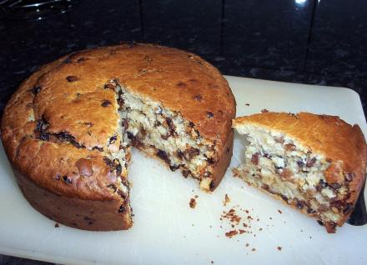
1 oz = 28.35g
Equipment
- Weighing scales
- Teaspoon
- Dessert spoon
- Measuring jug
- Mixing bowl
- Sieve
- 8-inch tin
- Greaseproof paper.
Always wash your hands before preparing food.
- Sieve the flour and salt into basin then rub in the margarine
- Add fruit and sugar and mix well
- Add this and the milk and water to the dry ingredients
- Beat very thoroughly and put mixture into an 8-inch tin that has been greased and dusted with flour
- Bake for 1½ hours in a moderately hot oven on the middle shelf

