World War Two- Evacuees

Children during World War Two, were sent away to live with families who lived in the countryside. It was too dangerous to live in the towns and cities because of the bombs.

The children took their gas mask and packed a suitcase for their journey.

1

Activity 1-

Making a gas mask box

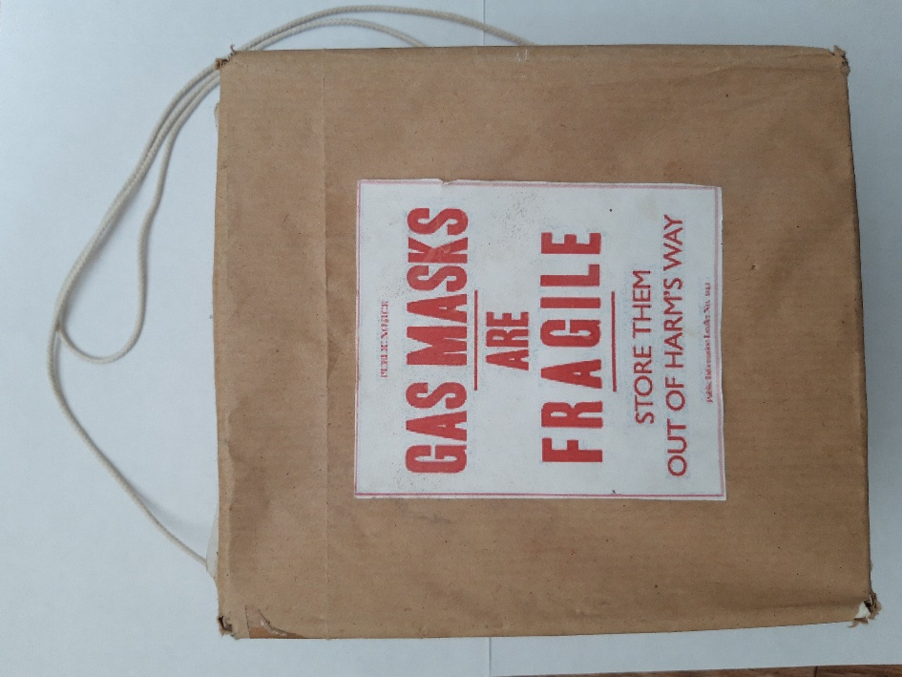

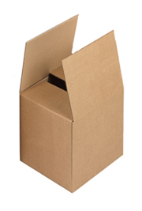Things you will need-

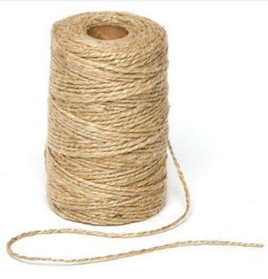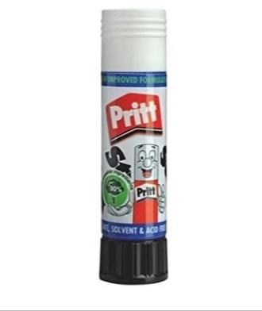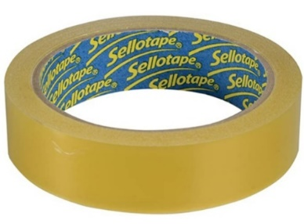

2

Small cardboard box

Brown paper

String

Glue

Tape

Scissors

label- print and cut out for box

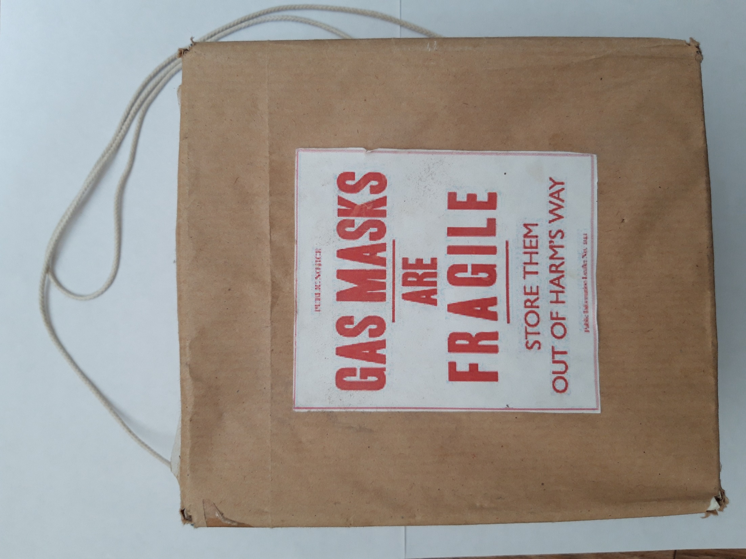

3

Instructions-

1. Cover the cardboard box using the brown paper using tape or glue.
2. Use string to make the strap. Thread the string through box, or use tape to stick on to the box.
3. Cut out the above label and stick on to front of box.
4. 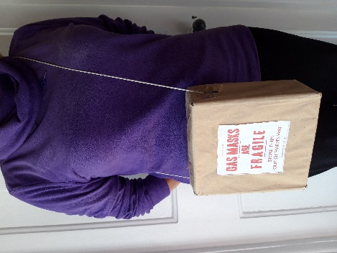Wear the box across your body or on your shoulder.

4

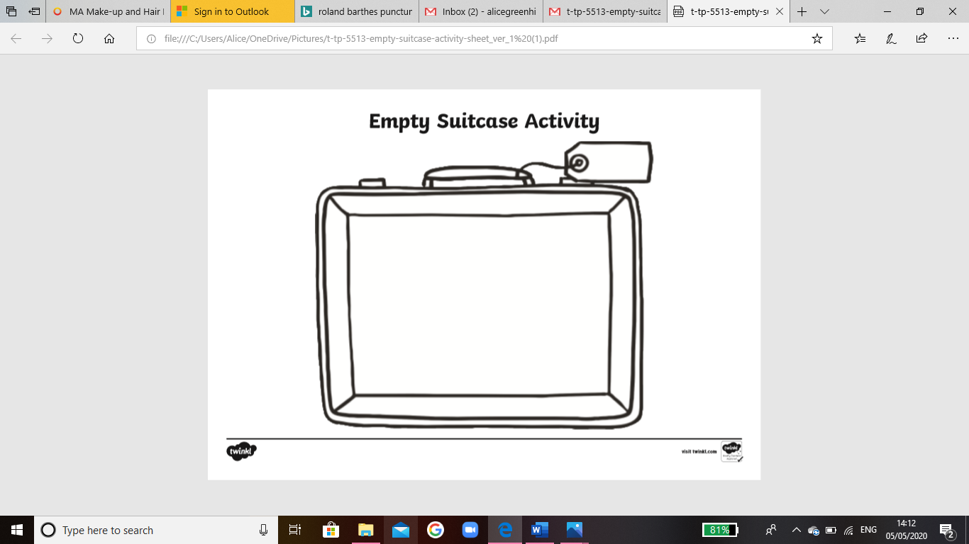

5

Activity 2-

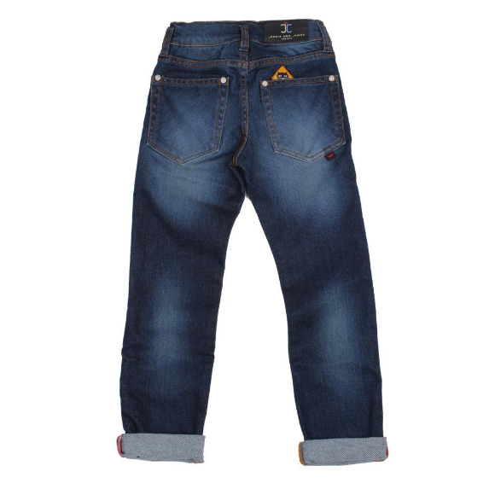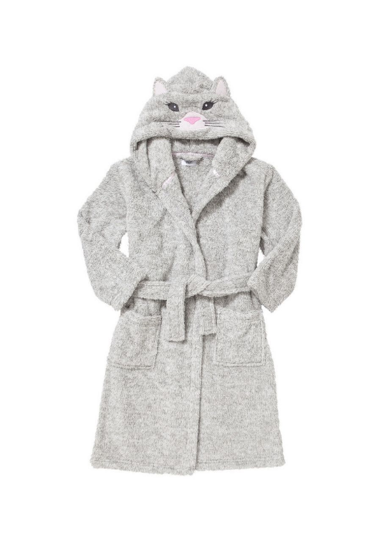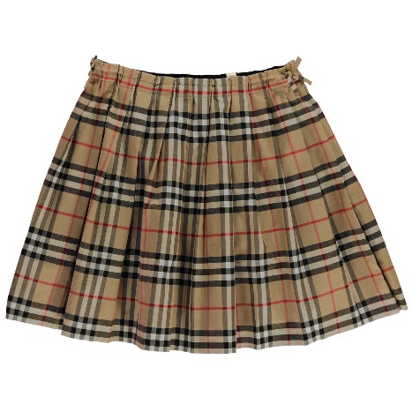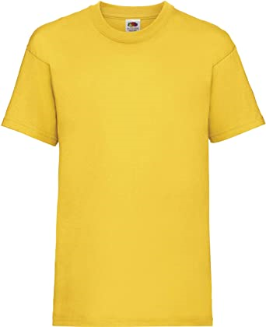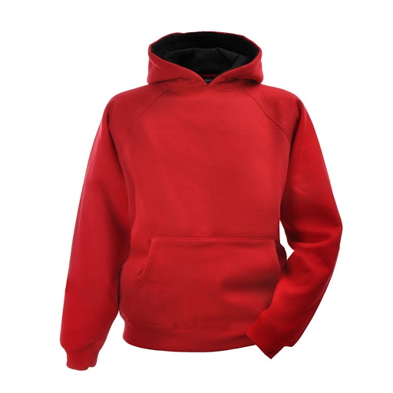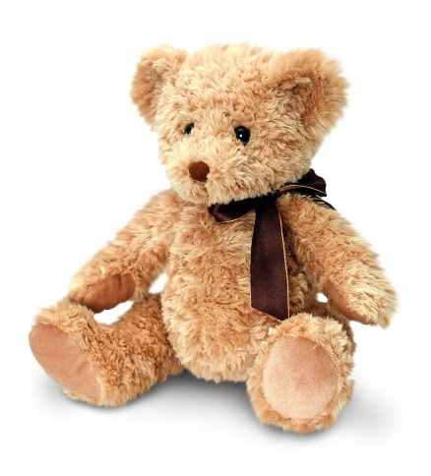Choose which items you would like to take with you. Cut out and stick them on your suitcase.

6