Hi children, I hope you are all ok and having fun at home. Today we are going to have fun and make:
Homemade Microwave Puffy Paint!
What do you need:
- Plain flour
- Baking powder
- Salt
- Food colouring of your choice
- A4 paper
- Microwave
- 4 small bowls
- 1 big bowl
- 4 spoons
- 1 tablespoon
- Sandwich/freezer bags
- Elastic bands
- Scissors
Are we ready?? I will talk you through each stage and I hope my photos help you. Let’s have some messy fun.
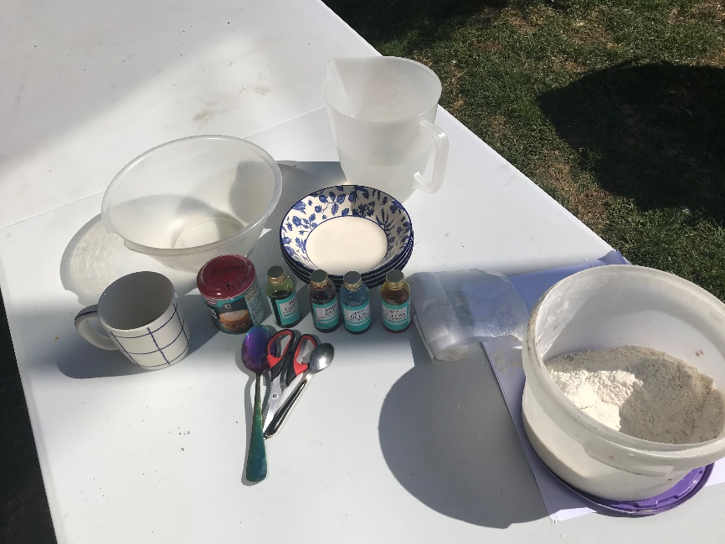
I have got all my items ready. I have decided to do this outside as it may make a bit of a mess.

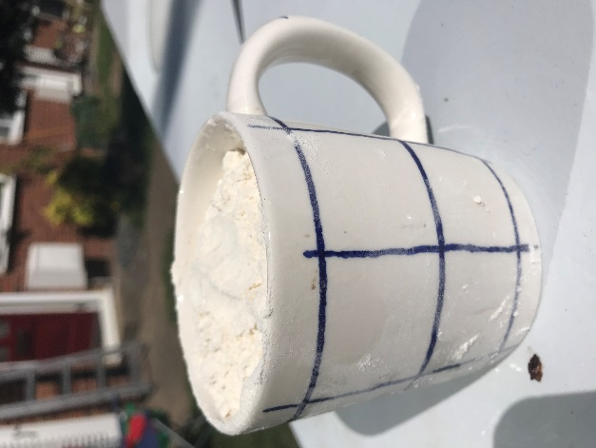
- Put one cup of plain flour in to the mixing bowl.

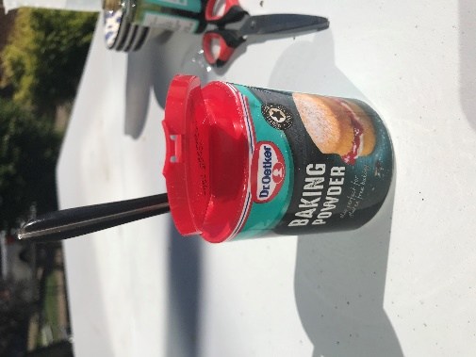
- Add 3 teaspoons of baking powder to the flour.

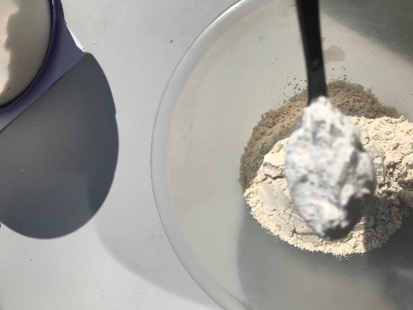

- Add 1 teaspoon of salt to the flour and stir.
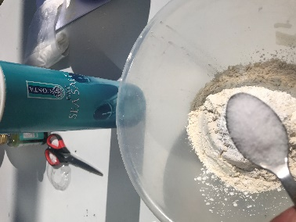

- Add enough water to the mixture to make it look like pancake batter.
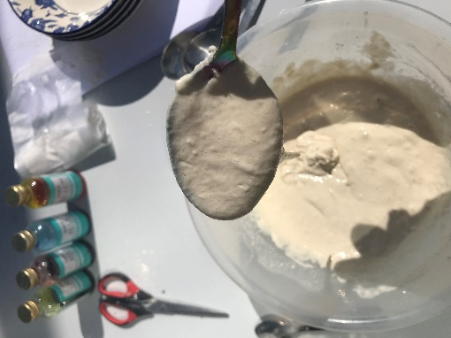
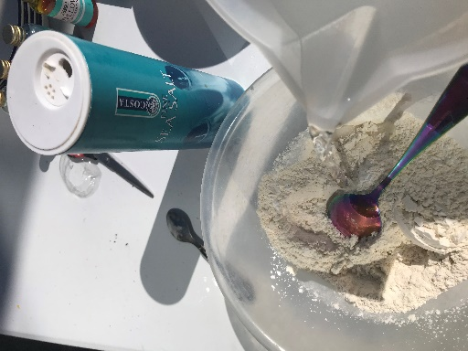

- Get the 4 small bowls and place them out on the table.

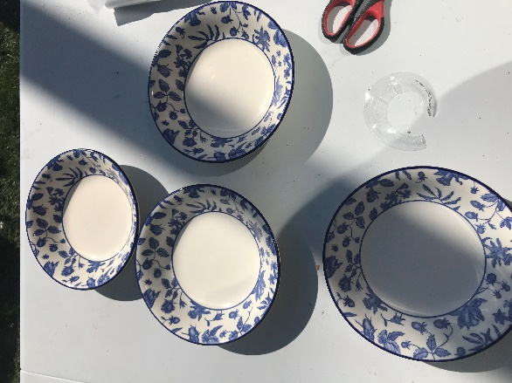

- Using a tablespoon share the flour mixture out in to the 4 bowls (3 tablespoons per bowl.
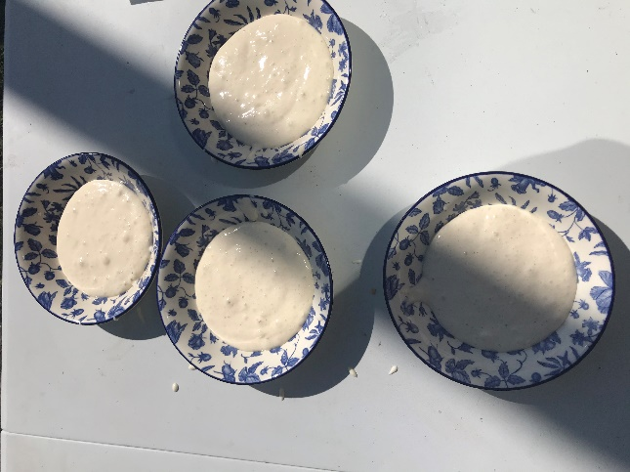
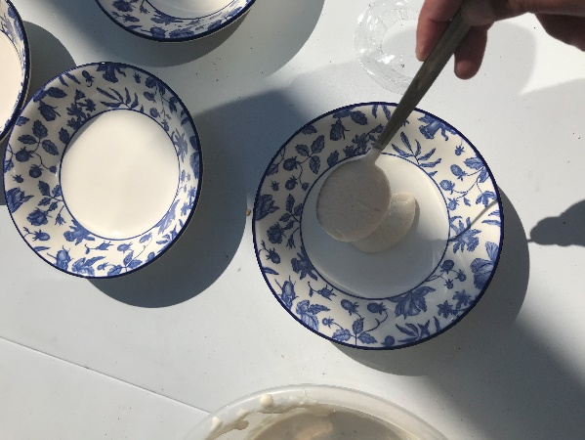

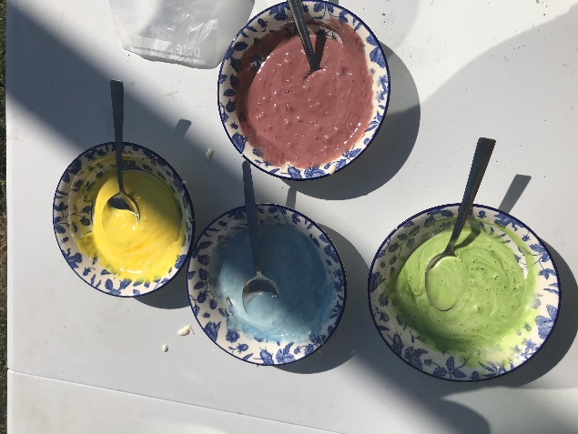
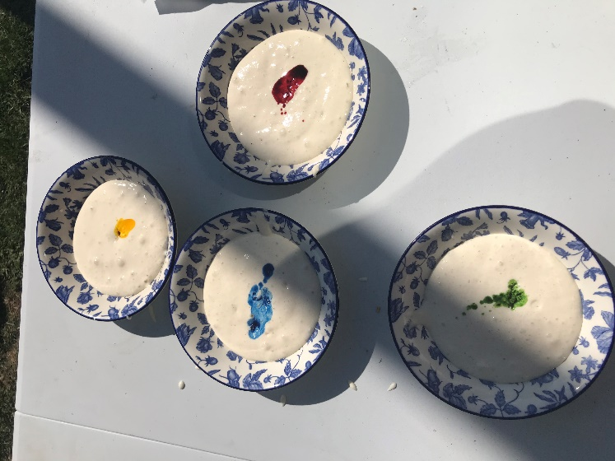
- Add a different coloured food colouring to each bowl I chose red, blue, green, and yellow and mix it all together.

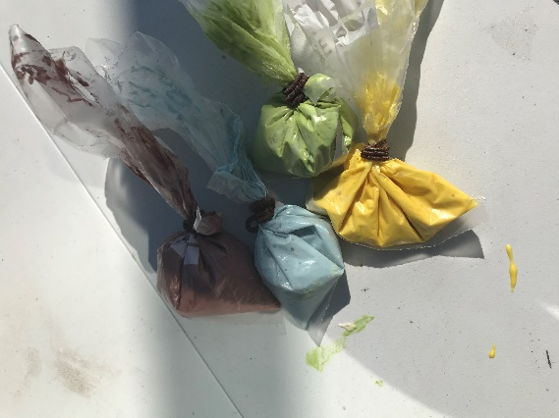
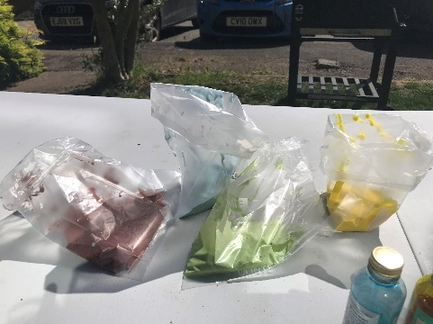
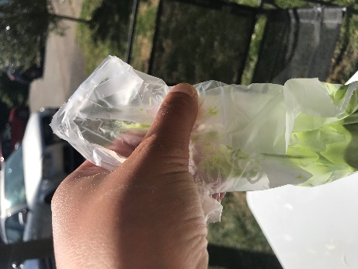
- Now get the freezer bag and spoon a different colour in to each of the bags and tie with an elastic band make it tight.

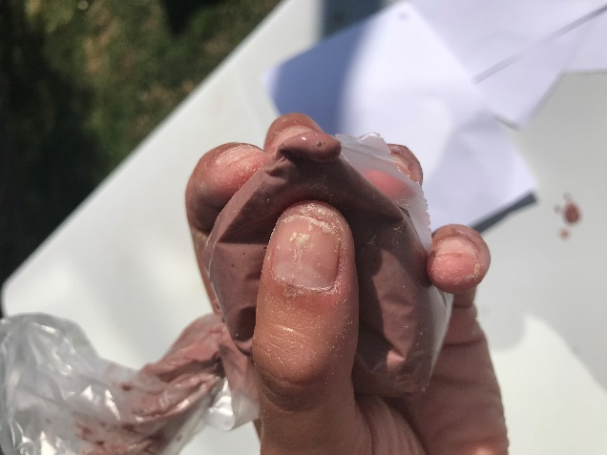
- Now with some help cut a tiny bit of the bag in the corner on all 4 bags.

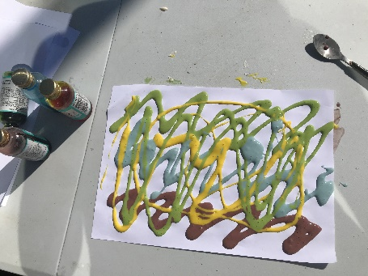
10. Very carefully start squeezing the flour mixture on to the paper (pretend your icing a cake) and drawing pattens or pictures.

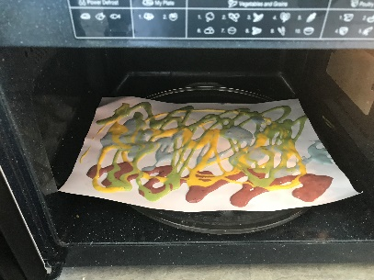
11. 0nce you have created your lovely masterpieces ask an adult to help you put the paper in to the microwave.

12. Now you need an adult’s help to set the microwave to 40secoonds and press START
What do you think will happen?
Will the paint be hard or soft?
Let’s have a look

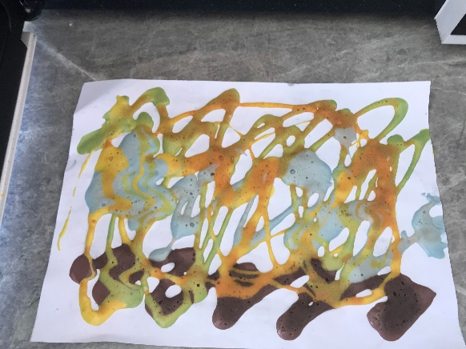
13.

I can not wait to see your creations.

I hope all your families stay safe and enjoy the sunshine.

Love Miss Stavrou

