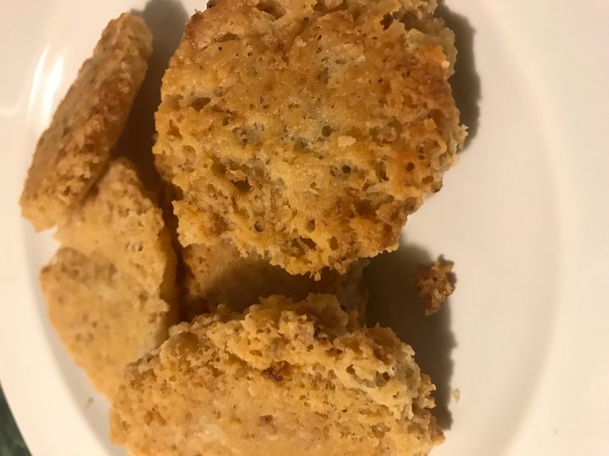
Cheese Frizzles
- 2 Tablespoons medium or coarse oatmeal.
- 1 Tablespoon flour.
- 2 Tablespoons grated cheese.
- 1 Teaspoon baking powder.
- Salt and pepper.
- A little water to mix.
- Fat for frying.
Method, Mix all dry ingredients together with the exception of the baking powder, then add enough cold water to mix into a stiff batter. Just before using add the baking powder. Melt a little fat in a frying pan and when smoking hot drop spoonfuls of the mixture into hot fat. Fry till golden brown on both sides.

