Welcome to Miss. Stavrou’s step by step cooking lesson today we are making:
1940’s VE Day Carrot Cookies.
In the 1940s they used carrots as a sweetener, the people who ran the government convinced the children that carrots were just as tasty as ice creams, and eating carrots will help them see in the dark during the blackouts.
What you will need:
- Mixing bowl
- A tablespoon
- A teaspoon
- A grater
- A greased baking tray
- Oven needs to be 200c (Do not touch the oven let mum, dad, nanny, grandad or carer put the cookies in and out of the oven)
Ingredients:
- 1 tablespoon of margarine
- 2 tablespoons of sugar
- 1 teaspoon of vanilla essence
- 6 tablespoons of self-raising flour
- 4 tablespoons of grated raw carrot
- 1 tablespoon of water
Put the oven on
Are we ready?
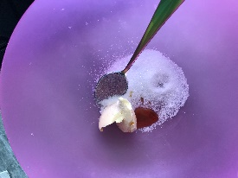
- Put the margarine, sugar and vanilla essence in the bowl.

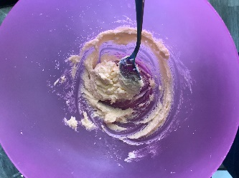
- Cream together the margarine, sugar and vanilla essence.

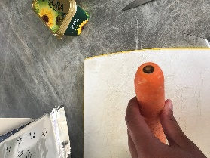
- Wash the carrot and cut the end off it.

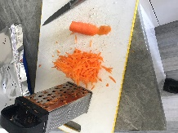
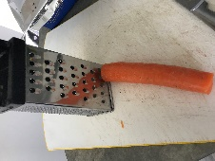
- Grate the carrot ( this can be hard make sure you have help from mum, dad, nan, grandad or carer be careful of your fingers.)

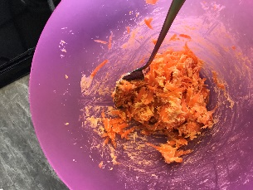
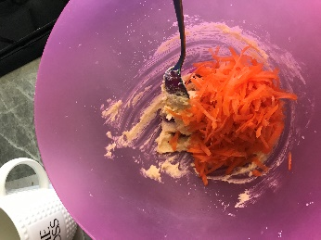
- Put 4 tablespoons of the grated carrot in to your creamed margarine mixture and stir.

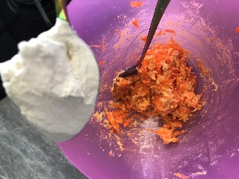
- Add 6 tablespoons of flour to the mixture and mix in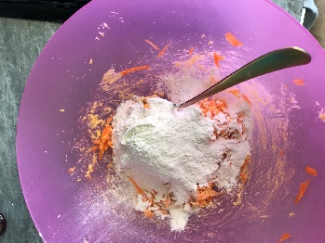.

If the mixture is dry add a tablespoon of water
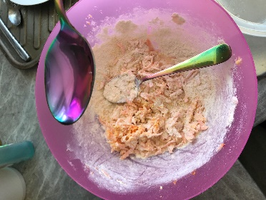
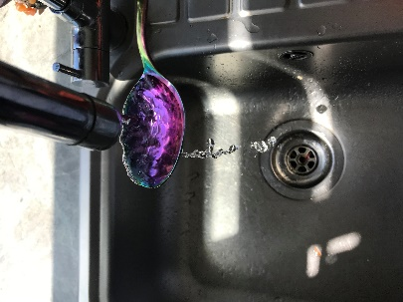

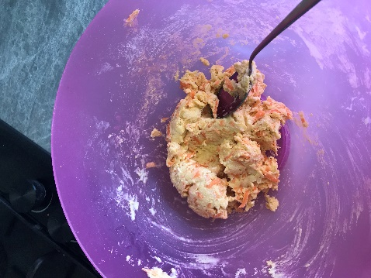
The mixture should look like this

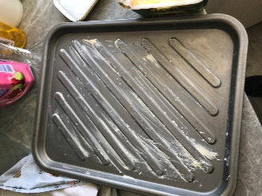
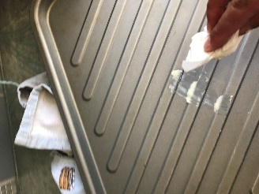
- Put some margarine on the baking tray to grease it so the biscuits don’t stick

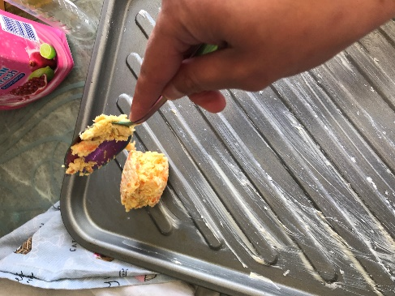
- Drop spoonful’s of the mixture on to the baking tray.

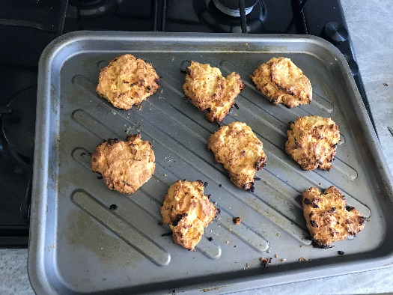
- Put in the oven fo10 – 15 minutes.

Once cool sprinkle with sugar, and enjoy eating them, I am going to sit in the garden with a cup of tea as I eat them.
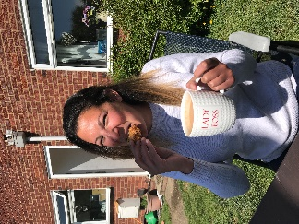
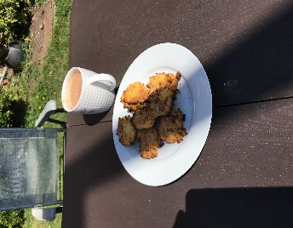
Miss you all stay safe and happy baking.
Love Miss Stavrou x

