Shopping list
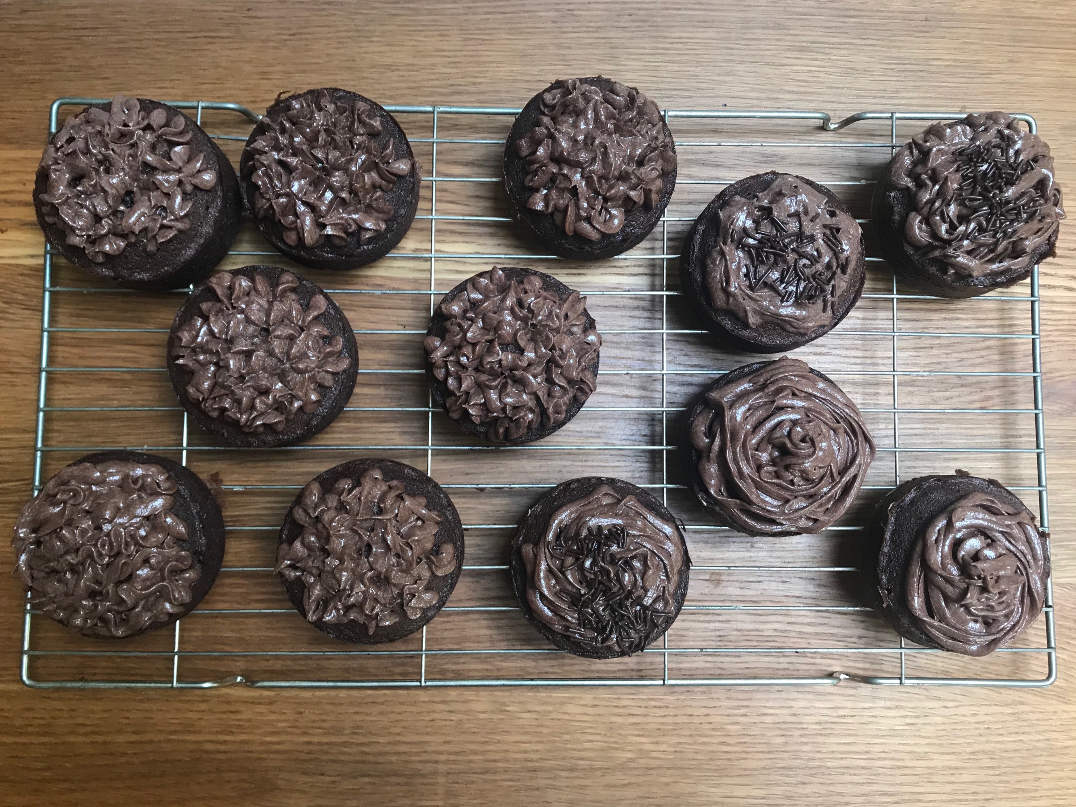

Chocolate Cupcakes
- 175 g Unsalted Butter
- 175 g Light Brown Sugar
- 3 Large Eggs
- 135 g Self Raising Flour
- 40 g Cocoa Powder
- 1/2 tsp Vanilla Extract

Chocolate Buttercream Frosting (OR 100 g chocolate (melted))
- 125 g Unsalted Butter
- 225 g Icing Sugar
- 25 g Cocoa Powder
- 1/2 tsp Vanilla Extract

Decoration (optional)
- Sprinkles

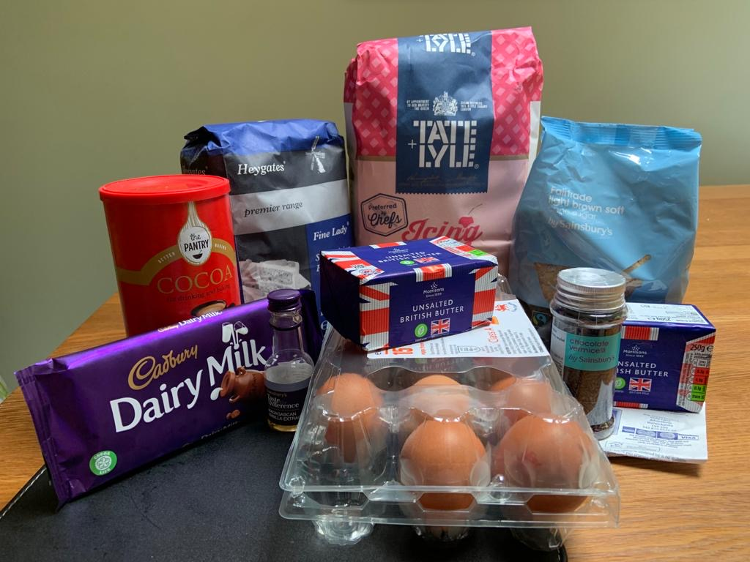

Recipe
- Preheat your oven to 170C/160CFan.

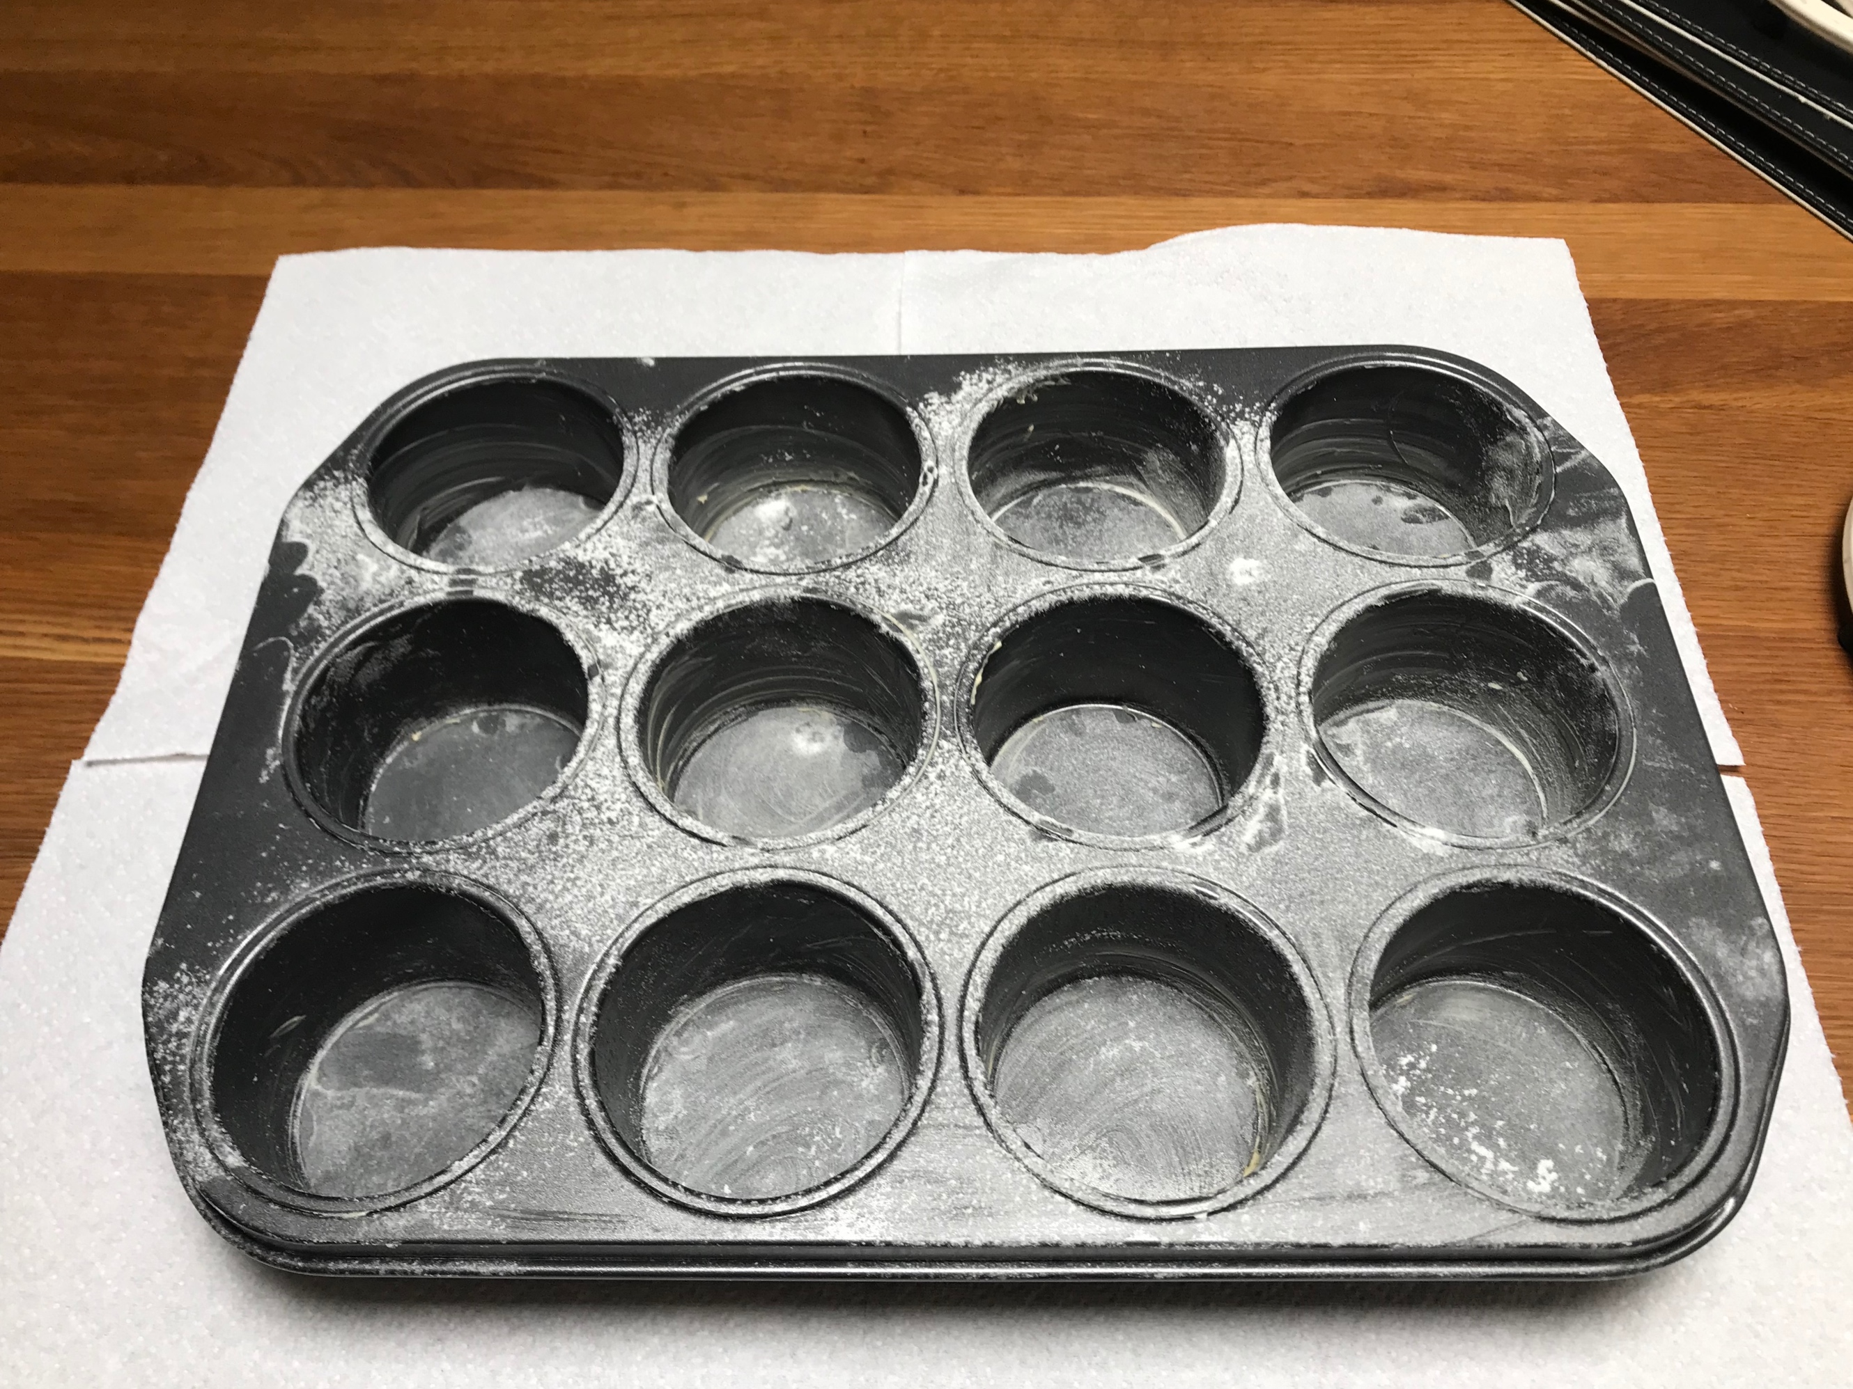
- Grease and flour your 12-Hole Cupcake Tin

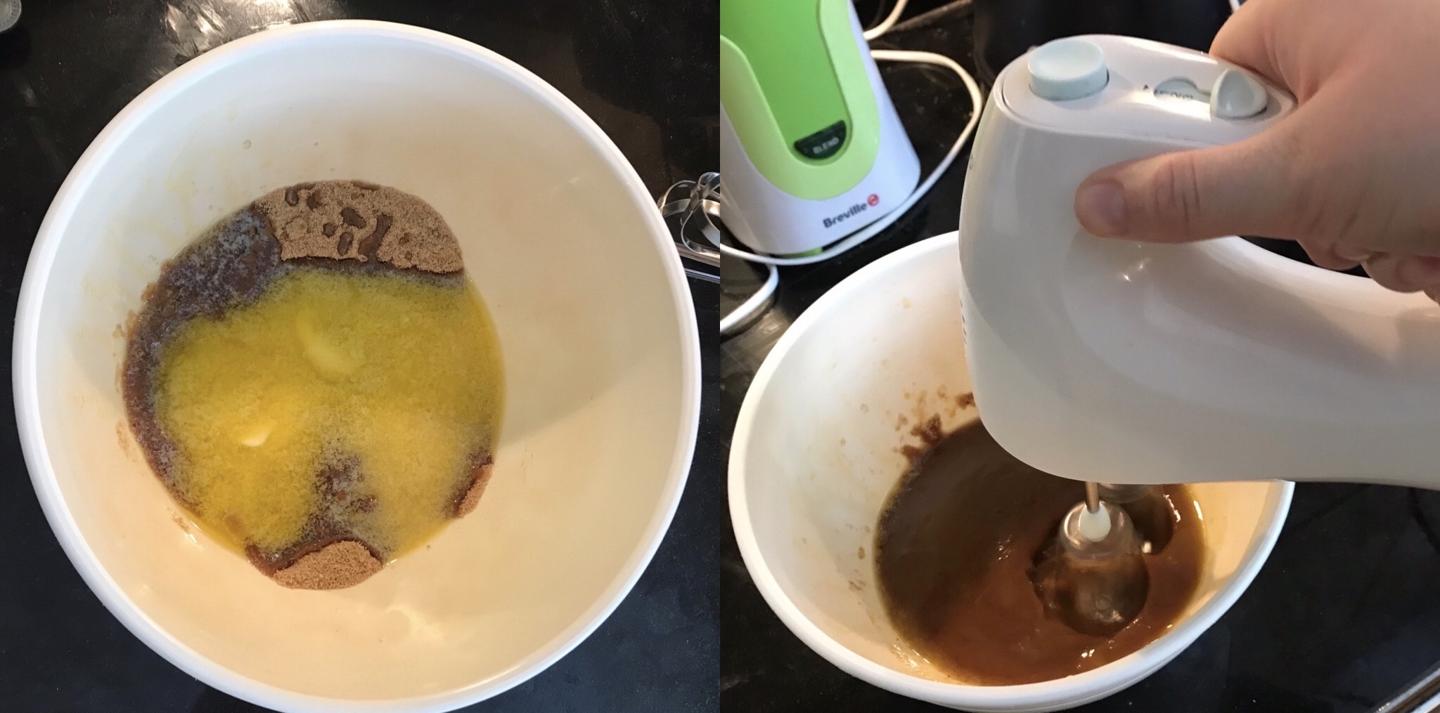
- Mix together the Butter and Light Brown Sugar until it’s smooth.

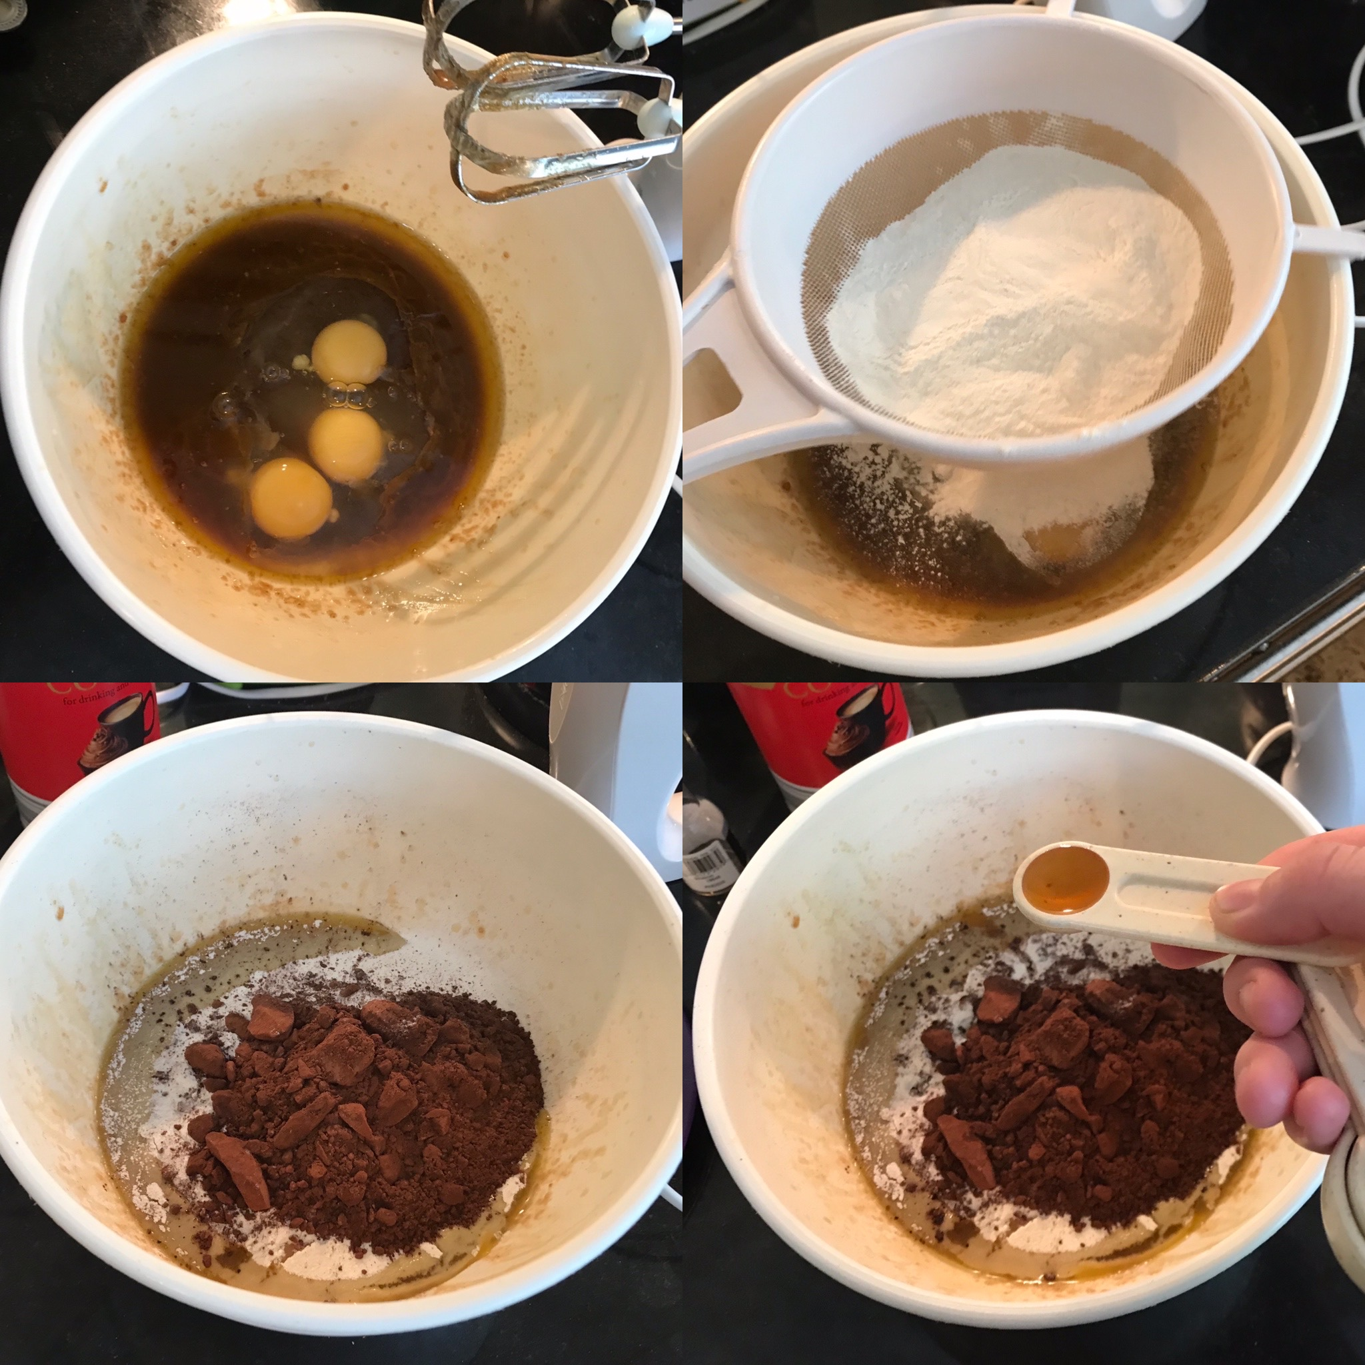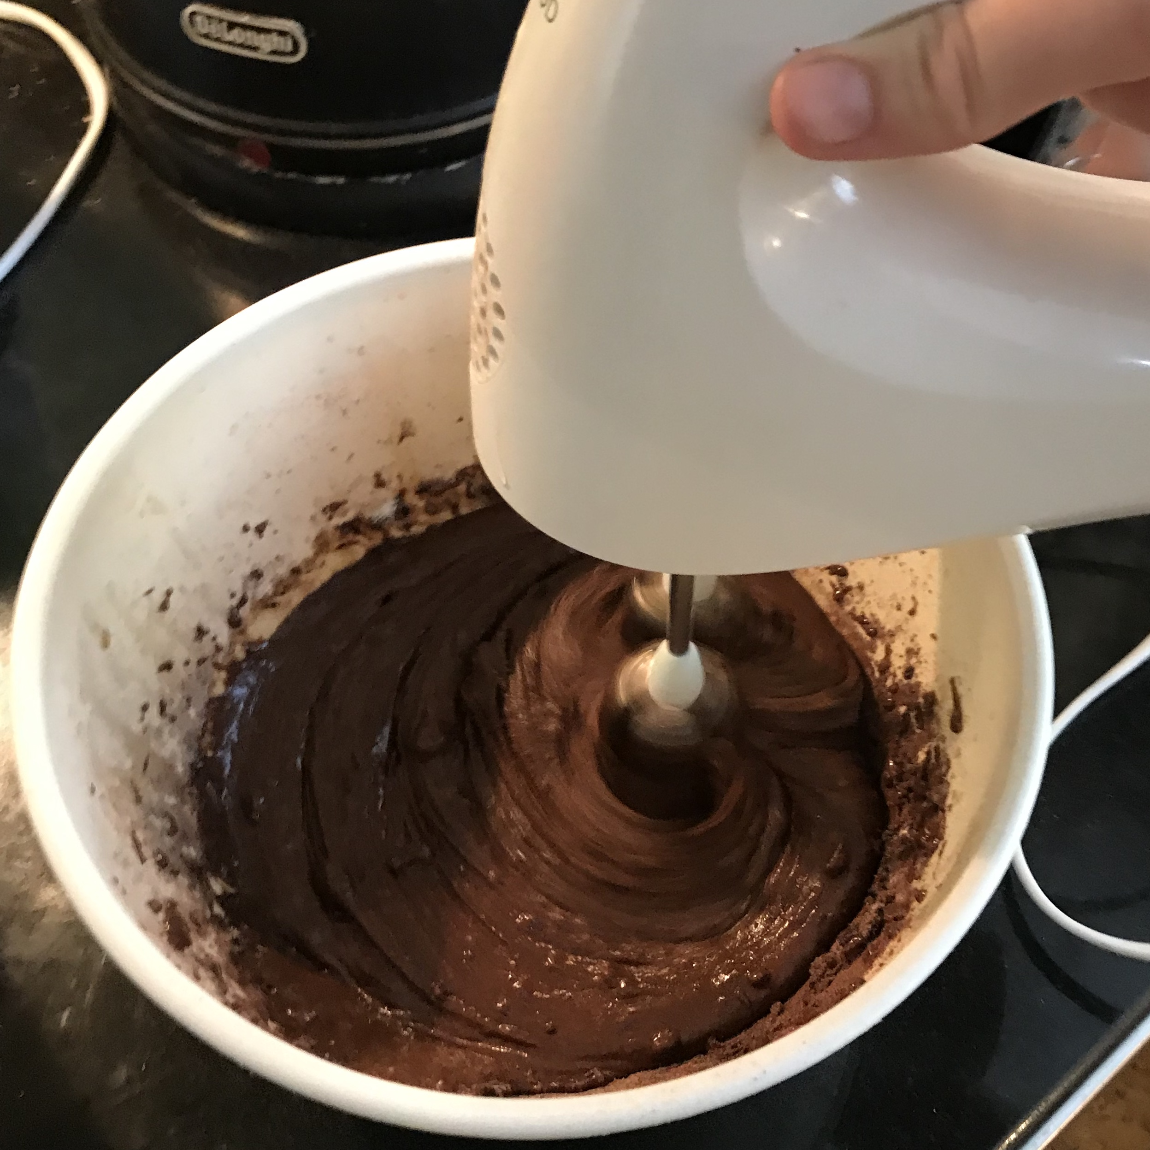
- Add in the Eggs, Flour, Cocoa Powder and Vanilla Extract and mix again.

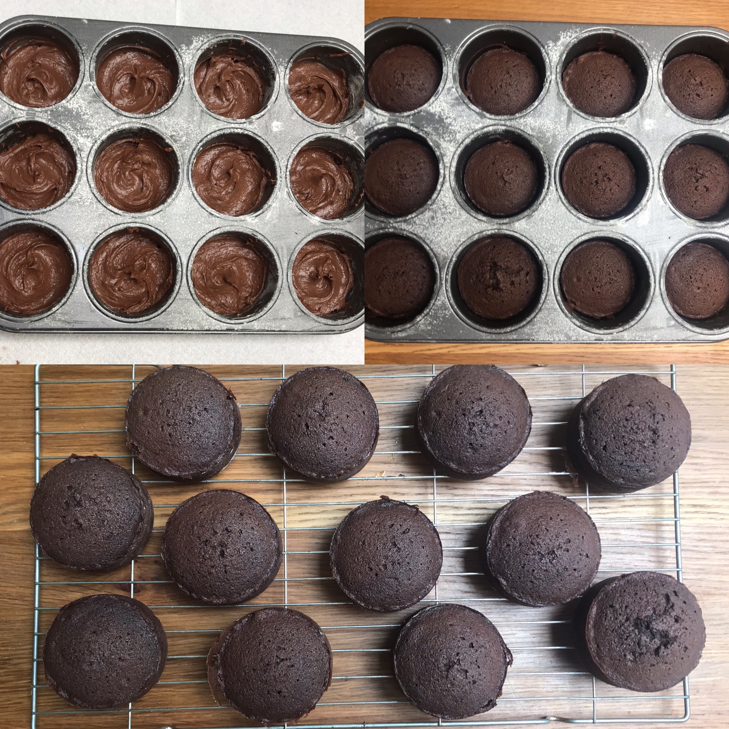

- Spoon the mixture into your tin.

- Bake in the oven for 16-18 minutes.

- Leave the cupcakes to cool on a wire rack.

Instead of making buttercream frosting, you can melt chocolate and drizzle it over the cupcakes!
- Pipe buttercream frosting on to each cupcake.

- Add some sprinkles.

- ENJOY!

- Beat the Butter until it’s smooth.

- Add in the Icing Sugar and Cocoa Powder 1/3 at a time and mix well.

- Add the Vanilla Extract.

