Digestive Experiment
So today children we are going to learn about our digestive system.
Who knows what the digestive system does? This consists of part of the body that work together to turn food in to liquid to keep is healthy and gives us the food we need to keep our body working.
Where does the digestive system start? In our mouth
Have a look at this song and lets see what it does.
https://youtu.be/fiRKW0W51Pg
Now for the fun part. Are we ready to make our digestive system using our fine motor skills. This is how our bodies break down food.
What you need
A bowl
Bread
Tea towel
Water
Vinegar
Here we go let’s have some fun!!!!
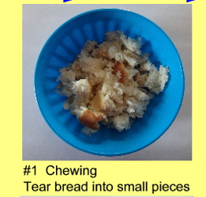
- Is the chewing stage that happens in our mouths so tear the bread up and put it in to a bowl.

- So the bread is in nice small bits in the bowl, what is the liquid in side your mouth called? Silivia or spit so we need to add this to your bread like it does in your mouth so add a small amount of water to the bread and stir with your hands.
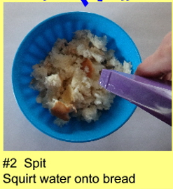

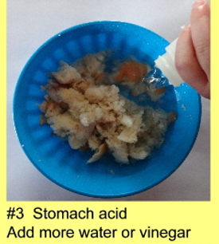
- So the water should be wet, and if you remember we swallow the bread down our oesophagus which leads to our stomach were there is acid which helps to break down the food, so in the bowl add a bit of vinegar or more water.

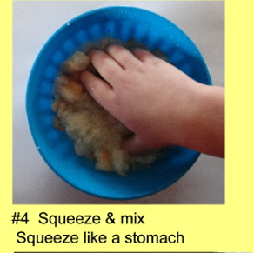
- Now with your hands pretend they are your stomach muscles squeeze and mix the bread and the vinegar/water like your stomach does to the food.

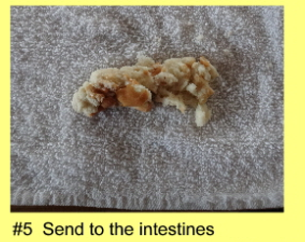
- After the stomach has squeezed and mixed all the food up it travels to your small intestine. Now pour the mixture on to an old tea towel.

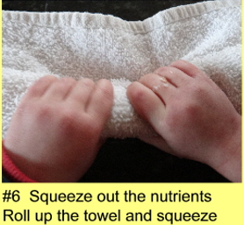
- Roll the tea towel round the food like a cylinder and squeeze the liquid out in to the bowl the, the liquid is what is called the nutrients. The nutrients are what we need to make us grow and keeps us healthy. We also need to squeeze the towel to. The nutrients are good for us.

- Unravel the towel and what do you see? It should be a solid mass, that has travelled through your large and small intestines and this is what is left. This is your poo, which we need to get rid off. Your body has absorbed all the good nutrients and we need to get rid of the bad ones buy going to the toilet. What are the differences? Is it had? Soft? Good or bad?
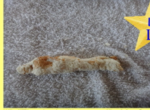

- Have a look at all the nutrients pour from the bowl on to the towel you may want to put a tray underneath.

Well done children we have just made our digestive system.

