Instructions for Dancing Raisins experiment

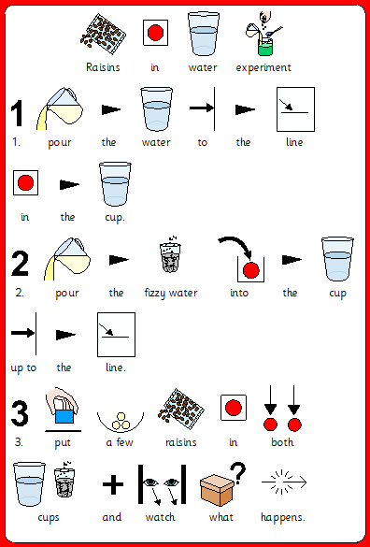

Can you draw or write what you saw happen during the experiment?

|  |
| --- |
| 7oz Clear Plastic Cups x 1000 - Logic Vending |
| 7oz Clear Plastic Cups x 1000 - Logic Vending |