FROZEN FLOWERS
A simple, sensory Summer activity.
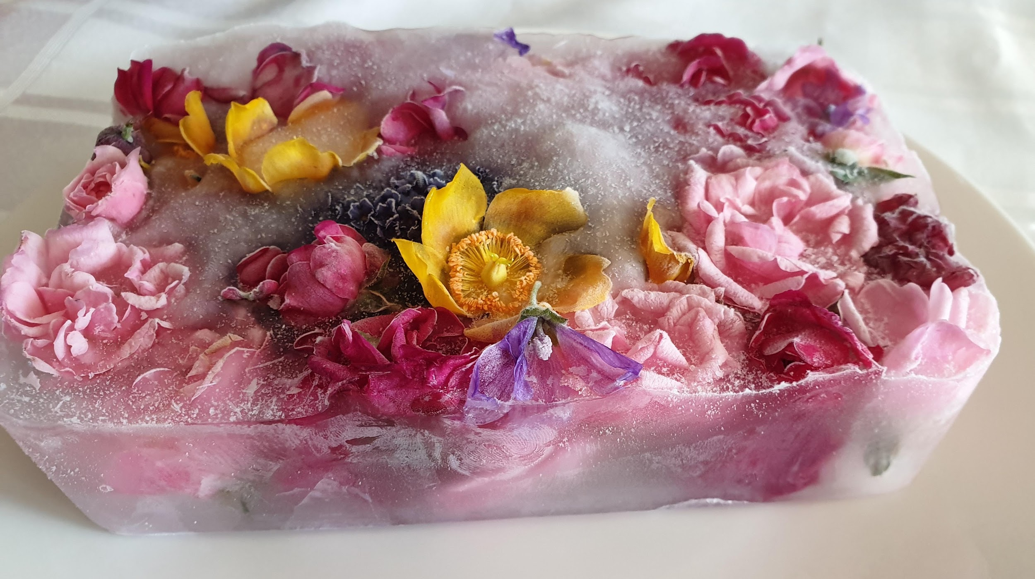

YOU WILL NEED:
A tub (eg. used ice cream tub)
Wild or garden flowers
Water
Scissors
Freezer space

1. First of all, you will need to collect some flowers. These can be from your garden or some wild flowers as you go out for a walk. As you collect them, talk about their colours, scents, size and textures and, if you know them, their names.

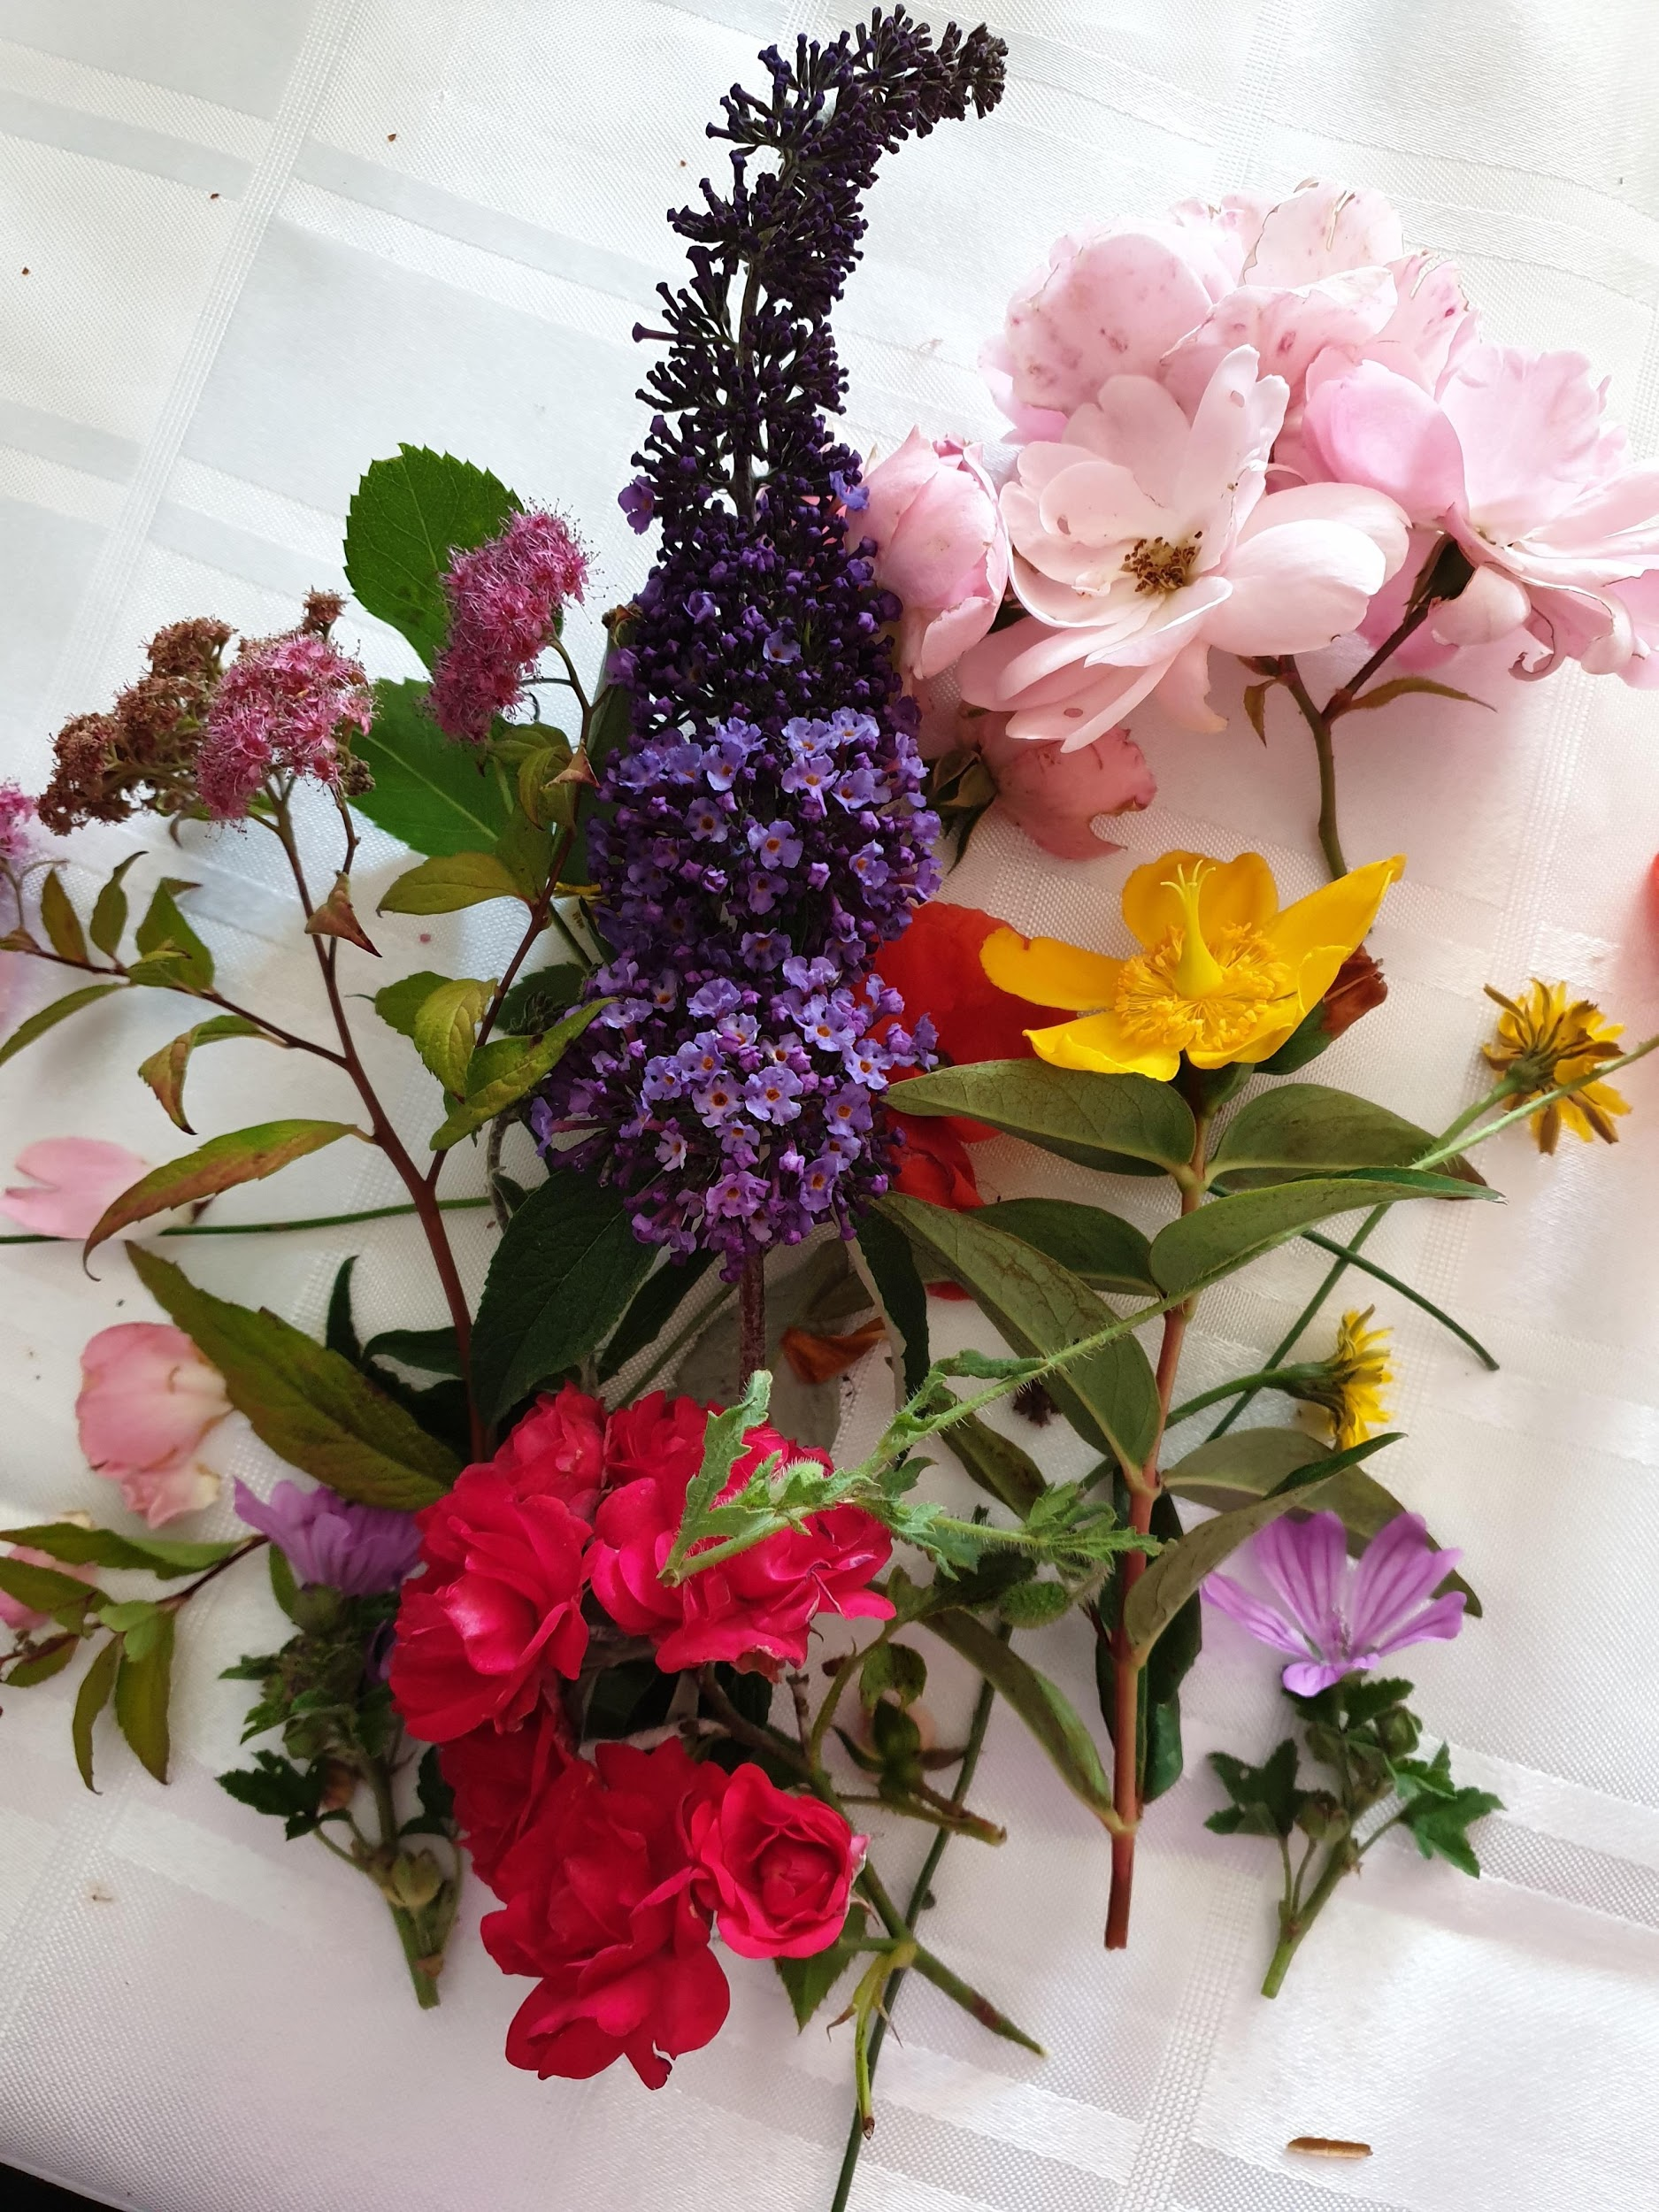
2. Cut the flower heads from the stems with your scissors and place them in the tub. Pour some water into the tub, 1-2 inches deep.

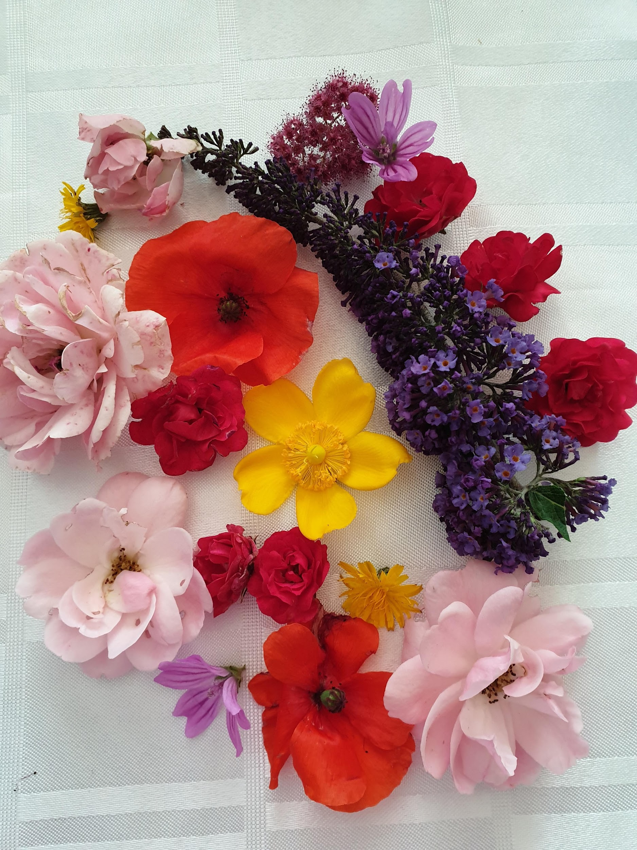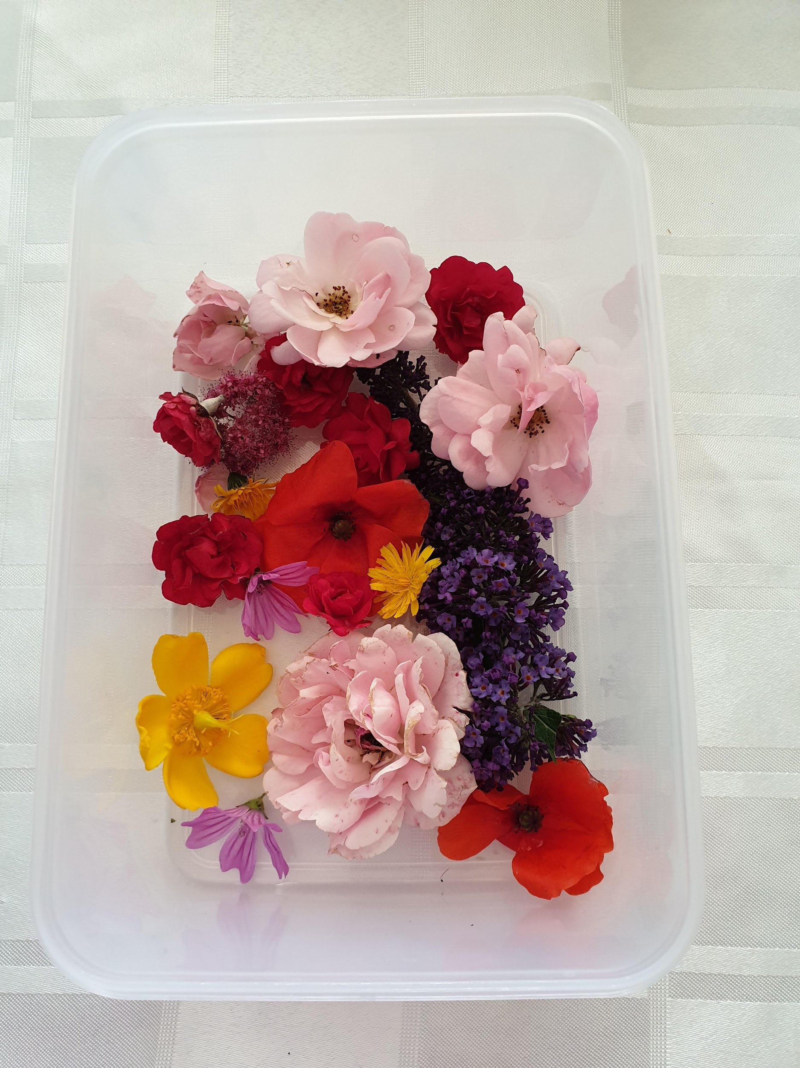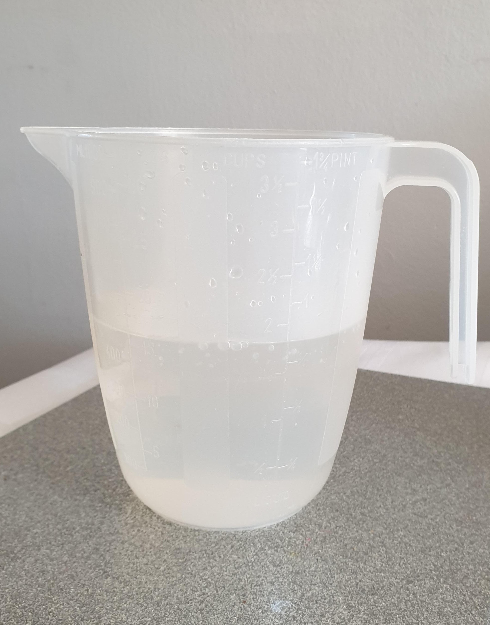
3. Leave in the freezer overnight.

4. The next day take your flowery ice block from the freezer. Explore and play with the ice. Take it outside as it could become a bit messy!

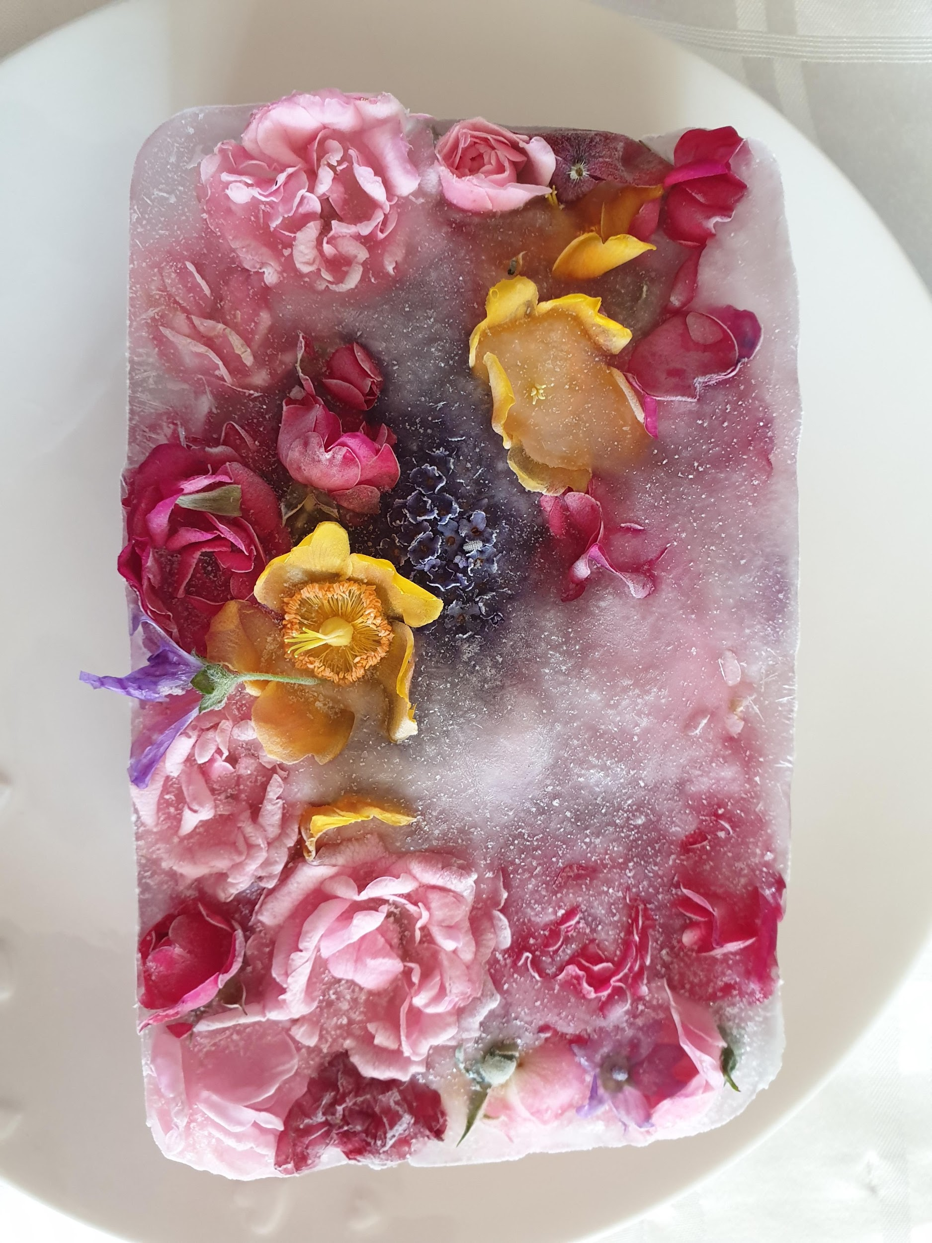

Have fun!

