Growing a plant and observing its growth

(For the Parents/carer)
You will need:
- A pot
- Soil
- Seeds (for a plant/flower of your choice)
- Ruler
- Watering can/bottle

On the other page is an observation sheet/journal to record the plants growth. You can document the progress every day, every couple of days or each week, it is up to you. You will need to print out the sheet below for each recording.

What you need to document:

What day is it?
How’s the weather?
Do you have any notes to write?
What does your plant look like?
What time did you water the plant?
How tall is your plant?
How much has it grown?

My Plant Journal
Day:_______________

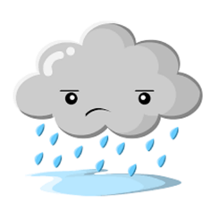

Observation Notes:________________________________________
________________________________________________________
What I can see:
I watered my plant at:_________
My plant is ______ cm tall. My plant grew: ______ cm.

