Science Experiment
Learning how plants grow!
Learning about how plants absorb water!

Hi All,
Mrs Ward here again. This week Jude and I have been learning about growing plants and what they need to grow.
- Sun
- Light
- Water
- Air
- Time
- Room to grow

We headed out to buy some seeds to try and grow some ourselves. We brought.

- Seeds
- Soil
- Little pots

We planted the seeds and waited for them to grow. Jude was so excited when he could see the plants had started growing.
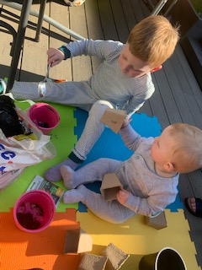

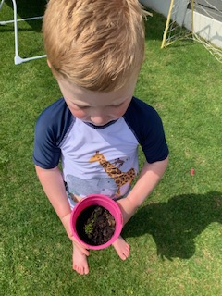
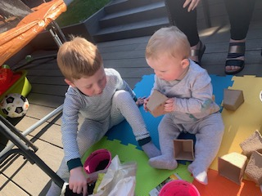

We talked about all the things plants and flowers need to grow. Jude wanted to see how the flowers drank the water so decided to do an experiment to see if we could see this with using food colouring.

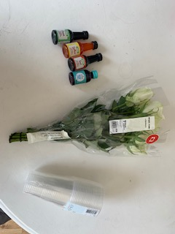
We needed-
- 4x food colouring
- 4 clear pots/containers
- 4 white flowers (of choice)

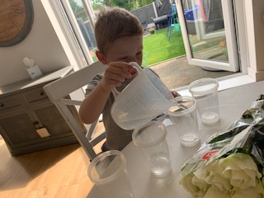
- First we poured water into 4 separate cups

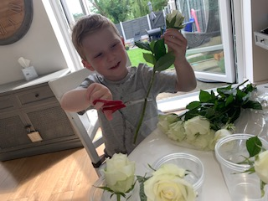
- Next we carefully cut four single white roses and placed them into the cups

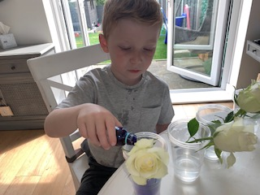
- Next we poured the different food colourings into each pot
(More is better as it helps show the different colours in the pot).

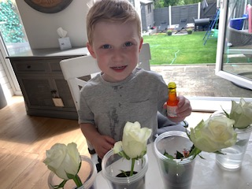

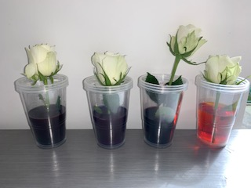
- Once all 4 pots were filled we put them on the side to watch
This is our before picture

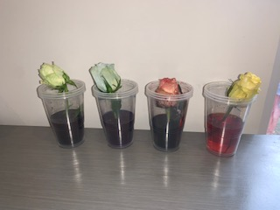
- Jude enjoyed watching the plants change colour

This is our after picture

Once the flowers has absorbed the different colours it was easy to see that each flower had drunk the water and it had changed the colour of the flowers.

I hope you enjoyed our experiment!

Hope to see you all very soon.

Mrs Ward

