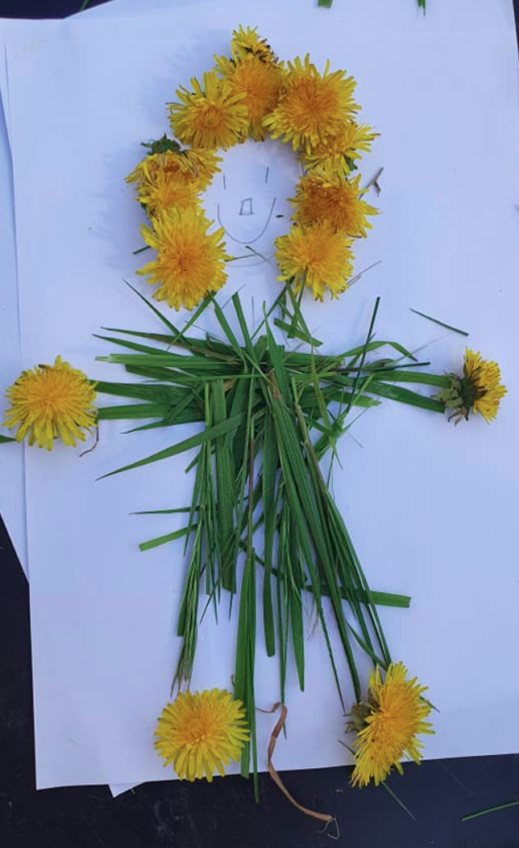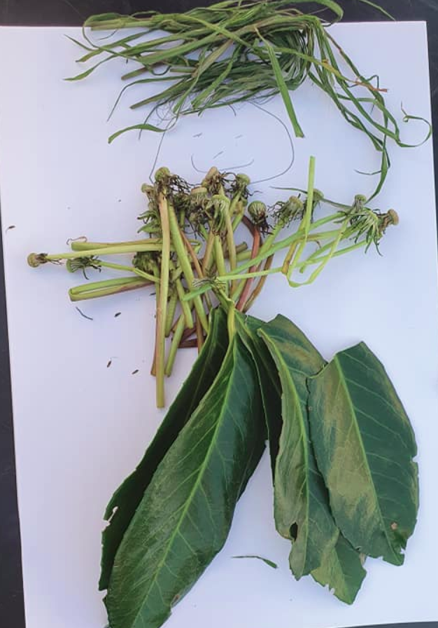
Nature
People
This activity could be completed either in a garden, or with items collected on a walk.
Items needed:
- Paper
- Pen/pencil
- Access to plants, sticks, stones, flowers, pine cones, blossom, leaves etc
Step One
Draw a face on the piece of paper. Try to allow room for hair/body/limbs to be added around the face.
Step Two
Collect anything from the natural world around you! This could include sticks, flowers, pine cones, blossom, leaves, grass and/or plants!
Step Three
Arrange the items collected to create hair, a body, legs, feet, arms, legs . . . or even create a monster creature of your own!

Colour Hunt

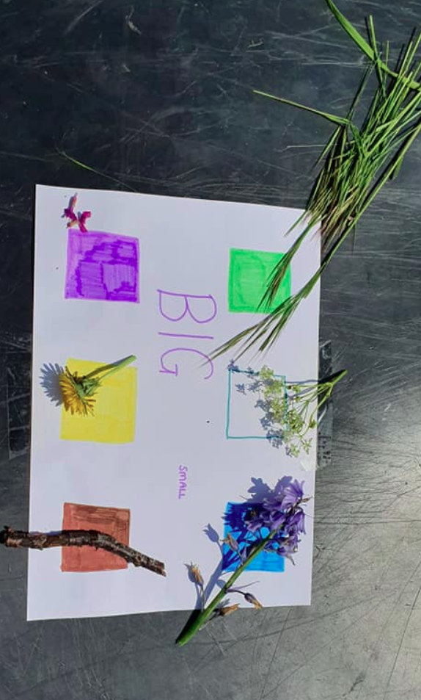

For this activity you will need to create colour squares on a piece of paper. You could also extend this further by writing/using symbols for big and small too.

Step One
Identify the colours that can be seen in the garden/on your walk. What colour are the tree trunks? The flowers? The stones? The leaves? Even the weeds?
Step Two
Identify the colours that can be seen on the paper. What colours can you see?
Step Three
Can you find any colours the same? If some prompting is needed, identify an object. For example, what colour is the dandelion? Can you find a colour on the paper that is the same?

