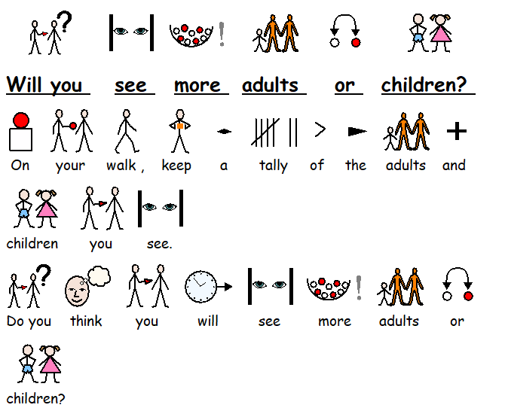

Tally Chart

|  |  |
| --- | --- |
| Person | Tally |
|  |  |
|  |  |

 