Plants need….

Use the words below to finish the sentences.
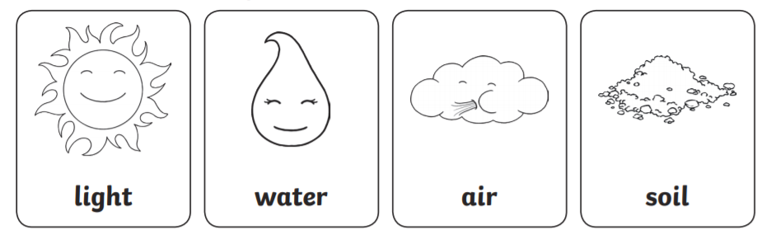

Many plants need ……………. from the sun.

Many plants need ……………. or they will dry out.

Many plants need ……………. to grow their roots in. They get nutrients they need from the soil.

Plants need ………………, ……………….., and ……………….. which they use to make food.

