Let’s investigate how we can make a rainbow!

You will need:
- A plate
- Lots of skittles
- Warm water

Step One
Place the skittles around the edge of the plate, alternating the colours
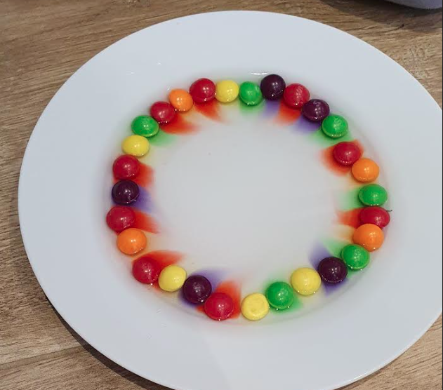
Step Two
Pour a small amount of warm water into the middle of the plate, allowing it to reach the skittles
Step Three
Watch the rainbow appear! Slowly the colours of the skittles should start to run to create a rainbow effect
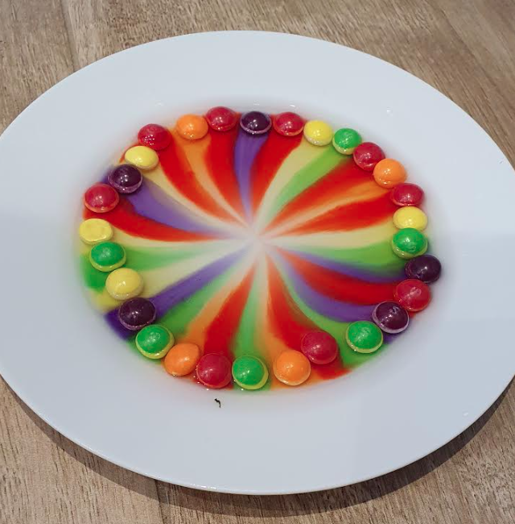
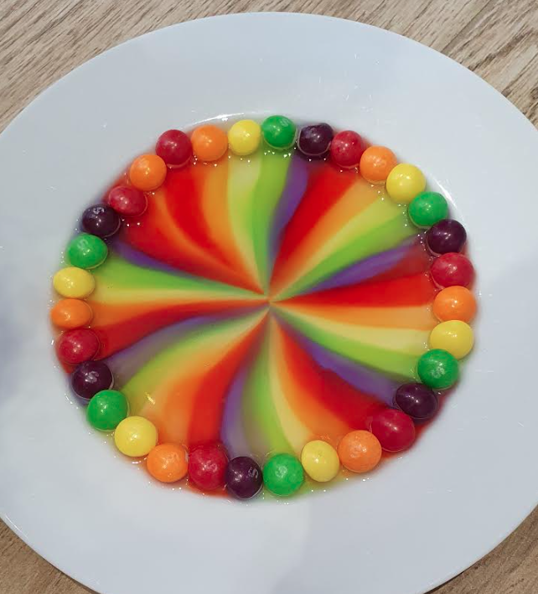

Questions to ask:
What colours have you used?
What do you think will happen when you add the water?
Why do you think the colours don’t mix?
Why do you think the colours spread?

Extension ideas:
Can you time how long the colours take to reach the centre of the plate?
Can you use warm water and then cold water? What time difference is there? Which do you think will be faster?
Try using other sweets. Can you find any that work as well as skittles?
Try using other liquids, such as white vinegar or even lemonade!

