Sort by number
One flower | 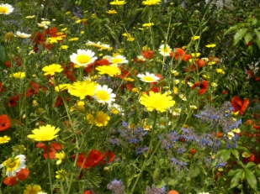  Lots of flowers

Take pictures like the above in your garden or take pictures of flowers whilst on a walk.

