Sort the flowers

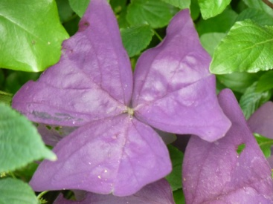  Purple flowers | 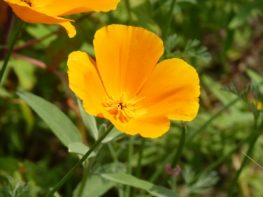  Orange flowers

Can you find some purple and some orange flowers in your garden or on your walk? Print the pictures and sort them above.

