Can you spot something red?
Can you spot the red objects around you? So today go for a walk out and about and see how many things you can spot that are red and do a tally chart to record your answers in the table I have made.
Object | Tally
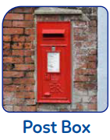

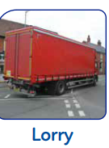

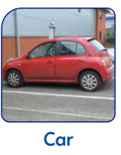

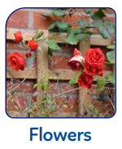

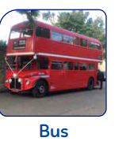

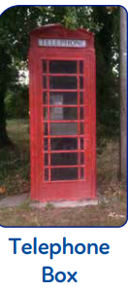

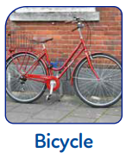

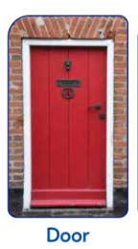
Did you find any more red things if so can you draw them for me and write what it is?

Now we are back from our walk I want you to know go and find some red objects you may have at home and make a table of the red objects like I have done.
How many things can you find that are red in your house?
Have we got the same objects?
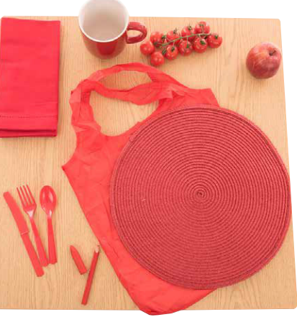

Get mum, dad, nan, granddad/ carer to send in your photos of your walk or your red table.

Can you spot something green?
Can you spot the green objects around you? So today go for a walk out and about and see how many things you can spot that are green and do a tally chart to record your answers in the table I have made.
Object | Tally
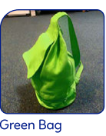

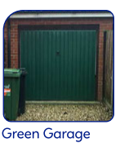
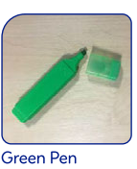
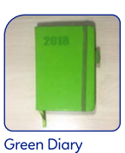
Or book
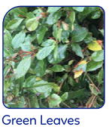
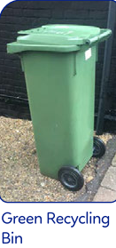
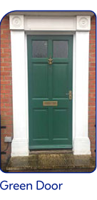

Did you find any more green things? If you did can you draw me a picture and write what it is?

Now we are back from our walk I want you to know go and find some green objects you may have at home and make a table of the green objects like I have done.
How many things can you find that are green in your house?
Have we got the same objects?

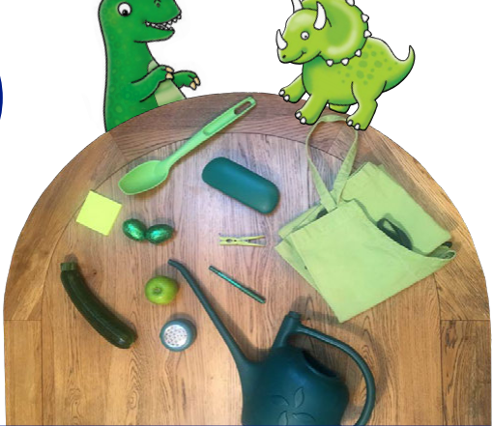

Go and enjoy the sunshine and have a lovely walk with your families, you may be able to find objects that are yellow, blue, orange, purple. If you do take photos and send them to school, happy spotting.

