The Rain Cloud Lets investigate
Why does it rain?
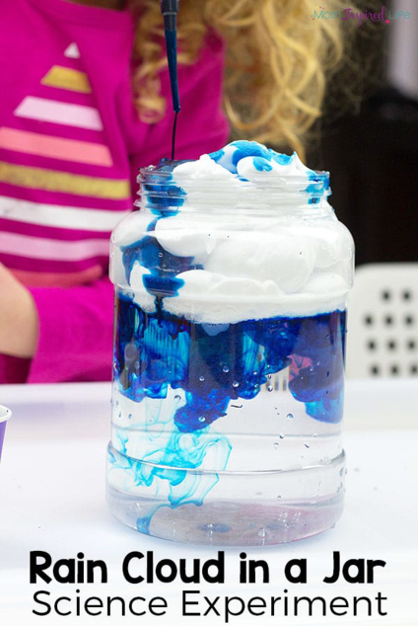
Knowing why it rains is a very difficult concept for children to grasp. Explaining that clouds are actually tiny droplets of water rather that solid white cushions is a very complex idea.
What you will need?
- A glass of water
- Blue food colouring
- Shaving foam
- A medicine dropper or pipette (teaspoon)
How you do it?
Using a glass of water to demonstrate the sky, create a cloud at the top by using shaving foam. Now, use a medicine dropper, pipette or a teaspoon to drop little droplets of food colouring into the cloud. Eventually, the food colouring will seep through the cloud to demonstrate rain.
Children may start to grasp the relationship: When the clouds get too heavy – some of the water has to rain down.
Please click and follow the link below for a video example:
Looking forward to hearing or seeing some of your experiments!
Good luck!
Miss Burns

