Let’s Investigate. Make a Twig Boat

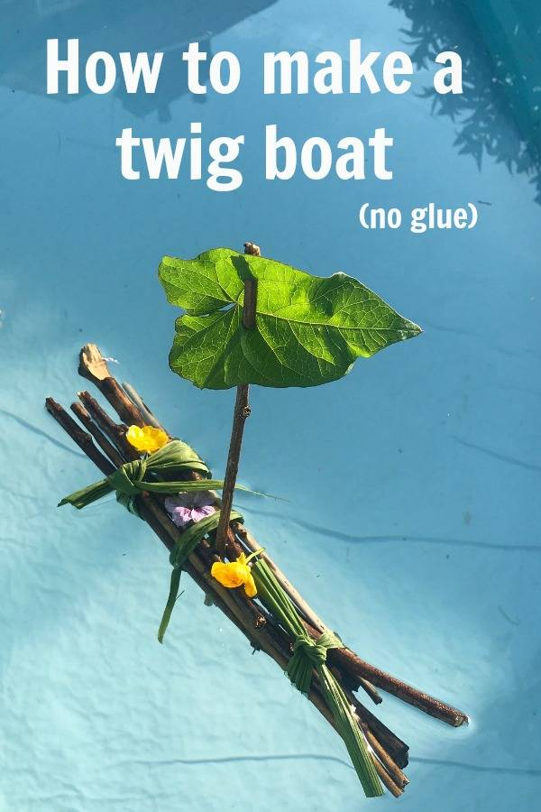

What you will need

Long pieces of grass
6-8 sticks broken to a similar size
A few fallen flowers
A leaf

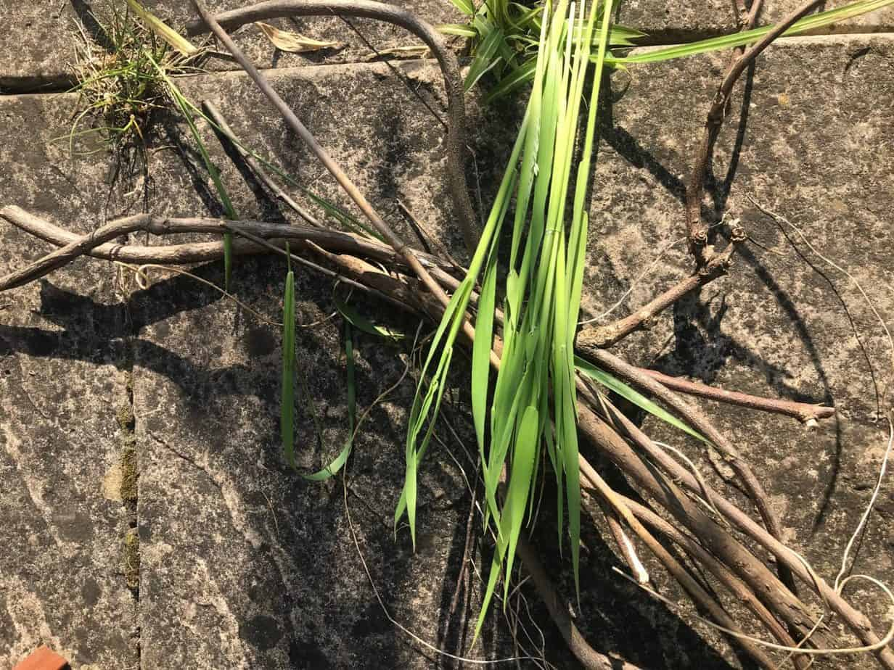

What to do

Lay your grass and twigs as shown below

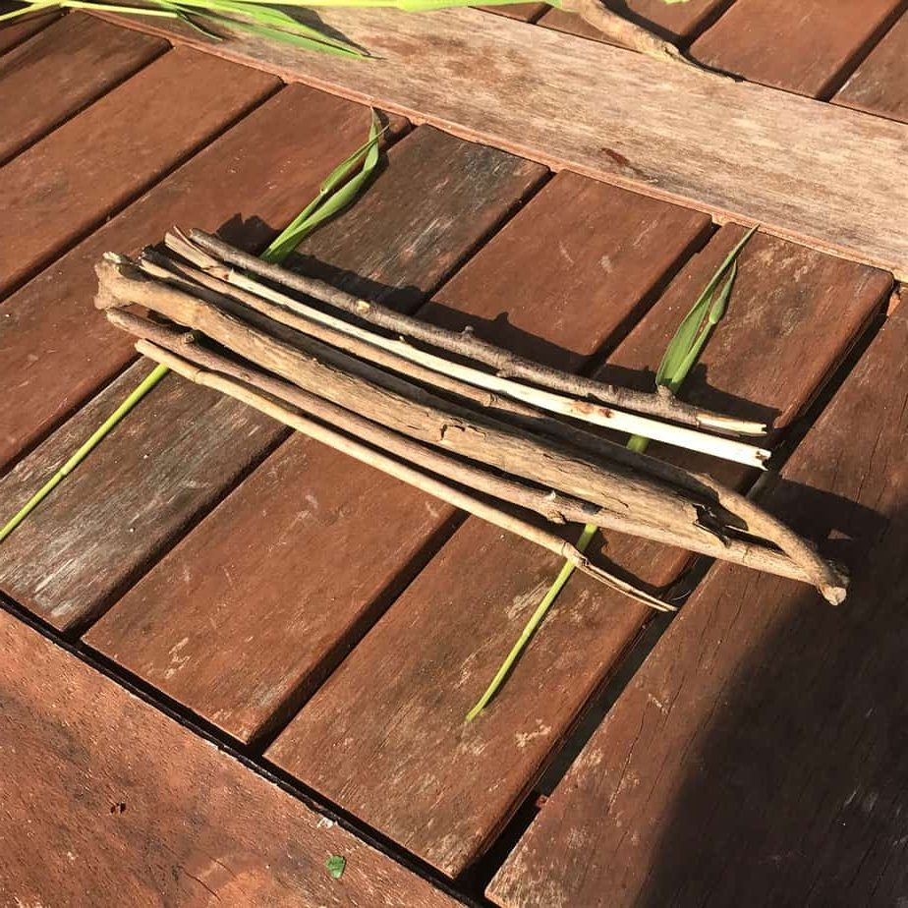

Tightly wrap your grass around the twigs to bring them together. Try to keep your twigs flat and as tight together as possible. (You may need a grown up to help you with this.)

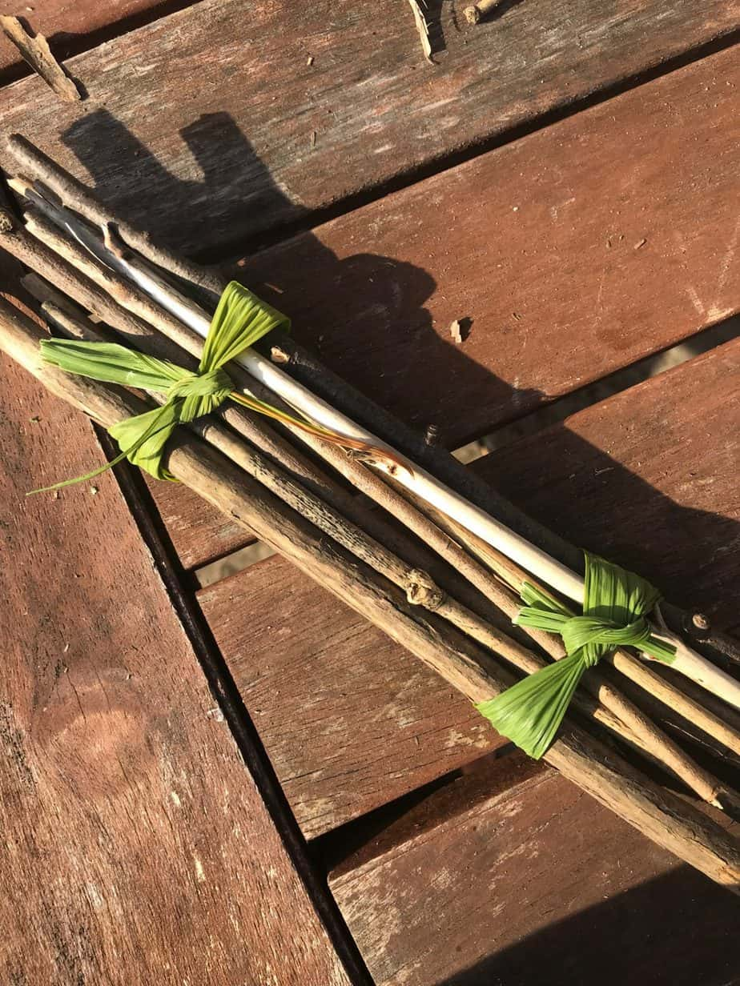

Next, take one extra twig and slot it into the bottom of your boat to become your mast.
Thread a leaf gently by poking the mast through it in two places. This will make the sail.

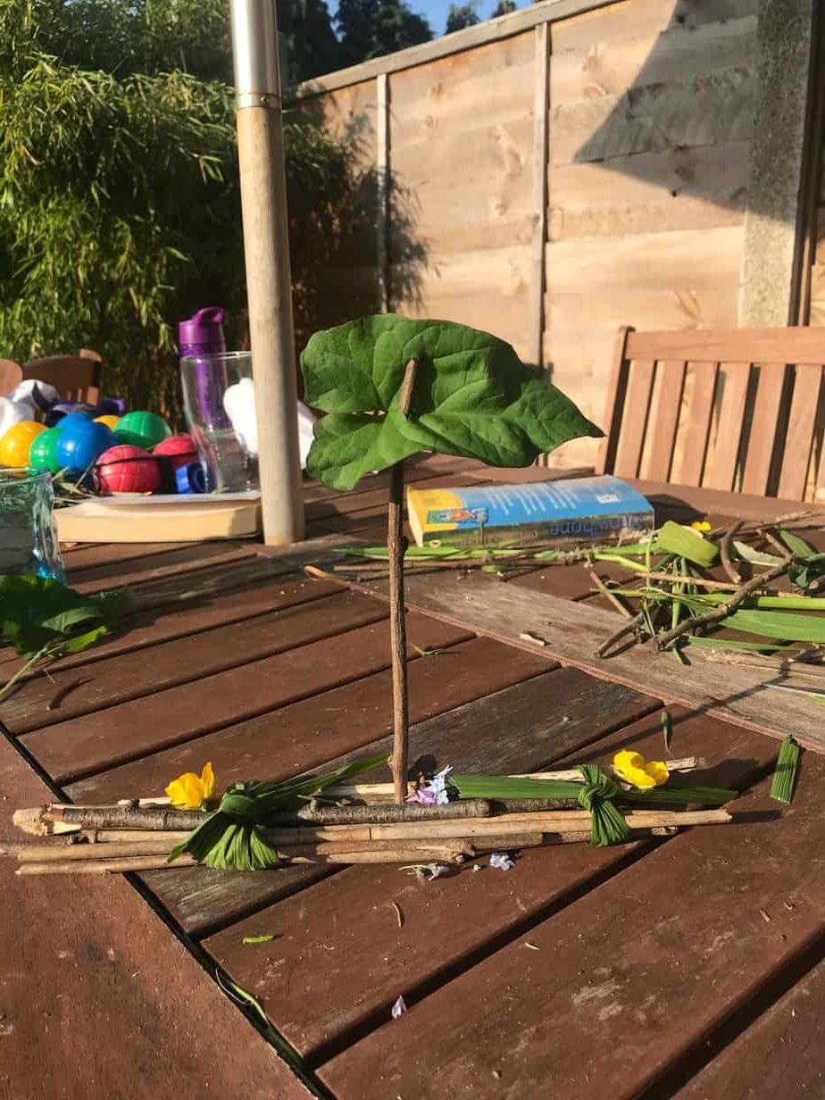
Add a few fallen tiny flowers for decoration

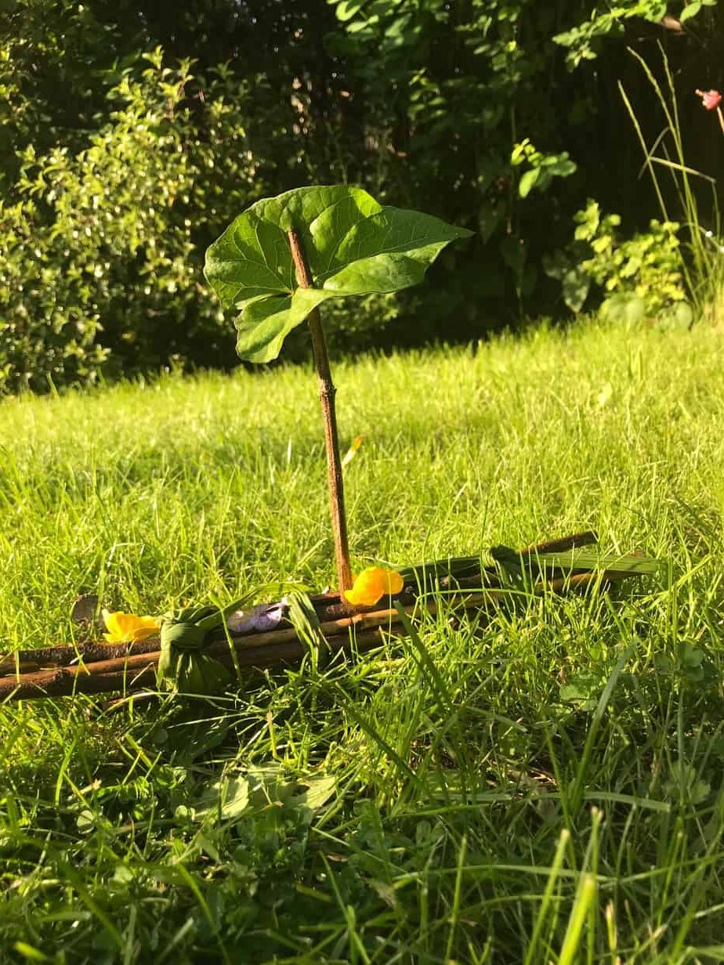

Your twig boat is finished. Set it afloat in a paddling pool, kitchen sink or bath.

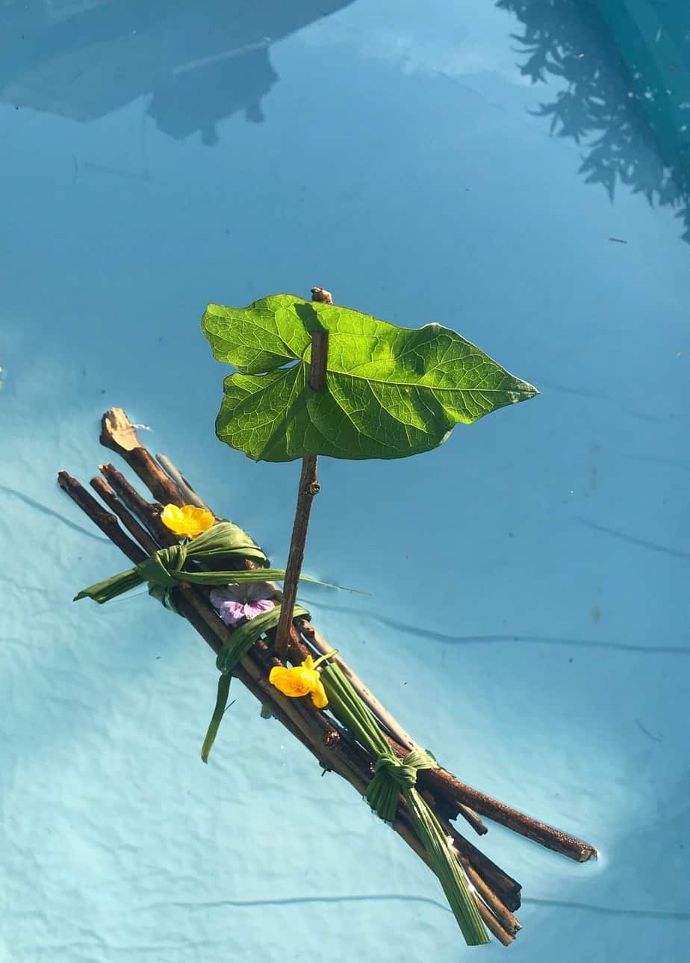

Enjoy your twig boat from Mrs Graves.

