Where do I live?
My street name is _______________________________

The postcode is___________
Here is a map of my street:

I live in North/South/East/West.
(Circle answer)
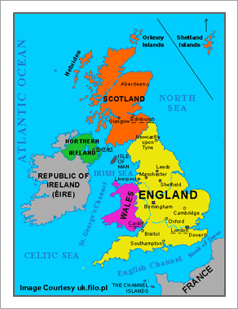

England is part of __________
______________. This includes
England, ___________,
__________ and __________.

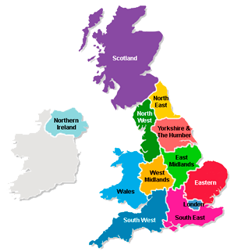
Mark off where you live on this map of Great Britain.
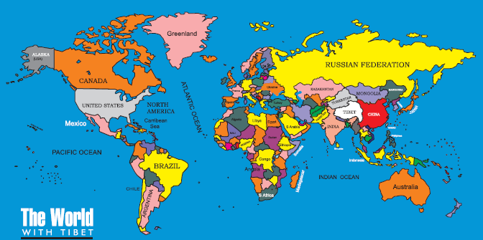
Mark off where you live on the world map.

