Leaf Printing

Things you will need:
- Paper
- Paint
- Paint Brushes
- Leaves
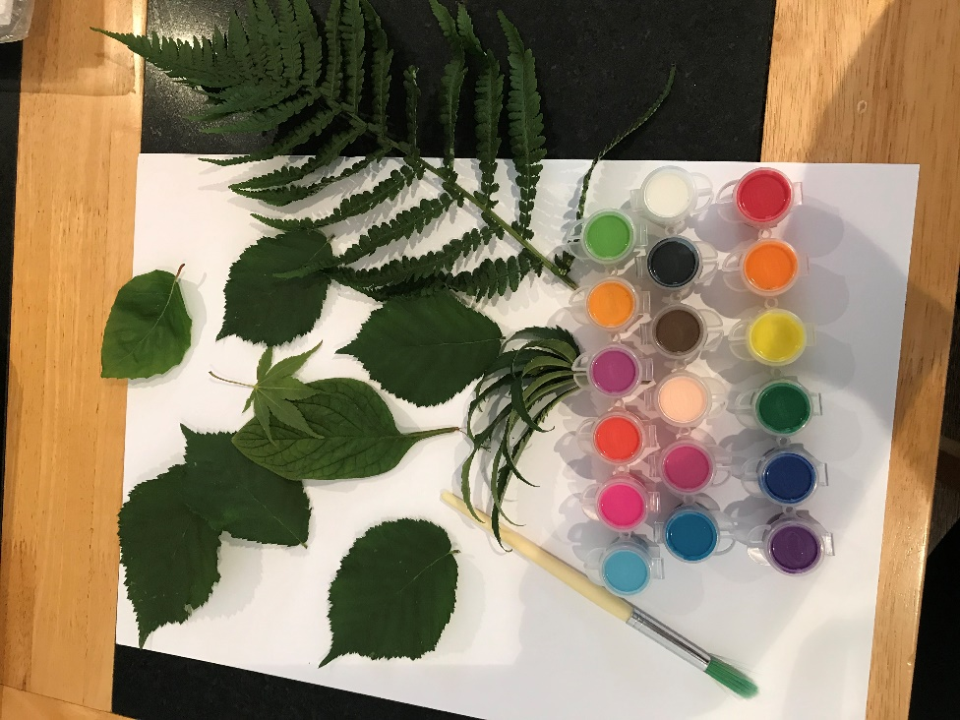

Gather as many different leaves you can from your garden or from a nice nature walk.
Paint your leaves with different coloured paints and press them onto a blank piece of paper to create your own design.

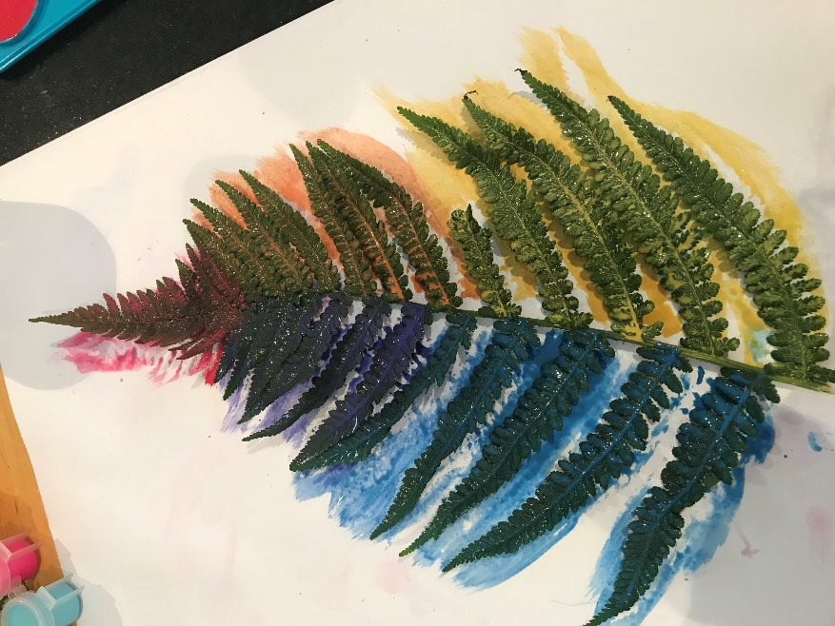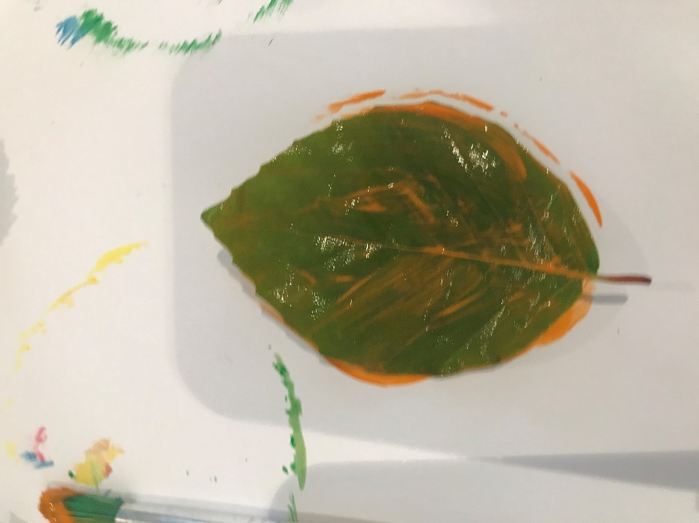
You can paint the leaves all one colour or use different colours to create a rainbow design. Have fun creating different designs.

