Hello everyone. It’s Mrs Morgan here. This is an activity you could try when you are out for a walk or in your garden. Good luck and have fun!

Tick the box when you have found or completed the activities.

- Find an insect and watch what it is doing. 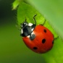 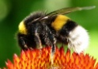 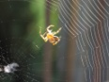
- Find something that smells beautiful.
- Build a pile of leaves to jump in.
- Find something green.
- Find something round.
- Find something brown.
- Build a house of sticks (big or small). 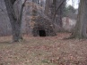
- Listen to birds singing. 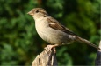 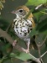
- Find a bumpy stick.
- Find a smooth rock or stone.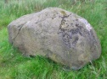
- Find something prickly. 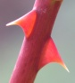 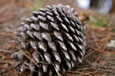
- Look at the shapes of the clouds.
- Look for shadows (if it is sunny).
- Make a picture from leaves, stones and twigs. 