Healthy Eating Snacks
We have to eat healthy to keep ourselves healthy, we need to eat 5 fruit pieces of fruit or vegetables a day here is a couple of ideas you can make at home for a snack.
Fruit Kebabs
These are really yummy and easy to make, and you get your 5 a day I made these the other day when I had a bbq, after you have had a couple you could be really cheeky and dip it in chocolate. Shhhhhh. You can add all the fruit you like, I added strawberries, pineapple, grapes, kiwi and mango.
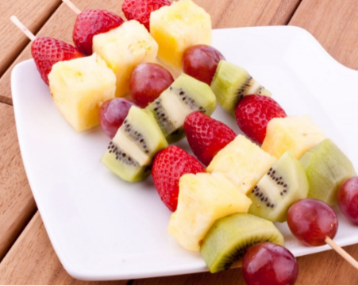
I went strawberry picking to get my strawberries, that was good exercise. To stay healthy we need exercise, sleep and to eat fruit and vegetables.

Cream cheese faces
I made these for my friends little ones when we had a social distance lunch last week in the garden they loved making faces.
What we did, we cut a bagel in half (you can use rice cakes, muffins, crackers) spread cream cheese on it and add vegetables to it to make a face.

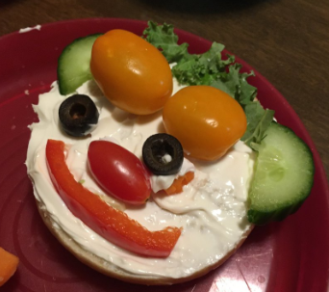
we used cucumber, pepper, olives, tomato, kale.

Have a great time making these and send school some pictures of what you have made.

