Middle School- Aliens Love Underpants

Last term the pupils in Middle School, absolutely loved learning all about the Story ‘Aliens Love Underpants’, by Claire Freedman. The pupils will love to share this story with you and we have lots of exciting ideas below which you can explore to help you share this story with your child.

We have shared with you a copy of the story and we have provided you with a video of one of the members of staff reading it.

Maths

Learning objectives:

To sort objects by two given categories.

To sort big, medium and small objects. To begin to sort them into order by size.

To use tally marks to record how many in one set.

To count objects up to 20.

To combine two sets of amounts when problem solving in practical situations.

To understand that adding together two numbers, the original number gets bigger.

To know number bonds to 10 or to 20.

Suggested activities- you do not (or are expected) to do them all, these are just lots of different suggestions; choose which one/ones you think your child will prefer:

Listen to the song- 5 Little Men in a Flying Saucer-https://www.youtube.com/watch?v=2E3p_51tJx0 Encourage your child to sing along. Model each key number when they are sung.

In the story the aliens, love underpants of all sizes- big and small. But the aliens have dropped all their socks and underpants when they were flying away quickly, so that the mum didn’t spot them. Can you help the aliens by finding socks or underpants (or it can be any objects) which are big and small. Can you then sort the objects into piles of big, medium and small? You can check their understanding by pretending to put one object in the wrong category and see if they notice. I have provided a copy of big, small and medium symbols, which you can use to help model this language to your child. Then can they order them in size order from biggest to smallest or smallest to biggest or tallest to shortest or shortest to tallest (as seen below). I have included these two symbols as well to aid with modelling the language. Challenge: Can you measure how tall the socks are with a ruler? Can you record all the lengths on a piece of paper? 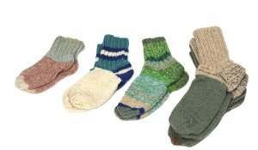

Aliens love underpants of all different colours as well as sizes and lots of different colours are mentioned in the story. Can you find any socks, underpants or objects in the house, which are; red, yellow, blue or green. Then can you sort them by two categories- for example, black, green and big and small and then put them into the correct category. I have provided an example of a sorting by two categories grid. You can either print it or draw your own version. You can check their understanding by pretending to put one object in the wrong category and see if they notice. Challenge: Can you go back through the story and find other colours or categories the aliens have mentioned? Can you then find objects of these categories and sort them by different categories?

When aliens are flying home they love to see how many of each type of underpants or socks they have. Can you make a tally to show how many of each types of socks or underpants you have. E.g. how many black socks, how many white socks, how many big underpants, how many small underpants? Here is a quick video/information about Tally charts- https://www.bbc.co.uk/bitesize/clips/zjbcd2p and https://www.bbc.co.uk/bitesize/topics/zxjj6sg/articles/zg496yc

When the aliens fly home they love to see how many underpants they have stolen. Before starting this activity, get a selection of underpants or socks. Place the underpants or socks on the floor and get your child to count how many there are. To turn it into a game, and help the child stay engaged you could get them to close their eyes before you put the socks down, to help build the suspense. Start off with numbers from 10-15. When they are confidently able to correctly count these numbers (making sure they don’t count the same object twice) then keep increasing the amount until you get to 20.When your child is confident in this, then you can change the game, to adding two amounts together within 20. I have provided a short video to help explain this activity.

Aliens love matching pairs of numbers as well as matching underpants- can you have a go at making some number bond aliens. I have provided an outline- which you need to print and cut up. Then can the child make a completed spaceship by matching up all the correct number bonds. When your child is really confident with their number bonds to 10, then you can introduce your number bonds to 20. You do not need to print them out. You could just draw them on paper and see if they could match them up.

English

Learning objectives:
To listen and respond to a story
To use familiar story book language within play and discussion
To respond to the questions; ‘who’, ‘when’, ‘what’, ‘where’ and ‘why’.
To develop our punctuation skills within our sentences, including capital letters, full stops and finger spaces.

Suggested activities- you do not (or are expected) to do them all, these are just lots of different suggestions; choose which one/ones you think your child will prefer:

You can listen to the story or read the story to your child. Afterwards you can talk to your child about whether they liked the book or not and why? What was their favourite part and why? Challenge: Can you write a sentence about your favourite part of the story. I have provided an outline which you can use.

Can you find props around your house, for example, a cardboard box for a space ship, underpants, a teddy bear for the alien etc. and then re-enact the story. Or you can use the props while the story is being read to you.

Ask your child how they think the aliens and people are feeling in different parts of the story. For example, at the start looking at the alien statues, when they are playing in the underpants and then at the end when they are flying. You can then ask your child why they think the aliens may be feeling that way. I have provided some symbols to help spark ideas of different emotions- you can print these or view these online.

You can verbally answer questions all about the story from our story question sheet. Challenge: Can you have a go at writing your answers down on a separate piece of paper?

When you have designed your alien or pants- can you tell someone about your alien/pants. E.g. for your pants-- what colour is it? For your alien- what is your alien called? Is it scary or friendly? Challenge: Can you write a fact file about your alien- its name, what it looks like, what its favourite types of underpants are? I have provided a suggested outline that you can use for this, but if you do not have a printer, you can write these headings on a separate piece of paper. I have included some symbols to help with this. Please go through the symbols with the child first, as they may not recognise all of them.

Can you sequence pictures from the story? Can you write a sentence underneath each picture to describe what is happening? If you aren’t able to print the pictures- could you move them around on the screen into the right order? Or you can have a go at drawing each scene?

Look near the end of the story, when the aliens are flying away, can you write some sentences about what the aliens have stolen from the washing line. Can you describe what pants look like? Did they take any other item of clothing? How may they be feeling? Where are they going home to? Where may they want to visit next? I have included a worksheet to go with this task which has the picture of that scene. However you do not have to use this- you can write it on a separate piece of paper.

If any alien came to visit you what would you do? Can you write a sentence about what you would do and why. I have provided an outline, however you can write the first part of the sentence on a separate piece of paper for your child if you don’t have access to a printer.

Phonics:

In our story Aliens love Underpants and our topic of space, we have all thought of different words linked to that topic, which start with the initial sounds we have been learning in class: n, p, s, a

You can listen to our Jolly Phonic songs for these sounds. Can you have a go at saying them and the actions? https://www.youtube.com/watch?v=klKuKKuPE4o

Can you have a go at writing these sounds- with paper, with chalk? Drawing them in flour? Drawing them in the air or on your hand?

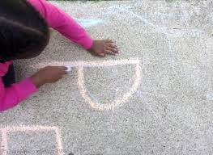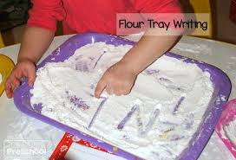

Can you think of some more words that begin with these sounds. I have started a list for you.
n | p | s | a
Neptune | Planets | Spotty | Aliens
 | Pants | Stripy
 |  | Spaceship

Could you have a go at writing the words you thought of. Use your robot arms to help you sound it out.

Can you find any objects around your house which begin with these sounds.

Science:

Space and Planets:

In our story the aliens visited Earth to get Pants. Where could they go next on their adventures to find pants?

You can listen to the planet song- https://www.youtube.com/watch?v=noiwY7kQ5NQ or https://www.youtube.com/watch?v=ZHAqT4hXnMw

After listening to the song- Can you remember and tell an adult the different names of the planets.

Can you the order of the planets from the sun? I have provided pictures of the planets that you can cut out and order and a completed solar system picture- with all the planets in order as a reference if needed for the pupils. Or you could have a go at drawing them and ordering them. Or you can use this link and there is an ordering game- near the bottom of this page on BBC Bitesize- https://www.bbc.co.uk/bitesize/topics/zdrrd2p/articles/ztsqj6f

Can you find out 1 fact about another planet for the aliens. E.g. is it hot planet?

Can you remember any facts about the Sun or any of the planets? Can you tell someone in your family. Or can you have a go at writing this on our planet/sun fact file. I have provided a outline that you can use if it helps.

Can you remember any other planet- can you draw the planet for the aliens to visit?

Alien shadow puppets:

Last term, we enjoyed learning all about shadows and how we make them.

You can watch this video to remind you all about shadows and how they are made. https://www.youtube.com/watch?v=3Mv4qa5c0q8

You can design your own alien (or print off an alien) and then attach a straw or stick (not essential). You will then need to hold it up to a light or use a torch (you can use the torch on your phone) to help you create a shadow.

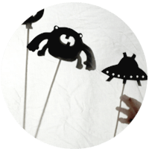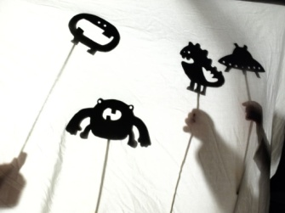

PE:
- The aliens have Upside-Down-Pant Races. Could you plan another PE competition for them? Running races? Obstacle course? Jumping races- as the aliens like to jump from the parachute.
- Can you find someone in your house and have relay races where you have to put different items of clothing on?
- Aliens love to dance, to celebrate all the pants they have brought back or they have found- Can you come up with an alien dance movement to celebrate the pants you found? Can you do a silly alien walk? Can you be a space rocket? Can you spin like a space ship?

Art:
- Design and/or make an amazing set of underpants that the aliens would love to come and take back to space. You can design it on paper with pencils and colouring pencils. I have found an outline that you are welcome to use or you can design your own. Could you then have a go at then making it- you could use cardboard, paper, tin foil, paint etc. Anything you can find.
- 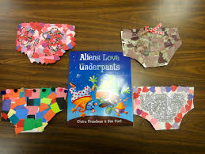
- Can you design and/or make your very own alien. You can design it on paper with pencils and colouring pencils. Or you can use the outline we have provided. Think about what colour they are, are they scary or friendly. Do they have an antenna? Do they have strips or spots? How many eyes? I have found an outline that you are welcome to use or you can design your own.
- Can you make an alien headband? You can use a strip of paper for the head band and then use paper for eyes, nose etc. Below is an example one- but you can make it however you like. You don’t need to use pipe cleaners for the antenna- use could use straws or other pieces of paper.
- 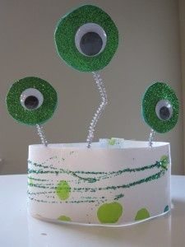
- Design and make a new spacecraft for the aliens to travel to Earth in. You can use any junk modelling you have- e.g. car board boxes, tin foil, paper etc.
- 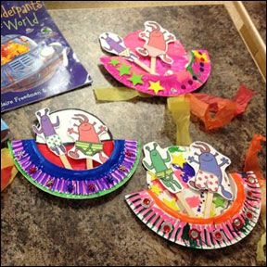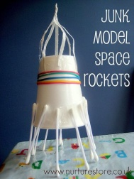
Cooking:
- You can make Toast aliens. For this you will need a slice of toast and then you can use whatever ingredients you have at home to make them. You could use peanut butter, chocolate spread, jam, cheese spread etc. To make the base of the alien. You could then use fruit or vegetables, such as tomatoes, cucumber, banana, raisins, grapes etc. That the pupil can then cut to make into the shape for that part of the alien. This will help pupils work on their cutting and spreading skills. Below are some examples of toast aliens and animals- so you can see all the different ways you could make them- but these are only suggestions- you can be as creative as you want. I have provided a video of a staff member giving this activity a go to give you some ideas. I have provided a video of a staff member giving this activity a go to give you some ideas.
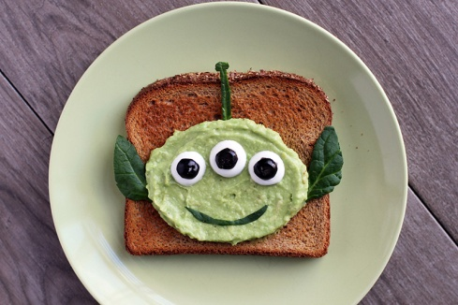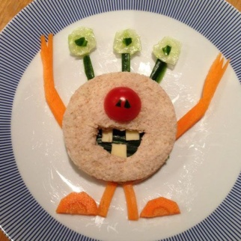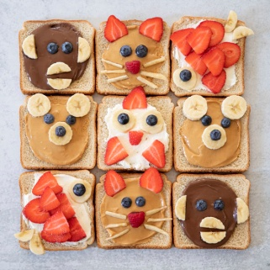
- Can you decorate biscuits to make your own space ship? You could use sprinkles, buttons, strawberry laces or anything else you can find to make the different parts of the space ship.
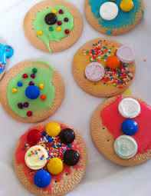
PHSE- Independence:
- Can you find some socks, trousers and pants and practice putting them on your teddy?
- Can you peg your socks and pants onto a washing line. Make sure to check there are no aliens about ready to come and get your socks and pants! You can make a washing line up with some string and pegs. Challenge: Can an adult time you to see how fast you can do it?
- Aliens also love socks- can you have a go at putting your socks on all by yourself!
- The aliens’ favourite things are underpants. Can you find one of your favourite items that you love? Can you show it to an adult and tell them why it is special and important.

