Middle School- Aliens Love Underpants

Last term the pupils in Middle School, absolutely loved learning all about the Story ‘Aliens Love Underpants’, by Claire Freedman. The pupils will love to share this story with you and we have lots of exciting ideas below which you can explore to help you share this story with your child.

We have shared with you a copy of the story and we have provided you with a video of one of the members of staff reading it.

Maths

Learning objectives:

To match a pair of objects.

To comment upon and make groups of ‘one’ and ‘lots’.

To count objects up to 3.

To join in familiar number rhymes

To match big and small objects of the same size.

Suggested activities- you do not (or are expected) to do them all, these are just lots of different suggestions; choose which one/ones you think your child will prefer:

Listen to the song- 5 Little Men in a Flying Saucer-https://www.youtube.com/watch?v=2E3p_51tJx0 Encourage your child to sing along. Model each key number when they are sung.

Aliens love underpants of all sizes- big and small. Find socks or underpants (or it can be any objects) which are big and small in an obvious way- as shown below. Find objects which of similar sizes to the above objects. Then with support encourage your child to match the objects to original big and small objects. I have provided a copy of big and small symbols, which you can use to help model this language to your child.

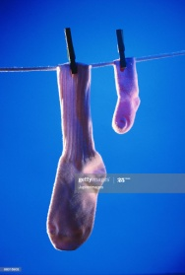

Aliens love underpants of all different colours as well as sizes and lots of different colours are mentioned in the story. Can you find any socks, underpants or objects in the house, which are; red, yellow, blue or green. I have provided symbols of these colours, to help your child. You can either print them or take one colour at a time and show the symbol up on a device to your child, or you can colour a piece of paper that colour, for them to see the exact colour before they go off looking.

As well as underpants, aliens also love socks- especially matching socks. Before starting the activity, the adult will find up to 4 pairs of matching socks- all of which are very different. Then you can tell the child oh no, the aliens dropped these socks on their way back home but they are all mixed up. Can you find which pairs of socks belong together?

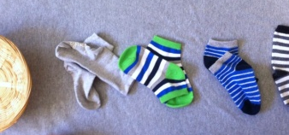

When the aliens fly home they love to see how many underpants they have stolen. Before starting this activity, get a selection of underpants or socks. Then place them into piles of one and lots. You can then ask the pupil to point to which one has lots. Then which one has one. Change the group of socks around and repeat these questions. Model the language of one and lots throughout. I have provided a short video to help explain this activity.

When they are confident with the above activity you can then have a go at this activity. When the aliens fly home they love to see how many underpants they have stolen. Before starting this activity, get a selection of underpants or socks. Place the underpants or socks on the floor and get your child to count how many there are. To turn it into a game, and help the child stay engaged you could get them to close their eyes before you put the socks down, to help build the suspense. Start off with numbers up to 2. Then when they are confidently able to correctly count these numbers then go up to 3. I have provided a short video to help explain both this and the above activity.

English

Learning objectives
To listen and respond to a story
To use familiar story book language within play and discussion
To respond to the questions ‘who’ and ‘what’
To develop mark making or emergent writing (early ‘pretend’ writing)

Suggested activities- you do not (or are expected) to do them all, these are just lots of different suggestions; choose which one/ones you think your child will prefer:

You can listen to the story or read the story to your child.

Can you find props around your house, for example, a cardboard box for a space ship, underpants, a teddy bear for the alien etc. that you can use while the story is being read to you. Or you can choose your favourite page of the story and then use them to re-enact this page from the story.

Ask your child how they think the aliens and people are feeling in different parts of the story. For example, at the start looking at the alien statues, when they are playing in the underpants and then at the end when they are flying or the little boy at the end of the story. I have provided some symbols to help spark ideas of different emotions- you can print these or view these online. You will need to go through all the symbols at the start, as pupils may not have seen them before.

You can verbally answer some questions all about the story from our story question sheet.

When you have designed your alien or pants- can you tell someone about your alien/pants. E.g. for your pants-- what colour is it? For your alien- where is its arms? Legs? Eyes? You can show and use the symbols I have provided to help pupils talk about their creation- please go through the symbols first with the pupils as they may not as have some of them before.

Can you sequence pictures from the story? If you aren’t able to print the pictures- could you move them around on the screen into the right order? Adults can ask key questions for each picture. For example, Who is that? What are they doing?

Can you write labels for the key parts of the alien? I have provided an outline you can use. However if you don’t have access to a printer- you can have a go at drawing the alien and then verbally labelling, using the symbols- they could point to the correct symbol. To help your child, make sure you read through the symbols first, so they all know what each symbol means, as they may not have come across them before.

Phonics:

In our story Aliens love Underpants and our topic of space, we have all thought of different words linked to that topic, which start with the initial sounds we have been learning in class: n, p, s, a

You can listen to our Jolly Phonic songs for these sounds. Can you have a go at saying them and the actions? https://www.youtube.com/watch?v=klKuKKuPE4o

Can you have a go at writing these sounds- with paper, with chalk? Drawing them in flour? Drawing them in the air or on your hand?

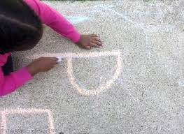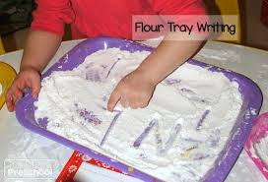

Science:

Space and Planets:

In our story the aliens visited Earth to get Pants. Where could they go next on their adventures to find pants?

You can listen to the planet song- https://www.youtube.com/watch?v=noiwY7kQ5NQ or https://www.youtube.com/watch?v=ZHAqT4hXnMw

After listening to the song- Can you remember and tell an adult any of the names of the planets.

Can you explore the order of the planets from the sun? I have provided a completed solar system picture- with all the planets in order, which you can then use to explore the names of the planets and their order from the sun. I have also provided pictures of the planets that you can use to help, as they are bigger than the completed solar system picture.

Can you draw or colour a picture of one of the planets for the aliens to visit? I have provided planet colouring sheets if needed.

Alien shadow puppets:

Last term, we enjoyed learning all about shadows and how we make them.

You can design your own alien (or print off an alien) and then attach it to a straw or stick (not essential). You will then need to hold it up to a light or use a torch (you can use the torch on your phone) to help you create a shadow.

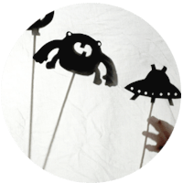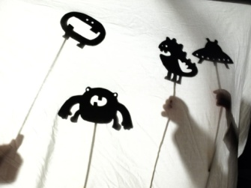

PE:
- The aliens have Upside-Down-Pant Races. Could you have another PE competition? For example, running or jumping races- as the aliens like to jump from the parachute.
- Aliens love to dance, to celebrate all the pants they have brought back or they have found- Can you come up with an alien dance movement to celebrate the pants you found? Can you do a silly alien walk? Can you be a space rocket? Can you spin like a space ship?

Art:
- Design and/or make an amazing set of underpants that the aliens would love to come and take back to space. You can design it on paper with pencils and colouring pencils. I have found an outline that you are welcome to use or you can design your own. Could you then have a go at then making it- you could use cardboard, paper, tin foil, paint etc. Anything you can find.
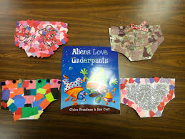
- Can you design and/or make your very own alien. You can design it on paper with pencils and colouring pencils. Or you can use the outline we have provided. Think about what colour they are, are they scary or friendly. Do they have an antenna? Do they have strips or spots? How many eyes? I have found an outline that you are welcome to use or you can design your own.
- Can you make an alien headband? You can use a strip of paper for the head band and then use paper for eyes, nose etc. Below is an example one- but you can make it however you like. You don’t need to use pipe cleaners for the antenna- use could use straws or other pieces of paper.
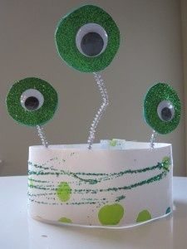
- Design and make a new spacecraft for the aliens to travel to Earth in. You can use any junk modelling you have- e.g. car board boxes, tin foil, paper etc.
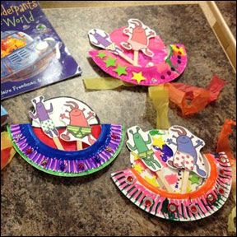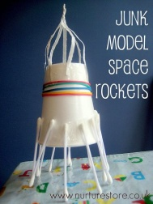
Cooking:
- You can make Toast aliens. For this you will need a slice of toast and then you can use whatever ingredients you have at home to make them. You could use peanut butter, chocolate spread, jam, cheese spread etc. To make the base of the alien. You could then use fruit or vegetables, such as tomatoes, cucumber, banana, raisins, grapes etcs. That the pupil can then cut to make into the shape for that part of the alien. This will help pupils work on their cutting and spreading skills. Below are some examples of toast aliens and animals- so you can see all the different ways you could make them- but these are only suggestions- you can be as creative as you want. I have provided a video of a staff member giving this activity a go to give you some ideas.
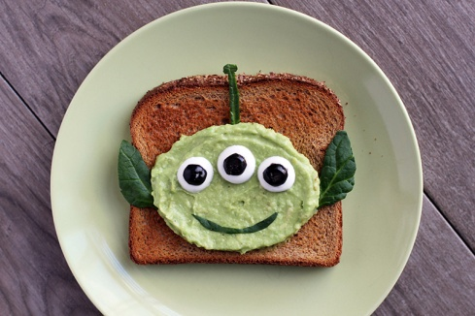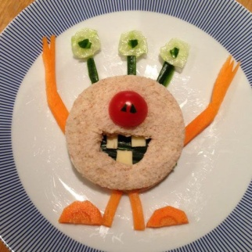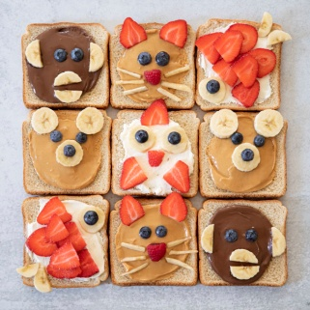
- Can you decorate biscuits to make your own space ship? You could use sprinkles, buttons, strawberry laces or anything else you can find to make the different parts of the space ship.
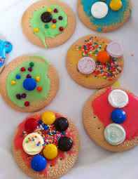
PHSE- Independence:
- Can you find some socks, trousers and pants and practice putting them on your teddy?
- Can you peg your socks and pants onto a washing line. Make sure to check there are no aliens about ready to come and get your socks and pants! You can make a washing line up with some string and pegs. Challenge: Can an adult time you to see how fast you can do it?
- Aliens also love socks- can you have a go at putting your socks on all by yourself!
- The aliens’ favourite things are underpants. Can you find one of your favourite items that you love? Can you show it to an adult and tell them why it is special and important.

