Today’s activity is Emotion Yoga. PE , Listening and PSHE
The Colour Monster is very confused he doesn’t know how he is feeling.
In Today’s Yoga Video – Join Mr Andrews as he goes on a dramatic journey through each colour and emotion. Join in with the yoga moves and see if you can show all of your emotional through movement and drama.
Experience the emotions of:
Yellow Happy
Blue Sadness
Red Angry
Grey Scared
Green Calm
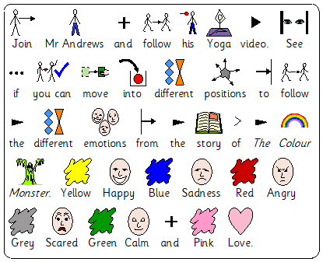
Pink Love

M Scales PE
M9 - Pupils copy, repeat and explore simple skills and actions with basic control and coordination.
M10, 11, 12 - Pupils explore simple skills. They copy, remember, repeat and explore simple actions with control and coordination.
M Scales PSHE- Relationships and living in the wider world
M9 - Pupils identify a range of feelings and emotions
M10 - Pupils name a range of feelings and emotions
M11 - Pupils accurately interpret a range of facial expressions
M Scales Listening
M9 - Pupils listen to others and usually respond appropriately
M10 - Pupils begin to show confidence listening, particularly where the topics interest them
M11 - They usually listen carefully and respond with increasing appropriateness to what others say

