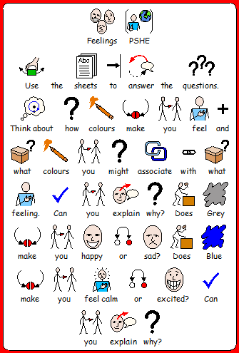
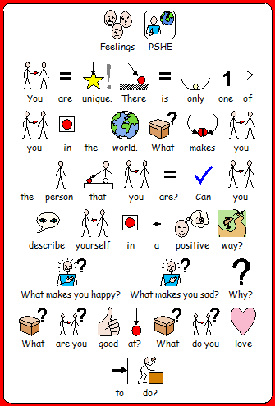
M Levels
Attention and Engagement
M11
Pupils engage with new tasks that are adult directed. Pupils are motivated to maintain a two way conversation about a matter of interest to them.
Pupils, when questioned, can identify areas of their work which please them and areas which can be improved. Pupils are aware there is importance placed on the quality of their work.

M12
Pupils are motivated to attempt new learning experiences through the praise and reassurance of others
. Pupils maintain focus on individual tasks without being distracted by environmental factors.

Independence and Personal Wellbeing
M10
Pupils recognise and celebrate their own strengths and talents
Pupils identify when they feel unhappy or anxious. Pupils use a wider breadth of vocabulary to describe their feelings and emotions.
M11
Pupils identify experiences which make them feel anxious and consider the consequences of these emotions. Pupils discuss how they have felt when they have lost something important to them.

M14
Pupils are confident in discussing their anxieties with trusted others. Pupils make suggestions as to how they and others can remain safe. Pupils explore a range of communication tools to seek help or support.
M15
Pupils strive to create positive happy feelings for themselves and others. Pupils are able to self regulate and remedy some anxiety related behaviours. Pupils recognise sadness and anxieties in others and seek to help them

Relationships and living in the wider world
M11
Pupils accurately interpret a range of facial expressions and offer emotional support to others. Pupils suggest how feelings can be managed in a positive manner.
M12
Pupils recognise the needs of others may differ to the needs of their own.
M13
Pupils demonstrate an empathy with the feelings and experiences of others and respond appropriately

