Link to The Colour Monster Story
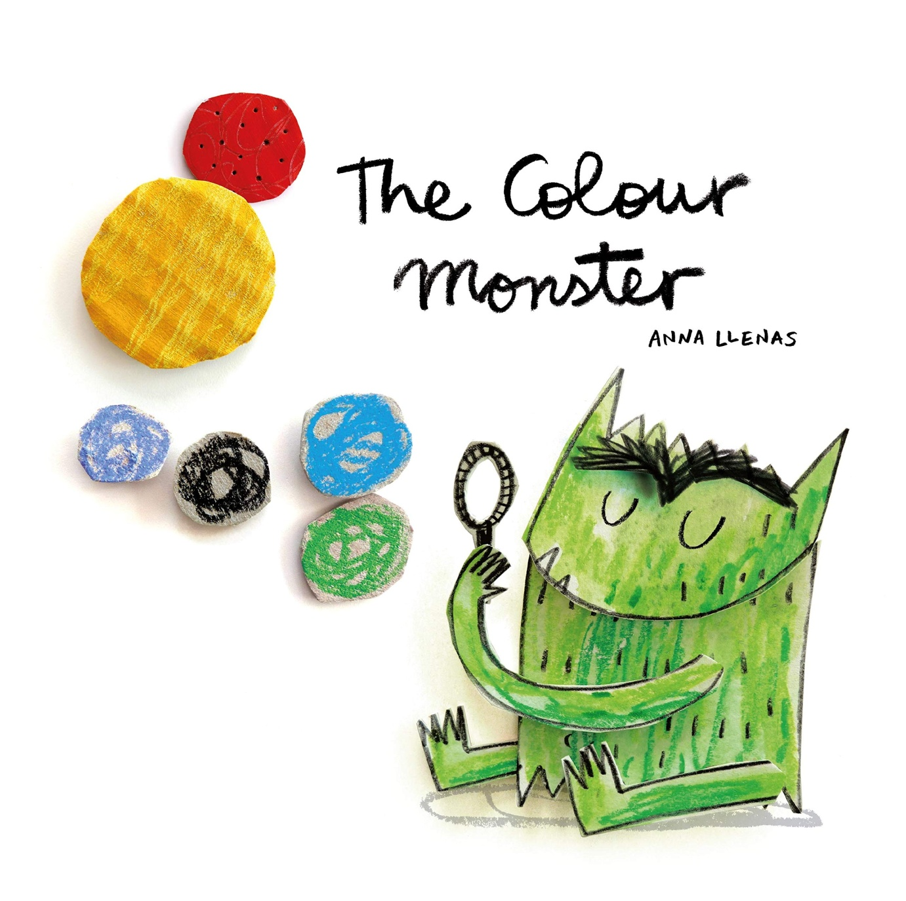
https://www.youtube.com/watch?v=Ih0iu80u04y

