Today’s activity is to explore colours and what happens when we mix colours. ART SCIENCE
The story: The Colour Monster explores different colours and their meanings: Yellow Happy Blue Sadness Red Angry Grey Scared Green Calm & Pink Love
Watch the video with Mrs Wilkinson and see how she explores mixing different colours. See if you can encourage your child to predict what colours will be created. Can you explore colours together?
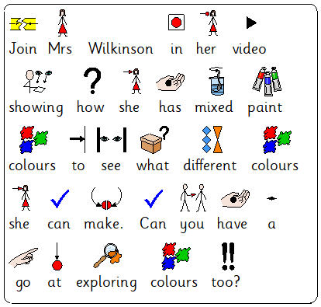
Can you help to explore mixing different colours. You can use paint, food colouring. Here are some activities that you could do?

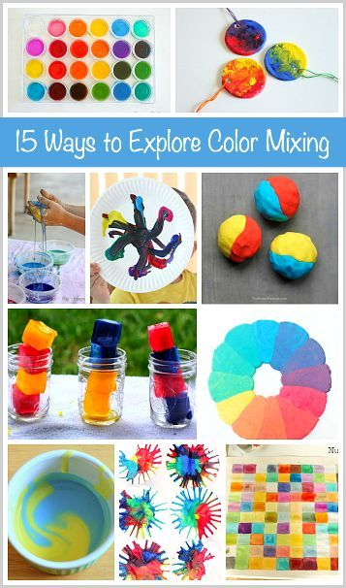
2 colours paint in a zip bag coloured water exploring
Play dough, Ice cubes,
Paint splat
Plastersine, Cakes
Food colouring and shaving gel
Coloured water, Corn flour,
Slime,
Coloured water and kitchen paper
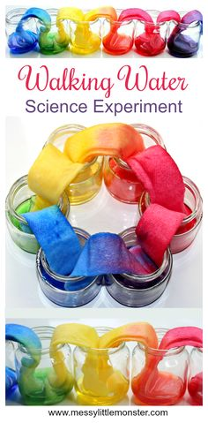

M Scales
Science - M9 They recognise evidence that has been used to answer a question such as identifying similar materials and make links between science and everyday objects
M10, M11, M12 They recognise, and describe similarities and differences between the materials they observe, using these to sort them into groups.

ART - M9 They describe what they think and feel about the work of others and what they have done in their own work
M10, M11, M12 - They investigate the nature and qualities of different materials and processes, exercising some control over those they use in their work

