Today’s activity is Feelings Monsters Writing PSHE
Can you help to write a sentence about each colour monster help to describe how they are feeling?
Try and to encourage children to use because to extend their sentence.
These sentences can be written by parents and you can encourage your child to write what they can.
Here are the sound mats to help sounding out words.

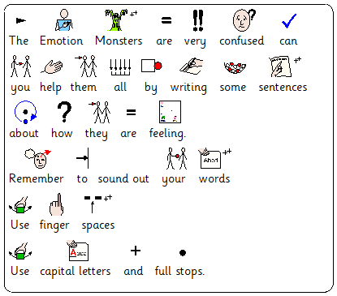

M Scales
Writing – M9 - Pupils writing communicates meaning through simple sentences
Through adult led structures and frameworks, pupils make choices about creative elements of their writing.
M10 - Pupils begin to plan verbally what they are going to write about.
They are able to discuss this with others, when guided by an adult, before starting a writing task.
Pupils are able to write a simple sequence of sentences.
M11 - Pupils use adjectives in simple sentences.
Pupils accurately spell at least half of the range of common exception words, as detailed in the year one program of study.
PSHE
- Relationships and living in the wider world
M9 - Pupils identify a range of feelings and emotions
M10 - Pupils name a range of feelings and emotions
M11 - Pupils accurately interpret a range of facial expressions
-Independence and Personal Wellbeing

