Today’s activity is an Art tutorial to draw ‘The Colour Monster’. Art Listening PSHE
The Colour Monster is very confused he doesn’t know how he is feeling.
In Today’s Art Tutorial Video.– Join Mrs Wilkinson as she creates her own Colour Monster. Follow her line by line to draw your very own Colour Monster. Please can you take a picture of your wonderful Art? We cannot wait to see them.
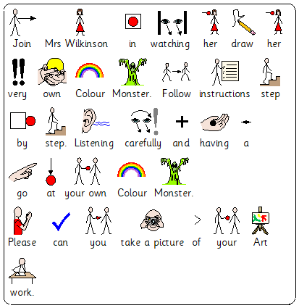
M Scales
Art - M9 They explore a variety of materials and processes to create their own work.
M10, M11 and M12
Pupils explore ideas and make some choices about what they will do.
They investigate the nature and qualities of different materials and processes, exercising some control over those they use in their work.
Listening – M9 Pupils listen to others and usually respond appropriately.
M10 - They usually listen carefully and respond with increasing appropriateness to what others say.
M11 - They usually listen carefully and respond with increasing appropriateness to what others say.
PSHE - Attention, Motivation and Self Reflection.
M9 - Pupils are motivated to engage with a task through observation of others.
M10 - Pupils are motivated by adult led tasks with favoured stimuli.
M11 - Pupils engage with new tasks that are adult directed.

