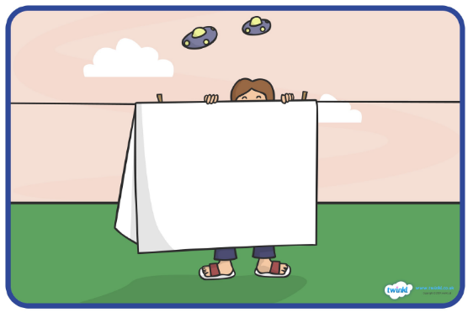
What the aliens did after they escaped the garden!

