Name: ___________________

Whatever Next!

LO: To create own version of a familiar story

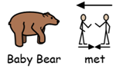

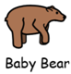

Encourage children to write their own answers the symbols are to support for ideas.

- Ask the children where baby bear went, they can choose Mars, Saturn or Neptune.
- Then ask who baby bear met was it an alien, dinosaur or a friend.
- Lastly, ask the children what did baby bear do did he play football, dance or did he explore?
- Extension: Encourage children to write a sentence. Remind children to use capital letters, finger spaces and full stops.

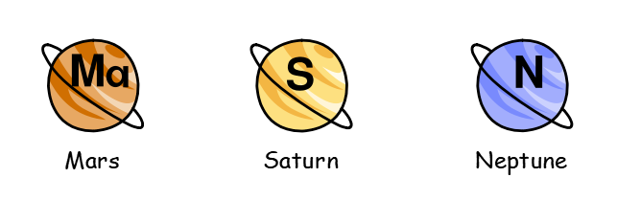

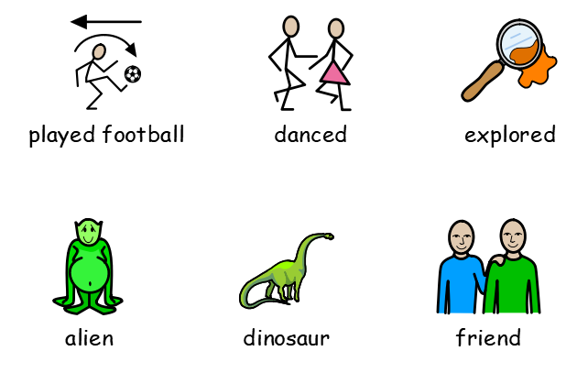

Name:__________________

LO: To write a sentence linked to familiar story remembering to use capital letters, fingers spaces and a full stop.

Children to draw what they have wrote in their sentence.

